Mr. Stephen V. King, Executive Director and Secretary
Washington Utilities and Transportation Commission
Attn: Records Center
P.O. Box 47250
Olympia, WA 98504

Re: Transmittal of SpeediShuttle Washington Tariff No. 1 Revisions Replacement Pages (TC-160378)

Dear Mr. King:

SpeediShuttle Seattle respectfully requests approval of the attached Tariff No. 1 revisions with an effective date of May 4, 2016 to reflect an increase of 5% to the maximum fare allowed in accordance with WAC 480-30-420 (2) (c). In addition, the tariff is being revised to consolidate the discounts allowed. Specifically, the references to “Round-Trip discount” are being eliminated since the discount no longer needs to be specified in the tariff because WAC 480-30-420 allows us to reduce our fares without notice. Rates to customer will not increase at this time, therefore no customer notice is required under WAC 480-30-316.

Please delete revised pages 3, 4 and 6 because there are no changes. Please replace revised pages 1, 2, 5, 7, 8, and 9 with the attached.

Respectfully submitted,
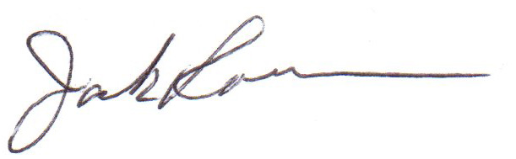
H. Jack Roemer
Chief Financial Officer

