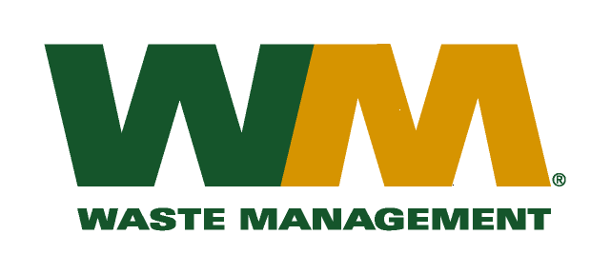
July 22, 2010
Washington Utilities and Transportation Commission
Chandler Plaza Building
1300 S. Evergreen Park Drive SW
P.O. Box 47250
Olympia, WA 98504-7250

Subject: Brem-Air Disposal, a division of Waste Management of Washington, Inc. (G-237); Tariff # 20
Enclosed are revised tariff pages 2, 19, 21, 22, 23 and 24 to the above-referenced tariff. The primary purpose of the revisions to these tariff pages is to reflect the adoption of Kitsap County Ordinance 453-2010 that expands the curbside recycling service to the entire County and adds compostable organics to the yard waste collection service. Since the adoption of this ordinance does not either result in an increase or decrease to our current tariff rates we are requesting an effective date of September 1, 2010 to implement this expanded service.
Also enclosed for your review is a copy of Kitsap County Ordinance 453-2010. If you have any questions or need additional information, please contact me at (425) 814-7840.
Very truly yours,

Michael A. Weinstein
Senior Pricing Manager, Pacific Northwest Market Area

cc: Terry Bickel
Clerk of the Board, Kitsap County Chair

