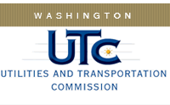

Memorandum

May 15, 2014

To: TR-132237 - File

From: Lori Halstead, Transportation Specialist

Subject: TR-132237 Central Washington Railroad
Completion of Grade Crossing Protective Fund (GCPF) Project

On January 16, 2014, the Washington Utilities and Transportation Commission (Commission) awarded a GCPF grant totaling $4552.80 to install emergency notification signs at 140 railroad crossings in Benton and Yakima counties.

On May 5, 2014, the applicant, Central Washington Railroad, submitted a request for reimbursement pursuant to Commission order. The actual reimbursement requested is $4536.54, which is $16.26 less than the approved amount in the order. Rail staff visited the area on May 5, 2014 and took pictures verifying that the new signs are in place. The project was completed according to the specifications outlined in the order approving the grant.

Please close this docket.

