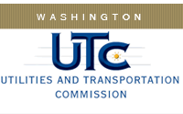

Memorandum
May 5, 2015

To: TR-143417 - File

From: Lori Halstead, Transportation Specialist, Rail Safety

Subject: TR-143417 – Western Washington Railroad
Completion of Grade Crossing Protective Fund (GCPF) Project-Installation of Emergency Notification Signs

On November 4, 2014, the Washington Utilities and Transportation Commission (Commission) awarded a GCPF grant totaling $297.33 to Western Washington Railroad for a project related to installation of Emergency Notification Signs (ENS) to at-grade crossings.

On March 30, 2015, Western Washington Railroad submitted a request for reimbursement for the project. Rail Safety Staff confirmed the signs have been installed and that the project was completed according to the specifications outlined in the order approving the grant. The total cost was $297.58. Reimbursement amount $297.33.

Please close this docket.

