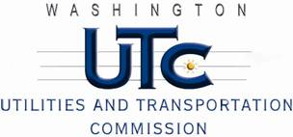

Memorandum
June 24, 2011

To: TR-110539 - File

From: Kathy Hunter, Deputy Assistant Director Transportation Safety

Subject: TR-110539 Eastern Washington Gateway Railroad
Grade Crossing Protective Fund (GCPF) Project at the Intersection of
State Route 2 (SR-2) and Eastern Washington Gateway Railroad’s Tracks in Grant County, Washington

On April 29, 2011, the Washington Utilities and Transportation Commission (Commission) awarded a GCPF grant totaling $8,597.47 to install LED lights, replace the battery charger and install a power off light at the SR-2 crossing in Grant County. The USDOT number assigned to this crossing is 066106E.

On June 15, 2011, the applicant, Eastern Washington Gateway Railroad submitted a request for reimbursement pursuant to Commission order. On June 10, 2011, Commission staff conducted a site visit and verified that the project is completed according to the specifications outlined in the order approving the grant.

Please close this docket.

