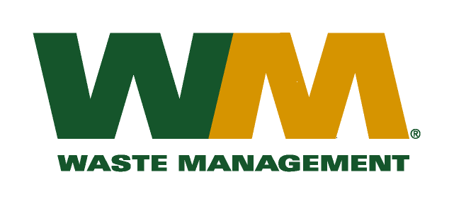
August 12, 2010
Washington Utilities and Transportation Commission
Chandler Plaza Building
1300 S. Evergreen Park Drive SW
P.O. Box 47250
Olympia, WA 98504-7250

Subject: Waste Management of Greater Wenatchee, a division of Waste Management of Washington, Inc. (G-237); Tariff # 12; TG-101357
Enclosed are revised substitute pages 21, 22, 24, 25 and Appendices B and C to the above-referenced tariff filing in docket number TG-101357. These pages are being substituted to further clarify the application of re-delivery and re-start fees on page 24; to correct the description of the recycling program on page 25 and to correct the appendix references. Please do not re-docket.
Very truly yours,

Michael A. Weinstein
Senior Pricing Manager, Pacific Northwest Market Area

cc: Lewis Carver
Ken Gimpel

