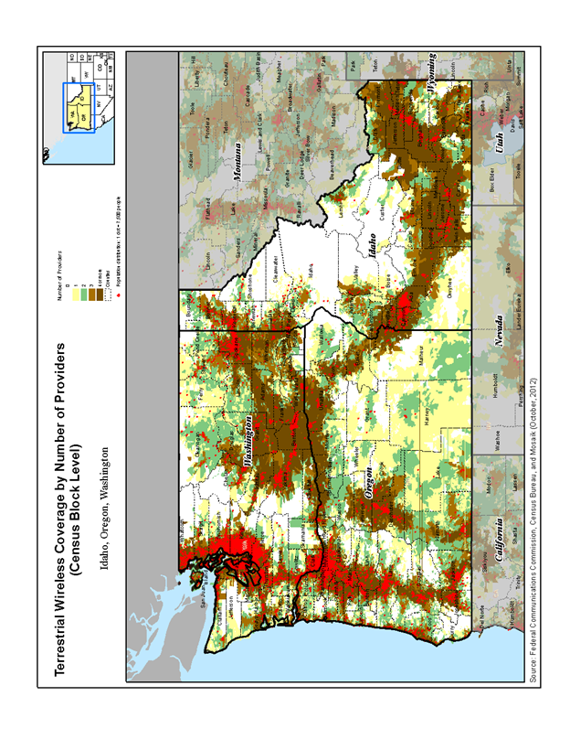

Source: Map C-12: Wireless Coverage by Number of Providers by Region (9), 2012
16th Mobile Wireless Competition Report (FCC 13-34) – March 21, 2013
http://transition.fcc.gov/Daily_Releases/Daily_Business/2013/db0321/FCC-13-34A1.pdf

