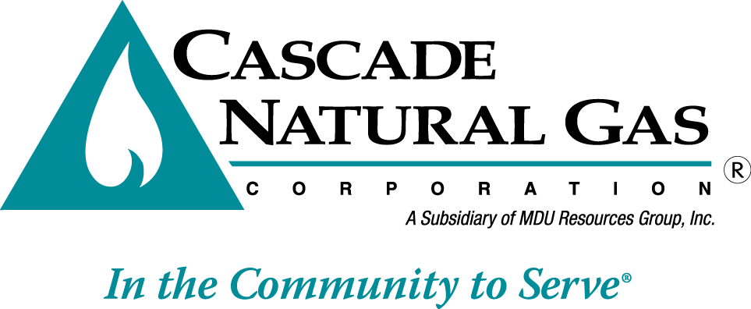 | 8113 W. GRANDRIDGE BLVD., KENNEWICK, WASHINGTON 99336-7166  TELEPHONE 509-734-4500 FACSIMILE 509-737-7166  www.cngc.com

September 9, 2016

Mr. Steven V. King
Executive Director and Secretary
Washington Utilities & Transportation Commission
P.O. Box 47250
Olympia, WA 98504-7250

RE: Advice No. CNG/W16-09-01

Dear Mr. King:

Enclosed for filing are the following tariff sheets to become effective with service on and after
October 10, 2016:

Seventh Revision Sheet No. 300
Fourth Revision Sheet No. 300-A
Third Revision Sheet No. 302-A.

These tariff revisions identify the actual rebates that will be provided to customers in the State of Washington. They also provide footnotes explaining the differences between the Conservation measures’ efficiencies.

The Company presented the proposed changes to our Conservation Advisory Group (CAG) during a meeting on July 13, 2016. Following the discussions with the CAG on August 5, 2016, consistent with the settlement agreement adopted in Cascade Natural Gas Corporation’s last general rate case, docketed as UG-152286, the Company provided the attached proposed revisions thirty days prior to the anticipated filing date of September 9, 2016.

Any questions regarding this filing may be directed to me at (509) 734-4593.

Sincerely,

Michael Parvinen
Director, Regulatory Affairs

Attachment

