June 20, 2014

Steven V. King, Executive Director and Secretary
Utilities and Transportation Commission
1300 S. Evergreen Park Dr. SW
P.O. Box 47250
Olympia, WA 98504-7250

RE: Washington Utilities and Transportation Commission v. Evergreen Transfer & Storage, Inc.

Commission Staff’s Response to Application for Mitigation of Penalties TV-140957

Dear Mr. King:

On June 5, 2014, the Utilities and Transportation Commission issued a $1,000 Penalty Assessment in Docket TV-140957 against Evergreen Transfer & Storage, Inc. for 10 violations of Washington Administrative Code (WAC) 480-15-480, which requires household goods carrier companies to furnish annual reports to the commission no later than May 1 each year.¹

On June 6, 2014, Evergreen Transfer & Storage, Inc. wrote the commission requesting mitigation of penalties (Mitigation Request).² In its Mitigation Request, Evergreen Transfer & Storage, Inc. does not dispute that the violation occurred. The company states, “…I would ask that that penalty be removed or mitigated to zero, as it was an oversight on my part…”. The statement continues, “I am usually reminded when I receive the annual report forms and fee packets from the Commission via mail. However, the Commission used an old address that the post office no longer forwards from. I understand it is my responsibility to submit the report on time and that the mailing of the packages is not the sole source of how an annual report is available to file.”

It is the company’s responsibility to ensure that the regulatory fee is paid and the annual report is filed by the May 1 deadline. On February 28, 2014, Annual Report packets were mailed to all regulated household goods companies. The instructions for annual report completion page of the annual report informed the regulated company that it must complete the annual report form, pay the regulatory fees, and return the materials by May 1, 2014, to avoid enforcement action.
UTC Annual Reports
June 16, 2014
Page 2

On May 28, 2014, Evergreen Transfer & Storage, Inc. filed the 2013 annual report and timely paid the required regulatory fees and late payment penalty. The company has been active since August 18, 2005. No previous violations of WAC 480-15-480 are on commission record. Staff supports the company’s request for mitigation as this is the company’s first delinquent filing. Staff recommends a reduced penalty assessment of $200.

If you have any questions regarding this recommendation, please contact Amy Andrews, Regulatory Analyst, at (360) 664-1157, or aandrews@utc.wa.gov.

Sincerely,

Sondra Walsh, Director
Administrative Services

ATTACHMENT A
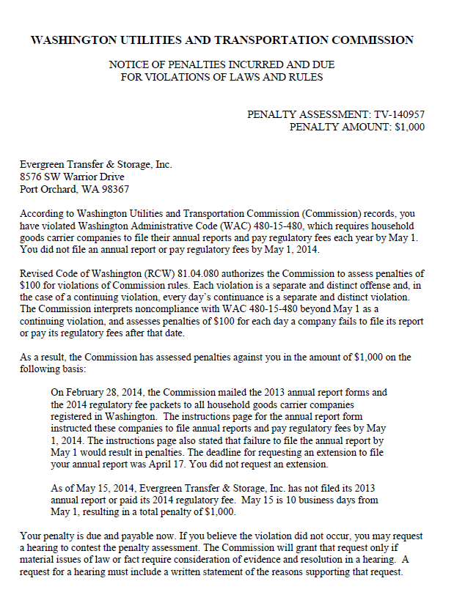

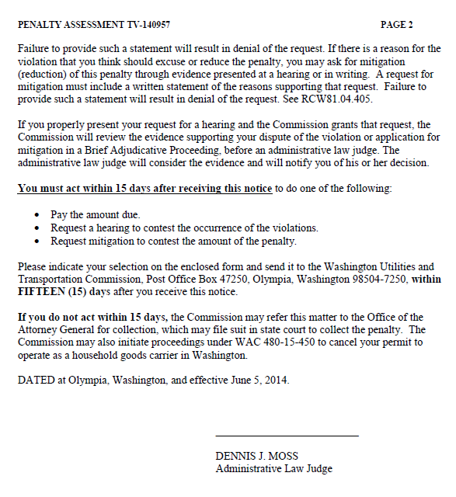

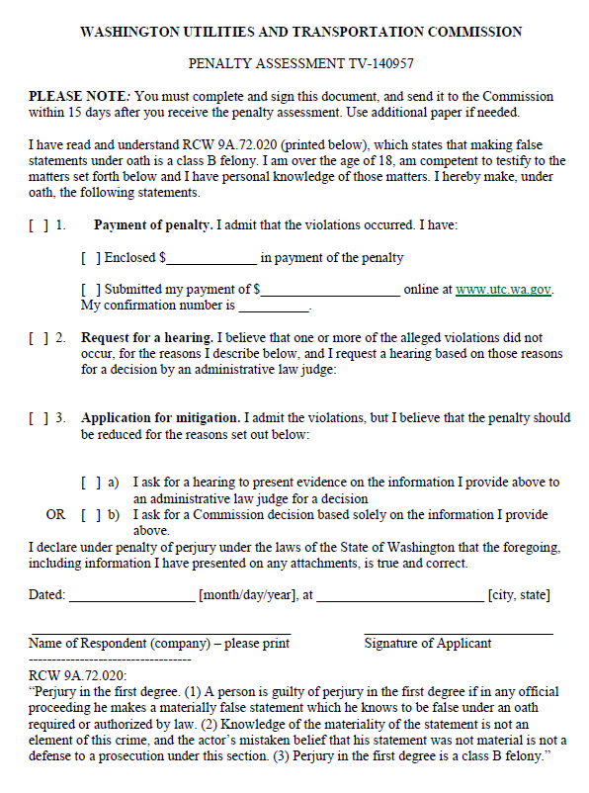

ATTACHMENT B
