 |  |  |  |  |  |  |  | Advice No. |  |  |  |  |  |  |  | 3650T
 |  |  |  |  |  |  |  | Commission Docket No.
 |  |  |  |  |  |  |  | Agenda Date Assigned
BEFORE THE WASHINGTON UTILITIES AND TRANSPORTATION COMMISSION

LESS THAN STATUTORY NOTICE AND WAIVER OF CUSTOMER NOTICE RULES REQUESTED BY:

Qwest Corporation 6012957939
(Utility Name) |  |  |  |  |  |  |  |  |  |  |  |  |  | (Utility UBI Number)
(Utility d/b/a if different than registered name)
Utility proposes to change |  |  | Qwest Exchange & Network Services Tariff |  |  |  |  |  |  |  |  |  |  | Number |  | WN U-40
 | (tariff title.)
Present provisions are: The City of Auburn, WA occupational tax rate is currently 5%. The effective tax rate for billing is also 5%.
Proposed changes are:
To increase the City of Auburn’s occupational and effective tax rate billing both to 6%.

Indicate below, or attach, an explanation of the reason the company requests permission to file the proposed provisions with less than statutory notice and to provide notification to customers on less than required notice.

Qwest respectfully requests this filing become effective with less than statutory notice in order to be in accordance with the effective date of the Auburn, WA tax ordinance.

Jesse Nava, Staff Manager |  |  |  | is authorized to issue and file tariffs on behalf of |  |  |  |  |  |  |  |  |  |  | Qwest Communications Corporation
(Name and title of issuing agent) |  |  |  |  |  |  |  |  |  |  |  |  |  |  | (Name of Utility)
I request these provisions become effective on |  |  |  |  | July 1, 2008
 |  |  |  |  |  |  |  |  |  | June 5, 2008
 |  |  | 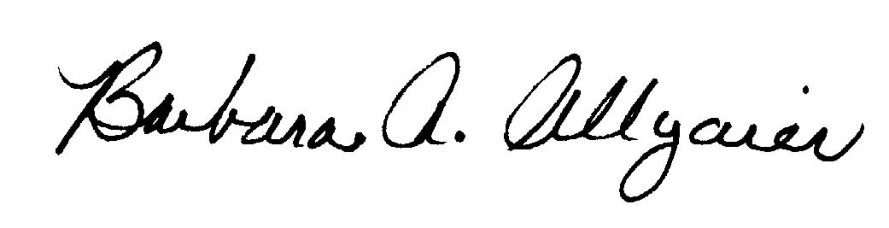 |  |  |  |  |  |  | Barbara Allgaier, Director Legal Issues
(Signature of Authorized Agent) |  |  |  |  |  |  |  |  |  | (Title)
Jesse Nava
(Print Name)
(303) 896-5904 |  |  |  |  |  | ( 303) 896-9994 |  |  |  |  |  |  | Jesse.Nava@qwest.com
(Telephone Number) |  |  |  |  |  | (Fax Number) |  |  |  |  |  |  | (E-Mail Address)
1801 California Street, Suite 4740 |  |  |  |  |  | Denver |  |  |  |  |  |  | CO |  |  |  | 80202
(Mailing Address) |  |  |  |  |  | (City) |  |  |  |  |  |  | (State) |  |  |  | (Zip Code)
WASHINGTON UTILITIES AND TRANSPORTATION COMMISSION

O R D E R
The Commissioners, having determined this order is consistent with the public interest, directed the Secretary to enter this order granting the provisions requested above.
DATED and signed at Olympia, Washington, this |  |  |  |  |  |  |  |  | Day of
 |  |  |  |  |  |  |  |  |  | (Month and Year)
 |  |  |  |  |  |  |  |  |  | Secretary
Util LSN Form 02/24/04

