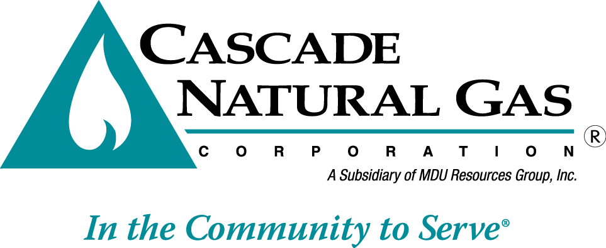 | 8113 W. GRANDRIDGE BLVD., KENNEWICK, WASHINGTON 99336-7166  TELEPHONE 509-734-4500 FACSIMILE 509-737-7166  www.cngc.com

January 19, 2017

Mr. Steven V. King
Executive Director and Secretary
Washington Utilities & Transportation Commission
P.O. Box 47250
Olympia, WA 98504-7250

RE: UG-170041, Supplemental Filing
Advice No. CNG/W17-01-01

Dear Mr. King:

On January 18, 2017, Cascade Natural Gas Corporation (Cascade or Company) submitted Advice No.W17-01-01. The Company now revises this filing with the following sheet which is stated to become effective with service on and after February 15, 2017:

Fifty-Third Rev. Sheet No. 500-A

This replaces one of the sheets in the initial January 18, 2017 filing.

The changes made herein correct an inadvertent error in the numbering of the ordinance no. and tax effective date within the tariff sheet.

Any questions regarding this filing may be directed to me at (509) 734-4593.

Sincerely,

Michael Parvinen
Director, Regulatory Affairs

Attachment

