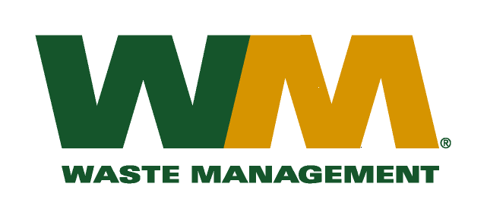
July 19, 2010
Washington Utilities and Transportation Commission
Chandler Plaza Building
1300 S. Evergreen Park Drive SW
P.O. Box 47250
Olympia, WA 98504-7250

Subject: Waste Management – Sno-King, a division of Waste Management of Washington, Inc. (G-237); Tariff # 15
Enclosed are revised pages 2, 21, 24, 25 and 26 to the above-referenced tariff. The purpose of these tariff revisions is to reflect the change in the commodity credits for residential and multi-family customers receiving recycling collection services. These tariff revisions reflect an increase of the current commodity credit from $1.05 to $1.31 per month for residential customers and an increase from $0.19 per yard to $0.21 per yard for multi-family customers.
These changes are principally due to the overall increase in commodity values since our last commodity credit adjustment on July 1, 2009. These changes also reflect the rate impact of the implementation of RCW 81.77.185 which allows the Company to retain up to 50% of the revenue the Company receives from the sale of commodities it collects from its customers provided that it; (1) submits a plan to the commission that; (2) is certified by the appropriate local government authority as being consistent with the local government solid waste plan and that; (3) demonstrates how the company will use the revenues to increase recycling. The proposed effective date of these tariff revisions is September 1, 2010.
Enclosed for your review are our accounting work papers and our Revenue Sharing Plan with King County that has been certified by Kevin Kiernan, the director of the King County Solid Waste Division. Customers will be notified of the change in their commodity credit adjustment on their next regularly scheduled billing after the approval of the Commission. In addition, the county has been notified of these proposed tariff changes.
If you have any questions or need additional information, please contact me at (425) 814-7840.
Very truly yours,

Mike Weinstein
Senior Pricing Manager, Pacific Northwest Market Area
cc: Dean Kattler
Jeff McMahon
Bill Reed, King County Solid Waste Division
Jeff Gaisford, King County Solid Waste Division
Kevin Kiernan, King County Solid Waste Division

