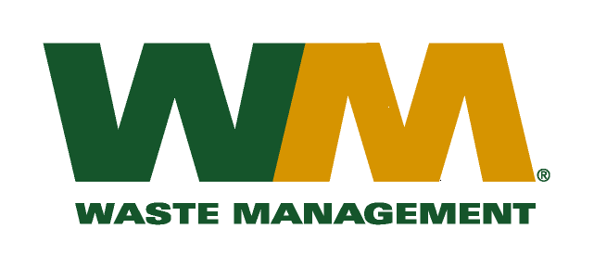

November 18, 2016

Washington Utilities and Transportation Commission
Chandler Plaza Building
1300 S. Evergreen Park Drive SW
P.O. Box 47250
Olympia, WA. 98504-7250

Subject: Waste Management – North Sound and Waste Management – Marysville, divisions of Waste Management of Washington, Inc. (G-237); Tariff No. 19 TG-161132

Enclosed, you will find revised substitute pages 22, 25, 30, 31, 34, 41, 42, 43 and 44 for the above referenced docket. These pages have been substituted in concurrence with WUTC staff recommendations. Please do not re-docket.
If you have any questions or need additional information, please contact me at:
Address: 720 4th Avenue, Suite 400, Kirkland, WA 98033
Telephone /Fax #: (425) 814-7840 / (425) 814-7866
e-mail: mweinstein@wm.com

Respectfully,

Michael A. Weinstein
Senior Pricing Manager, Pacific Northwest Market Area

