Exhibit 7

Corporate Operations Expense Adjustment and Certification
As Required in WAC 480-123-110(e)(vi)

I, Richard J. Weaver , an officer of Westgate Communications LLC dba WeavTel with personal knowledge and responsibility, under penalty of perjury, hereby certify that no corporate operations adjustment(s) to existing high-cost loop and/or interstate common line support mechanisms, as required by the Federal Communications Commission applied to the Company in 2015 and 2014.

Dated this 29th day of July, 2016

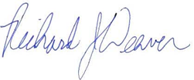
______________________________
Richard J. Weaver
General Manager

