June 24, 2014

Steven V. King, Executive Director and Secretary
Utilities and Transportation Commission
1300 S. Evergreen Park Dr. SW
P.O. Box 47250
Olympia, WA 98504-7250

RE: Washington Utilities and Transportation Commission v. Harris, Thomas Earl

Commission Staff’s Response to Application for Mitigation of Penalties TV-140961

Dear Mr. King:

On June 5, 2014, the Utilities and Transportation Commission issued a $1,000 Penalty Assessment in Docket TV-140961 against Harris, Thomas Earl for 10 violations of Washington Administrative Code (WAC) 480-15-480, which requires household goods carrier companies to furnish annual reports to the commission no later than May 1 each year.¹

On June 10, 2014, Thomas Earl Harris wrote the commission requesting mitigation of penalties (Mitigation Request).² In its Mitigation Request, Thomas Earl Harris does not dispute that the violation occurred. The company provided information regarding the status as a new business without any revenues and medical issues which have rendered the owner unable to actively work.

It is the company’s responsibility to ensure that the regulatory fee is paid and the annual report is filed by the May 1 deadline. On February 28, 2014, Annual Report packets were mailed to all regulated household goods companies. The instructions for annual report completion page of the annual report informed the regulated company that it must complete the annual report form, pay the regulatory fees, and return the materials by May 1, 2014, to avoid enforcement action.

On June 16, 2014, Thomas Earl Harris filed the 2013 annual report with no regulatory fees due. The company has been active since July 31, 2013. No previous violations of WAC 480-15-480

UTC Annual Reports
June 24, 2014
Page 2

are on commission record. Staff supports the company’s request for mitigation as this is the company’s first delinquent filing. Staff recommends to waive the penalty due to the compelling circumstances provided by the company.

If you have any questions regarding this recommendation, please contact Amy Andrews, Regulatory Analyst, at (360) 664-1157, or aandrews@utc.wa.gov.

Sincerely,

Sondra Walsh, Director
Administrative Services

ATTACHMENT A
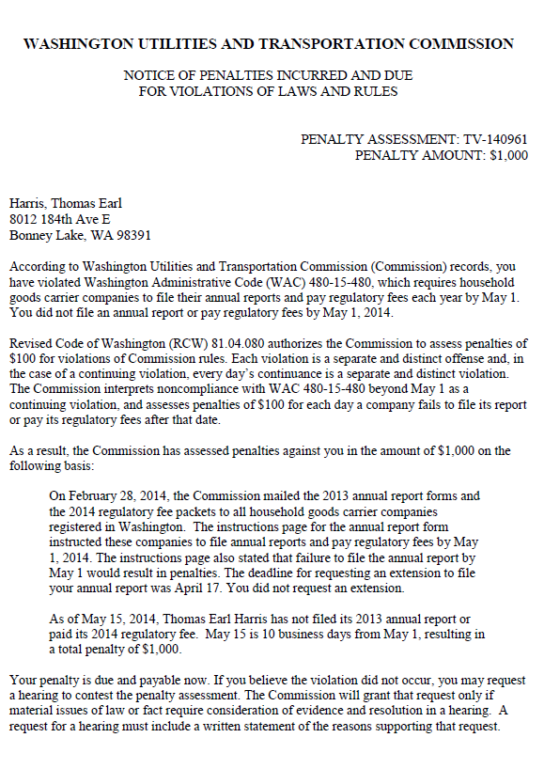

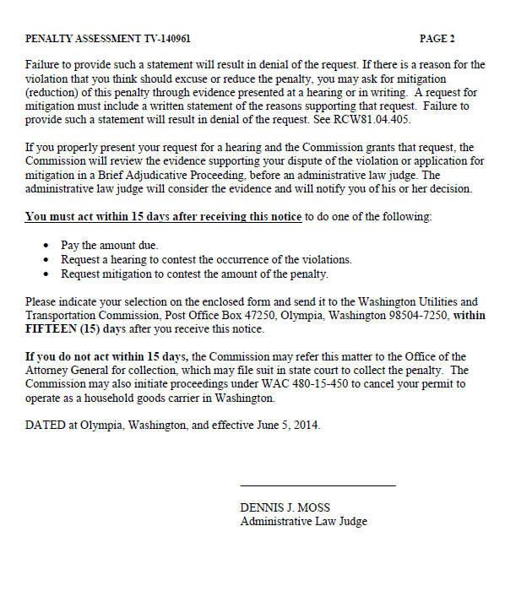

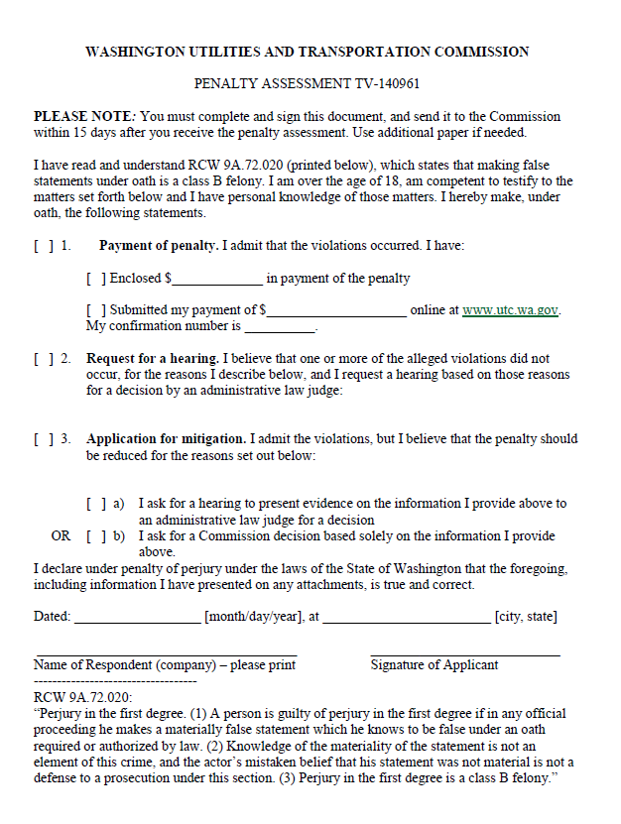

ATTACHMENT B
