July 7, 2014

Steven V. King, Executive Director and Secretary
Utilities and Transportation Commission
1300 S. Evergreen Park Dr. SW
P.O. Box 47250
Olympia, WA 98504-7250

RE: Washington Utilities and Transportation Commission v. Luo, Xianqin

Commission Staff’s Response to Application for Mitigation of Penalties TV-140966

Dear Mr. King:

On June 5, 2014, the Utilities and Transportation Commission issued a $1,000 Penalty Assessment in Docket TV-140966 against Luo, Xianqin for 10 violations of Washington Administrative Code (WAC) 480-15-480, which requires household goods carrier companies to furnish annual reports to the commission no later than May 1 each year.¹

On June 20, 2014, Xianqin Luo wrote the commission requesting mitigation of penalties (Mitigation Request).² In its Mitigation Request, Xianqin Luo does not dispute that the violation occurred. The company states, “Please see attached of my form 4868 of Application for Automatic Time Extension to File U.S. Individual Income Tax Return. I gave all my income information to my accountant Fidelity Accounting Tax Service to filing for 2013. All my information is still in their hands.”

It is the company’s responsibility to ensure that the regulatory fee is paid and the annual report is filed by the May 1 deadline. On February 28, 2014, Annual Report packets were mailed to all regulated household goods companies. The instructions for annual report completion page of the annual report informed the regulated company that it must complete the annual report form, pay the regulatory fees, and return the materials by May 1, 2014, to avoid enforcement action. The instructions for annual report completion page also provide instructions for filing for an extension to submit the 2013 annual report forms. The company did not file an extension with the commission.

UTC Annual Reports
July 7, 2014
Page 2

As of June 30, 2014, Xianqin Luo has not filed its 2013 annual report or paid the subsequent regulatory fees. The company has been active since March 14, 2013. No prior violations of WAC 480-15-480 are on commission record. Staff supports the company’s request for mitigation as this is the company’s first delinquent filing. Staff recommends a reduced penalty assessment of $200.

If you have any questions regarding this recommendation, please contact Amy Andrews, Regulatory Analyst, at (360) 664-1157, or aandrews@utc.wa.gov.

Sincerely,

Sondra Walsh, Director
Administrative Services

ATTACHMENT A
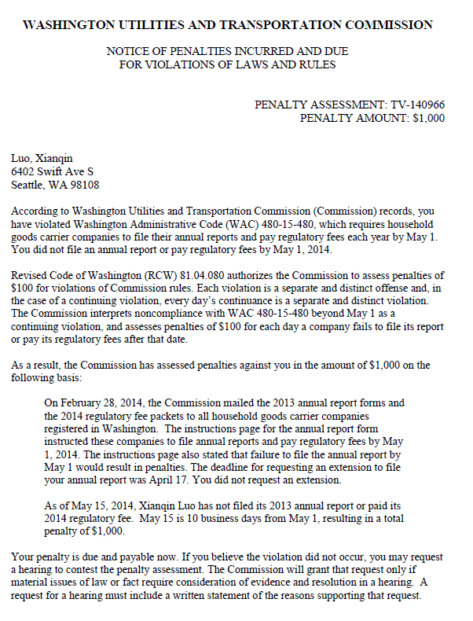

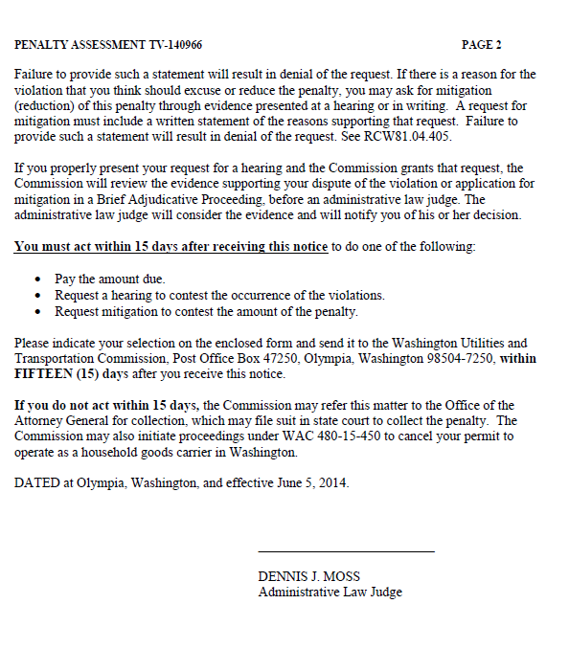

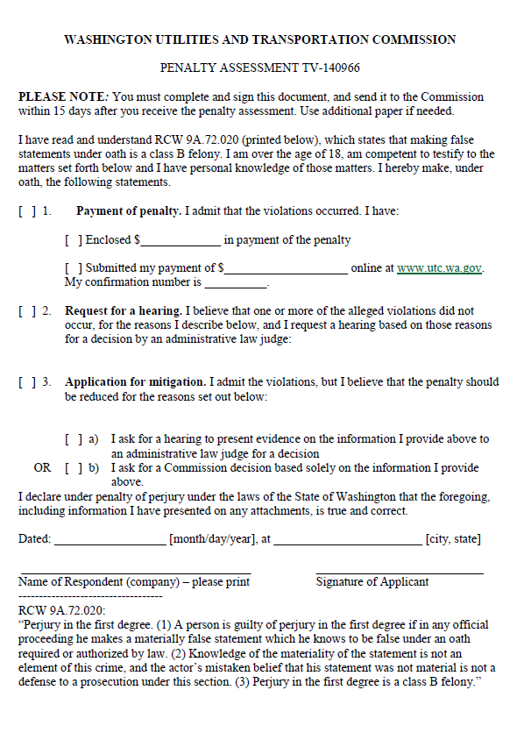

ATTACHMENT B
