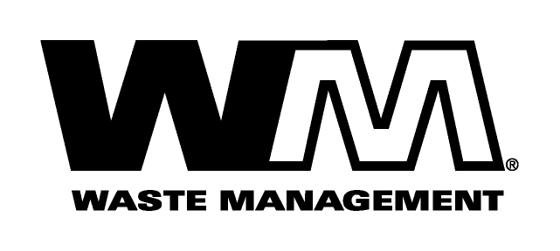

September 30, 2009

NOTICE OF PROPOSED RATE INCREASE

Dear Valued Customer,

Our goal at Waste Management is to provide you with the highest quality solid waste service. We value your business.

Like all of us, the garbage industry is faced with many challenges today. Rising costs for labor, fuel, maintenance and other general operating expenses have resulted in increased costs for us to provide collection services.

All of the above mentioned costs have risen considerably since our last general rate increase, nearly six years ago. Accordingly, we have applied for an increase in rates, subject to the review and approval of the Washington Utilities and Transportation Commission (U.T.C.). The U.T.C. regulates the rates and services of Solid Waste companies operating in the unincorporated areas of Washington. The U.T.C., upon completing its investigation, could approve rates that may vary from the proposed rates shown on the back of this letter. If approved, the new rates would become effective November 1, 2009.

As always, we are dedicated to responsive customer service. Should you have any questions, please give us a call toll free at 1(877) 466-4668.

U.T.C. staff will make a recommendation to the commissioners at an open meeting in Olympia, which is scheduled for 9:30 a.m. on October 29, 2009. You will have an opportunity to comment in person at this meeting. If you are unable to attend the open meeting, the commission has a bridge line which enables you to participate or listen by telephone. Call 360-664-1234 the day before the open meeting for instructions and to sign in. You can also comment by using the “Public Comment” feature at the commission’s web site at utc.wa.gov, or by using the contact information below.

Washington Utilities and Transportation Commission
1300 S. Evergreen Park Drive SW
P.O. Box 47250, Olympia, WA 98504-7250
E-mail: comments@utc.wa.gov
Telephone: 1-888-333-WUTC (9882)

At Waste Management, we are committed to finding new and innovative ways to provide high quality solid waste services at the most cost effective rates. As the industry leader, we will continue to work diligently to develop and implement the most efficient collection systems available and whenever possible, pass any recognized cost savings on to our customers. Thank you for your understanding and support. We appreciate your business and look forward to providing you with the best possible service.

Respectfully,

Waste Management of Ellensburg

