Utilities’ Profit Recipe: Spend More

To expand regulator-imposed earnings caps, electricity producers splurge on new equipment, boosting customers’ bills
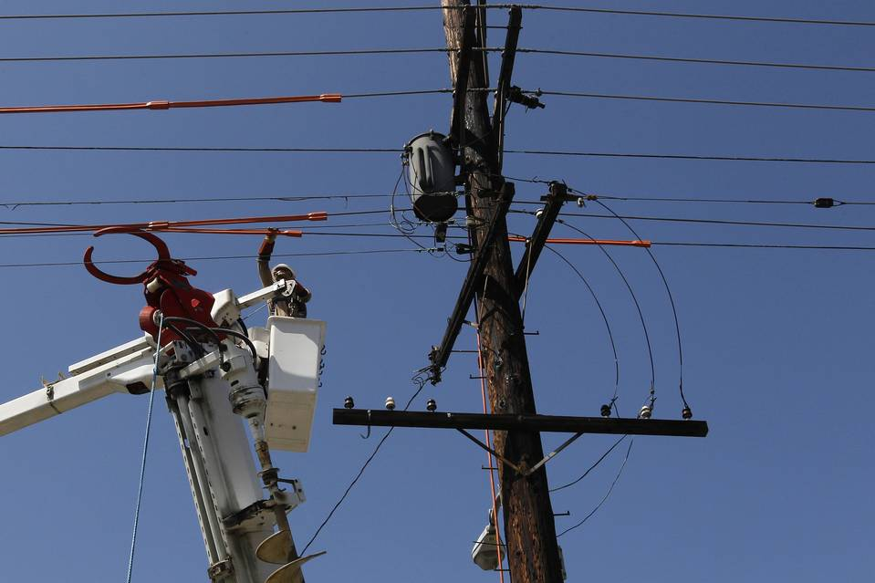
Every time Southern California Edison replaces a 50-year-old pole with a new one, it has a fresh investment on which it is eligible to earn an annual profit. Photo: Fred Prouser/REUTERS
By
Rebecca Smith
April 20, 2015 6:04 p.m. ET
Families in New York are paying 40% more for electricity than they were a decade ago. Meanwhile, the cost of the main fuel used to generate electricity in the state—natural gas—has plunged 39%.
Why haven’t consumers felt the benefit of falling natural-gas prices, especially since fuel accounts for at least a quarter of a typical electric bill?
One big reason: utilities’ heavy capital spending. New York power companies poured $17 billion into new equipment—from power plants to pollution-control devices—in the past decade, a spending surge that customers have paid for.
New York utilities’ spending plans could push electricity prices up an additional 63% in the next decade, said Richard Kauffman, the former chairman of Levi Strauss & Co. who became New York’s energy czar in 2013. It’s “not a sustainable path for New York,” he said.
New York is no outlier. Capital spending has climbed at utilities nationwide—and so have their customers’ bills.
The average price of a kilowatt-hour of electricity rose 3.1% last year to 12.5 cents a kilowatt-hour, far above the rate of inflation. Since 2004, U.S. residential electricity prices have jumped 39%, according to federal statistics.
Over that same period, annual capital expenditures by investor-owned utility companies more than doubled—jumping to $103 billion in 2014 from $41 billion in 2004, according to the Edison Electric Institute, a trade association. The group expects total capital spending from 2003 through 2016 to top $1 trillion.
“This is the biggest splurge in capital spending we’ve seen in at least 30 years—it’s the reason rates have been going up,” said Bob Burns, an independent consultant and former energy researcher at Ohio State University.
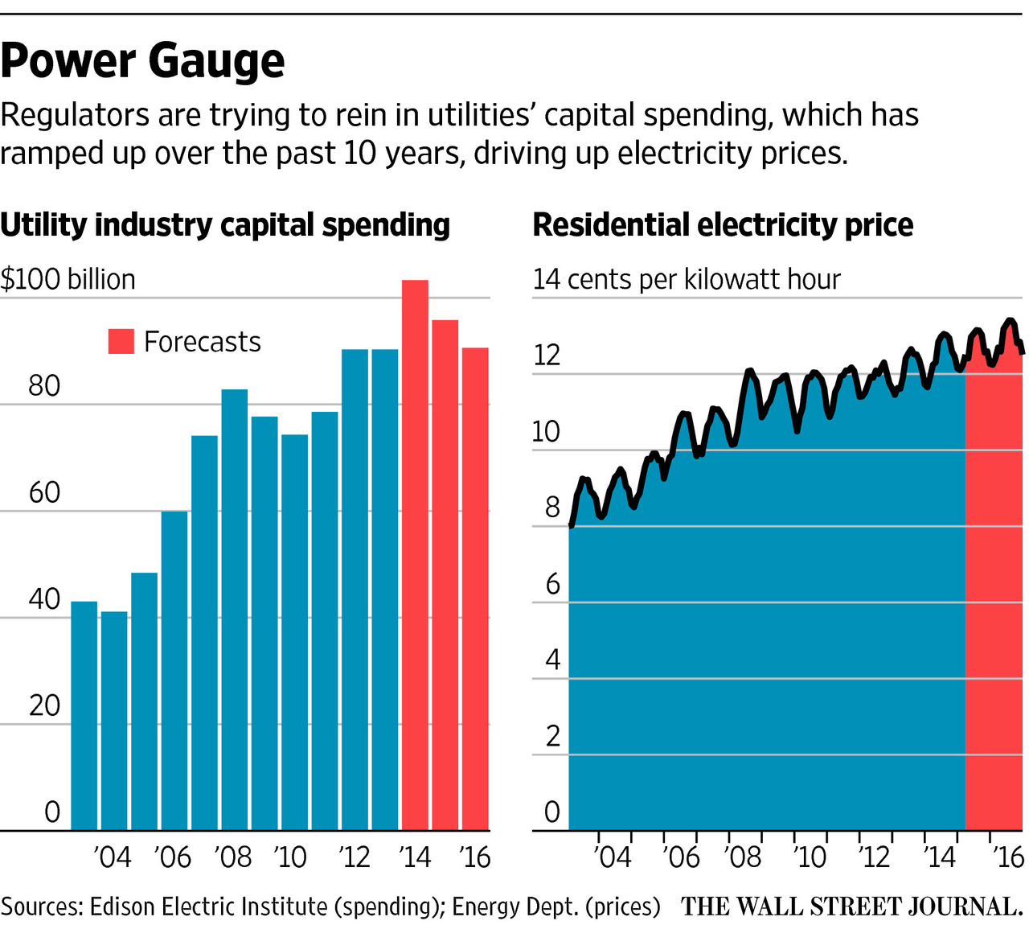
The biggest chunk of that spending—38% in 2013—went into new power lines and other delivery systems, the Edison Electric Institute said. Almost as much went to generation, often for new gas-fired plants to replace coal-fired ones that don’t meet new environmental rules.
Experts say there are several reasons for soaring spending, including environmental mandates, and the need to harden the grid to protect it from storms, physical attacks and cyber hacking.
But utilities have another incentive for heavy spending: It actually boosts their bottom lines—the result of a regulatory system that turns corporate accounting on its head.
In most industries, companies generate revenue, deduct their costs, and are left with profits, which can be expressed as a percentage of revenues—the profit margin. Regulated utilities work differently. State regulators usually set an acceptable profit margin for utilities, and then set electric rates at levels that generate enough revenue to cover their expenses and allow them to make a profit.
At the moment, it is common for utilities’ allowable profit to be capped at 10% or so of the shareholders’ equity that they have tied up in transmission lines, power plants and other assets. So the more they spend, the more profits they earn.
Critics say this can prompt utilities to spend on projects that may not be necessary, like electric-car charging stations, or to choose high-cost alternatives over lower-cost ones.
“Until we change things so utilities don’t get rewarded based on how much they spend, it’s hard to break that mentality,” says Jerry R. Bloom, an energy lawyer at Winston & Strawn in Los Angeles who often represents independent power companies.
Southern California Edison, a unit of Edison International in Rosemead, Calif., plans to spend about $1 billion in debt and equity replacing or repairing thousands of power poles, which cost $13,000 each. Every time the company replaces a 50-year-old pole with a new one, it has a fresh investment on which it is eligible to earn an annual profit, currently 10.45%, for 45 years.
The sudden interest in poles “suggests they’ve been negligent in the past or they’re just looking for ways to spend money,” said Bob Finkelstein, a lawyer at the Utility Reform Network, a San Francisco-based watchdog group.
Mike Marelli, SoCal Edison’s rates director, said his company analyzed 5,000 poles before deciding a massive program was needed to deal with deferred maintenance.
‘Until we change things so utilities don’t get rewarded based on how much they spend, it’s hard to break that mentality.’
—Jerry R. Bloom, an energy lawyer at Winston & Strawn
Overall, SoCal Edison intends to spend $15 billion to $17 billion on dozens of initiatives from 2014 through 2017. Similarly, Charlotte, N.C.-based Duke Energy Corp. DUK -0.69 % expects to make $17 billion worth of capital expenditures from 2014 and 2016. A rule of thumb it recently shared with investors: for every billion dollars in assets it adds to its inventory, it boosts earnings by about 8 cents a share.
Utilities can’t bill customers for new capital expenditures without first getting the consent of state or federal regulators, notes Richard McMahon, a vice president at the Edison Electric Institute.
But Ken Rose, an energy consultant in Chicago, says that regulators don’t always do enough to make sure projects are the best deal for the customers footing the bills. He says companies have a propensity to choose expensive solutions to problems—building a new power plant instead of promoting energy efficiency, for example—because it puts big chunks of capital to work that lift profits.
Some analysts say utilities’ capital spending has been necessary and smart at a time of low interest rates.
“I don’t subscribe to the belief that utility companies are gold-plating their systems just to increase profits,” says Jim Hempstead, associate managing director of the global infrastructure finance at Moody’s Investors Service.
Utilities earned $36 billion in 2013, excluding nonrecurring items, up 36% from 2004, according to the Edison Electric trade group.
So long as electricity consumption is growing, utilities can spread hefty costs across their customers without increasing rates. But since 2008, power sales haven’t been growing fast enough to absorb the impact of all the added spending.
Kansas City Power & Light has raised rates about 60% since it kicked off its current investment cycle in 2007. It is seeking rate increases of 12.5% in Kansas and 15.5% in Missouri.
Some states are pushing back.
In New York, regulators balked at Consolidated Edison Inc. ED -0.53 % ’s plan to build a $1 billion electrical substation in Brooklyn and Queens by 2017. Instead, the company has decided to help customers cut energy use by improving the efficiency of their electrical equipment through a $500 million program that defers a decision about a new substation for at least a decade.
“What we’re doing is an alternative that’s less costly,” said Stuart Nachmias, vice president of regulatory affairs for ConEd.
From now on, utilities must prove that their spending will make an electric system cleaner, more efficient or stronger, says Audrey Zibelman, chair of the New York Public Service Commission. “Business as usual has become unaffordable.”

