Cost Breakdown of the Manganes.e treatment at Laureldel Well Site.

Laureldel Site::

Total Cost $1$0,299.d@

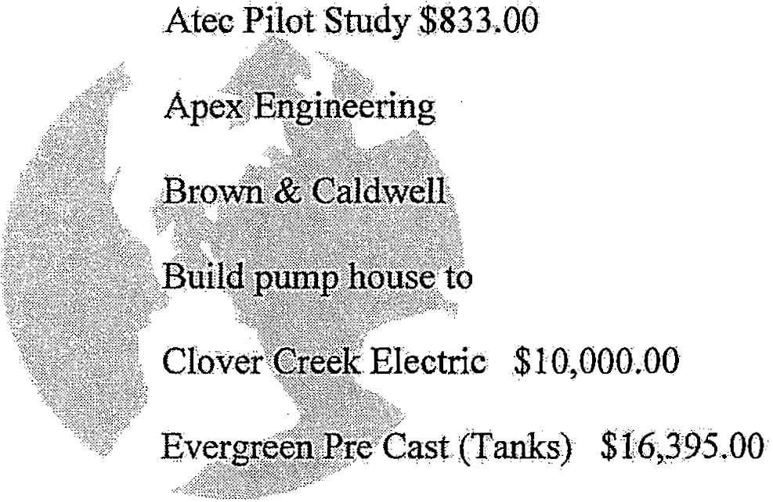AtecandAssociates $50,410.00

$&,ns.oa
$20;.000.00
,fit fi.I'tratfon system $9 JlOO.oo.

Crane Rental $16!H;OO.

FI DFowler (Pltirtibin) $7,J52;00 Fineline Chlorine analyzer $6QU0,.00 Chlotiti.ator $4;,000:.00
Labor $16,000.00
Build 12' x 14' pump .house t<> house new flltrntfon system..

.. •· ·• 4! • •. .• - , : , . • :• • •. •: •. .•. '• •. • -• •. •

Cost Breakdown ofthe Manganese treatment at Southwood 1 Well Site.

Southwo.od lSite:

Total Cost: $174,2'.;t7Jl0

Atec and Associates ,$74,338.00:

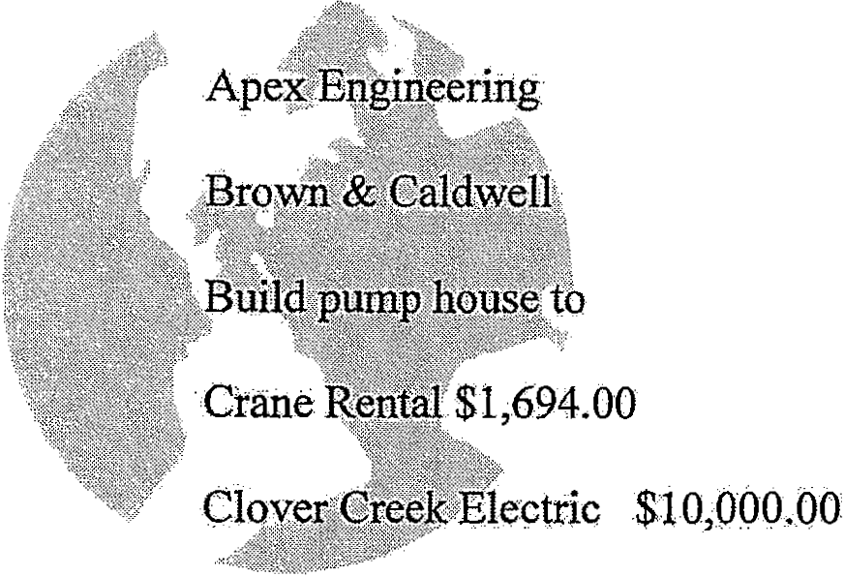Atec'Pilot Study $833;00

$8,815.00

$20,000 00

fit filtration s}rstem $91000,QO

Evergreen Pre Cast(Tanks) $16?395.00 II DFowler (Plumbin. ) $7,152..00 Fin_elin¢ Chlorirt ana1yz-er $6,000 ()0 Chlotinatot $'4. ,000.00
Lappr $J6 00000

Build p1:itnp house install treatment $id drain .field fat manges.e tiltratfon system.

···· ······· ···· ···· • • • '•' • • • ··· ·

Cost Breakdown of the Manganese treatment at'f itM¢adows Site.

Fir Meadows Site:

Total Cost: $255,.554.:00

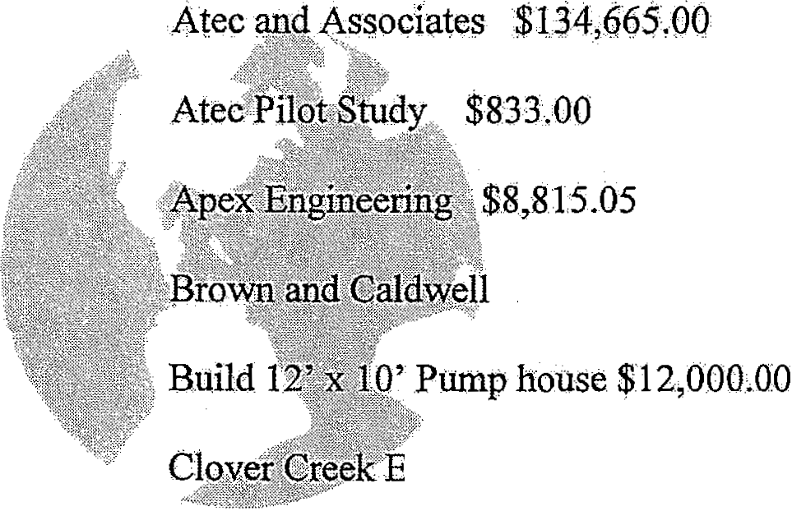
$34,000.00
. . lectric $J2,000.00
Evergreen Pre Cast ('l'®l<s) $19r395.00
Crane Rental $1,694;00
H]) J?owler (Plum.bing) $7,152.0()
Fineline Chlorine analyzer$o,OQO,OO

2"d Chlodnator for recycled water· $4,000.00 L.abor $18;000;QQ.
Build pump house and drain field fortreatment system.

.• ,. • • • • • • _:_. •. • • - •' • I! • - · .. •. •
•

Cost Breakdown of the·Manganese treatment at Centennial Elementary
Well Site..

Centennial Site:

Total Cost: ·$1s,s·.$9.©

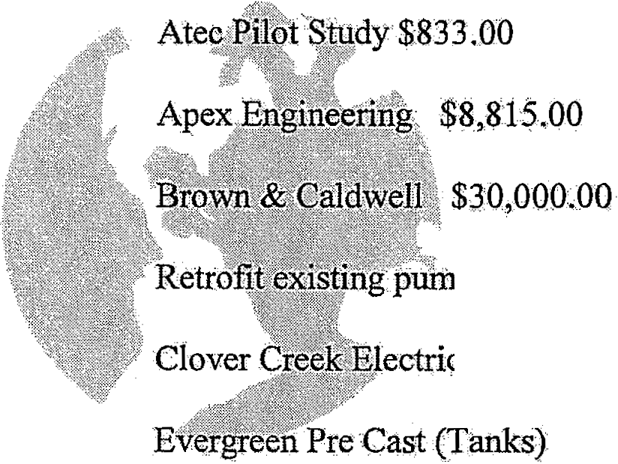Atec andAssociates $680QO'.'OO

p'house·to fit fllttation system $1,0bb..OO
ectric $1.o;OO<tbo

Crane Rental $'1694•.00
Hb:Fowler (Plumbing) $7J.5:2.00 Firteline Chlorine analyzer $6 000.00 Chlorfo.ator $4,000.00
Labor 18,000:.0Q
Install filtration system in.existing building; build separation walls and chlorine room. install
two tanks and drain field f'or backwash. ·

