October 12, 2012

David W. Danner, Executive Director and Secretary
Washington Utilities and Transportation Commission
1300 S. Evergreen Park Dr. SW
P. O. Box 47250
Olympia, Washington 98504-7250

RE: Washington Utilities and Transportation Commission v. Big River Telephone Company, LLC
Commission Staff’s Response to Application for Mitigation of Penalties
Docket UT-120959

Dear Mr. Danner:

On July 30, 2012, the Washington Utilities and Transportation Commission issued a $325 Mitigated Penalty Assessment in Docket UT-120959 against Big River Telephone Company, LLC for 13 violations of Washington Administrative Code (WAC) 480-120-382, which requires competitively classified telecommunications companies to furnish annual reports to the commission no later than May 1 each year.

On August 13, 2012, Big River Telephone Company, LLC wrote the commission requesting mitigation of penalties (Mitigation Request). In its Mitigation Request, Big River Telephone Company does not dispute that the violation occurred. The company states, “Big River Telephone Company, LLC, filed the Annual Report by the May 1, 2012, due date. The omission of our Audited Financial Statements was simply an oversight. This was Big River Telephone Company’s first offense of not filing an Annual Report complete with Financial Statements in a timely manner; therefore, we request the full penalty be waived. Thank you for the consideration.”

It is the company’s responsibility to ensure that the regulatory fee and the annual report are filed by the May 1 deadline. On February 29, 2012, Annual Report forms and Regulatory Fee packets were mailed to all regulated competitively classified telecommunications companies. In addition to other information, the cover letter informed the regulated company it must complete the annual report form, pay any regulatory fees and return the material by May 1, 2012, to avoid enforcement action. On May 14, 2012, the commission mailed a letter to those companies that had not yet filed an annual report notifying them that, to date, they had incurred a penalty of $800. The letter went on to explain that companies who filed their annual reports no later than May 25, 2012, would receive mitigated penalties of $25 per day, with an additional $25 per day for each instance in the previous five years that the company received a penalty for filing a late report.

Big River Telephone Company, LLC filed its annual report on May 18, 2012, which is 13 business days past the deadline of May 1, 2012. The penalty was mitigated from $100 per day to $25 per day, for a total of $325. Big River Telephone Company, LLC became regulated in February 2007 and has never received a penalty for filing a delinquent annual report in the past.

Staff does not support mitigating the assessed penalty as the penalty has already been reduced. Big River Telephone Company, LLC’s annual report was 17 days past the deadline of May 1, 2012, making the company liable for a penalty of up to $1,700. The commission nevertheless exercised its discretion and assessed a penalty of $325 against Big River Telephone Company, LLC based on the number of business days the company’s filing was late, rather than on the basis of calendar days. Staff believes that the $325 penalty assessed is a reasonable punitive measure to impose for the company’s violation of WAC 480-120-382.

If you have questions regarding this recommendation, please contact Mathew Perkinson, Compliance Investigator, at (360) 664-1105 or at mperkinson@utc.wa.gov.

Sincerely,

Sharon Wallace, Assistant Director
Consumer Protection and Communications

Attachment A

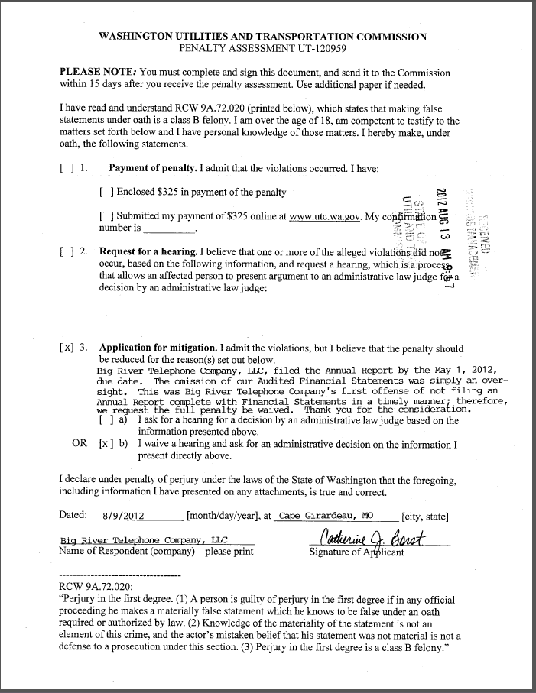
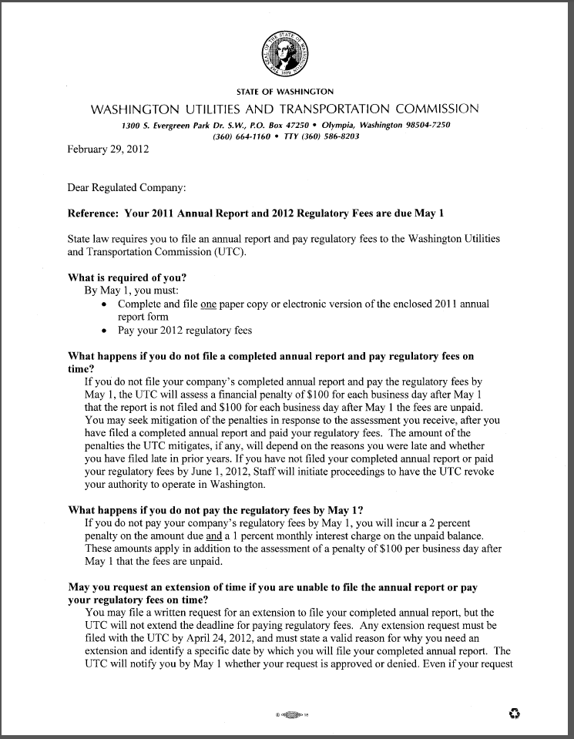
Attachment B
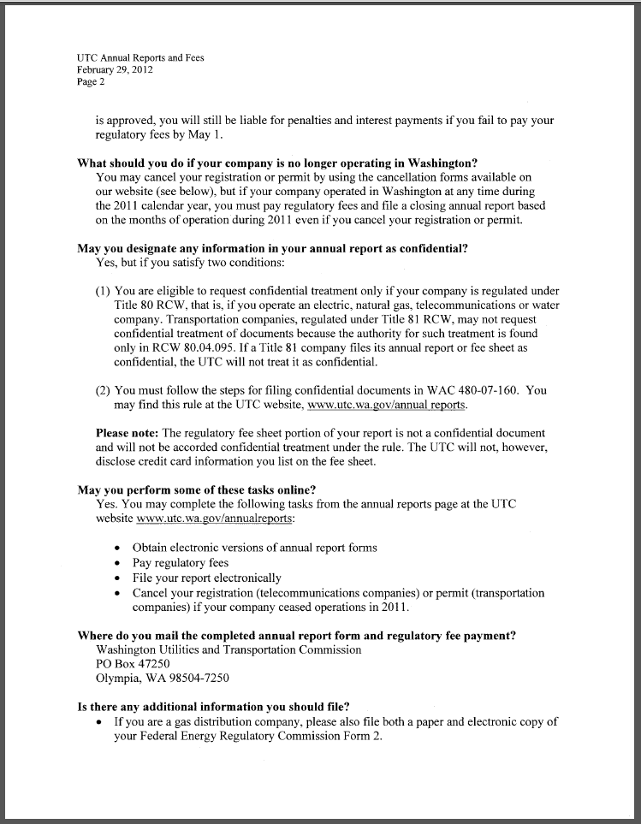
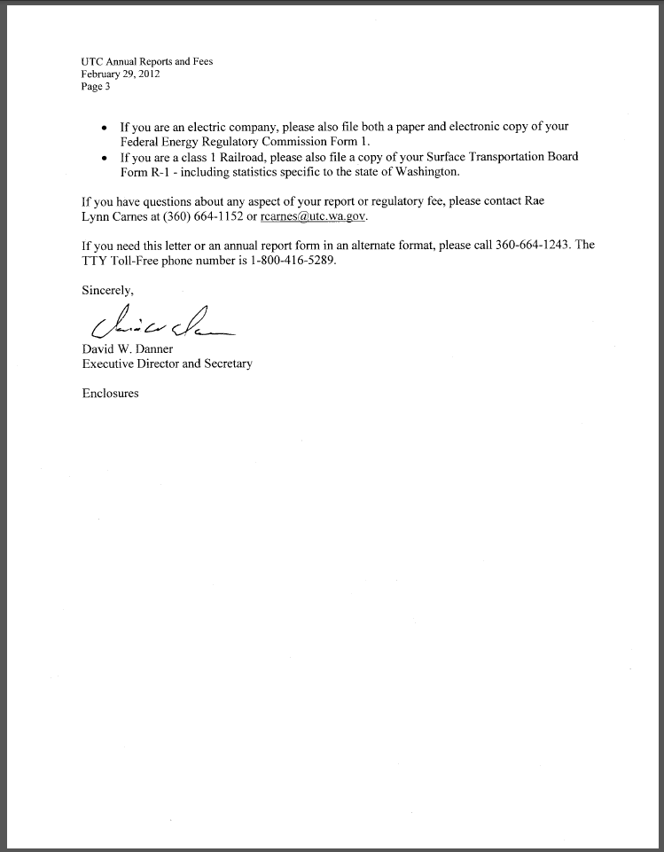

Attachment C
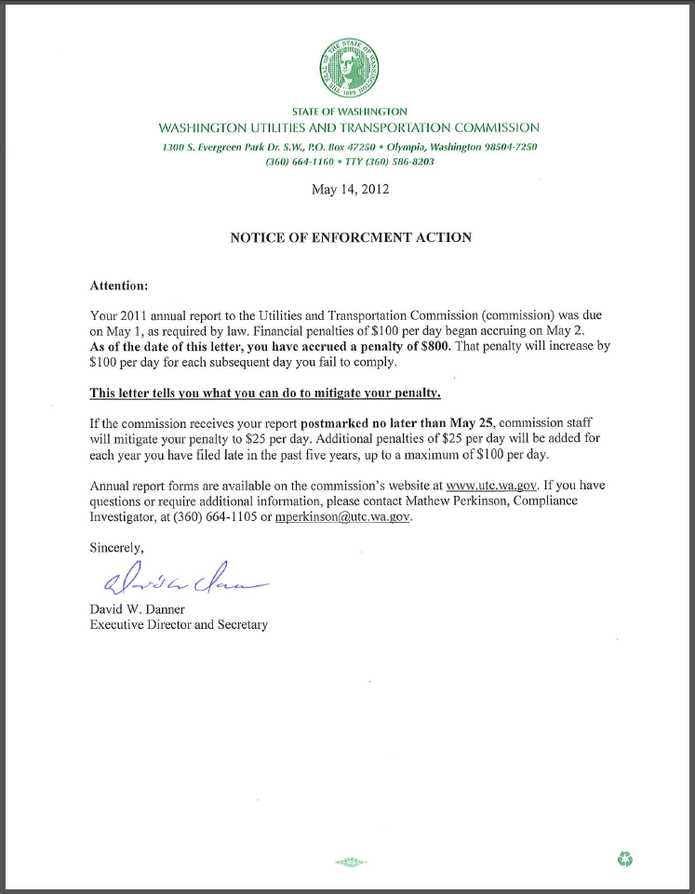

See attachment A for a copy of Big River Telephone Company, LLC’s Mitigation Request.
See attachment B for a copy of the letter sent to all regulated companies on February 29, 2012.
See attachment C for a copy of the enforcement letter sent to the company on May 14, 2012.

