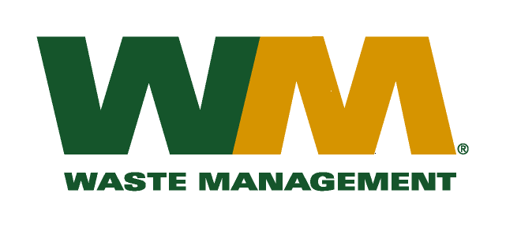
October 16, 2009

Washington Utilities and Transportation Commission
Chandler Plaza Building
1300 S. Evergreen Park Drive SW
P.O. Box 47250
Olympia, WA. 98504-7250

Subject: Waste Management – Sno-King, a division of Waste Management of Washington, Inc. (G-237); Tariff No. 14
Enclosed herein, you will find revised tariff page 2 and Fuel Component Supplement No. 4 for the above-referenced company. The purpose of these tariff changes is to revise Fuel Component Supplement No. 3 that expires on November 30, 2009. In accordance with Commission Order 01 in docket TG-061433, the Fuel Component Supplement will be revised annually and subsequent revisions to the fuel component will be determined utilizing the “deferred accounting method” similar to that used for the annual commodity credit adjustments.
This will be the final Fuel Component Supplement as part of the three year pilot program authorized in TG-061433. As such this supplement reflects a true up of the “deferred accounting method” utilized over the past three years. The proposed effective date for Fuel Component Supplement No. 4 is December 1, 2009 and this supplement will expire on February 28, 2010.
Enclosed for your review is an electronic copy of our accounting workpapers. Customers will be notified of the change in the Fuel Component Supplement on their next regularly scheduled billing after the approval of the Commission.
If you have any questions or need additional information, please contact me at (425) 814-7840.
Respectfully,

Michael A. Weinstein
Senior Pricing Manager, Pacific Northwest Market Area

cc: Jeff McMahon
Tim Crosby
Joe Krukowski
Clerk of the Board, King County

