Ken Nichols (EQL Energy) comments regarding March 10 T&D Workshop U-161024
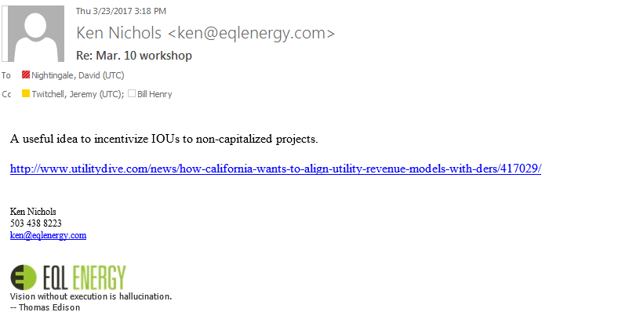

---------------------------------------------------------------------------------------------------------------------------

From: Ken Nichols [mailto:ken@eqlenergy.com]
Sent: Thursday, March 09, 2017 11:04 PM
To: Nightingale, David (UTC) <dnightin@utc.wa.gov>
Cc: Twitchell, Jeremy (UTC) <jtwitche@utc.wa.gov>; Bill Henry <bill@eqlenergy.com>
Subject: Re: Mar. 10 workshop
David,
EQL will not be at meeting Mar. 10, but will be on phone for portions.
Regarding framework,
We recommend a WUTC-approved, stakeholder-led distribution planning working group (DPWG) to craft the framework and an implementation plan, including a competitive solicitation process for T&D deferral RFPs and procurement.
Ken Nichols
503 438 8223
ken@eqlenergy.com
<image001.jpg>
Vision without execution is hallucination.
-- Thomas Edison

