October 5, 2012

David Danner
Executive Director and Executive Secretary
Washington Utilities and Transportation Commission
1300 S. Evergreen Park Dr. S.W.
PO Box 47250
Olympia, WA 98504-7250

RE: UG-121207, Commission Investigation into Natural Gas Conservation Programs

Introduction

The following reply comments are provided by the NW Energy Coalition (“Coalition”) in response to the Commission’s July 31, 2012 Notice of Opportunity to File Written Comments and an Optional Statement of Proposed Issues on the Commission Investigation into Natural Gas Conservation Programs.

Energy efficiency is an important hedging mechanism against gas price volatility and remains a good investment despite unsustainably low gas prices. Because of this, the Coalition is committed to developing creative solutions that ensure conservation programs continue for the benefit of utilities and their customers. In doing so, the Coalition supports approaches that still robustly consider conservation program costs and benefits.

There are several different ways to address the challenge determining cost effectiveness, all of which will likely take time and further research. Because of the complexity involved in any policy changes and the desire to implement changes that are not overly unwieldy or burdensome to utilities, the Coalition recommends adopting the same approach as Oregon’s proposed 2-year waiver. Doing so would preserve the many benefits of gas conservation programs while providing the time necessary to develop a workable solution that is amenable to all parties.

Discussion

The Coalition disagrees with the Northwest Industrial Gas Users’ assertion that “Alterations to avoided cost calculations could mask or skew the cost-effective basis of [conservation] programs and, therefore, run the risk of preventing all utility customers from realizing the economic benefits of the current market conditions.” There are arguments to be made that avoided cost calculations already mask or skew the cost-effectiveness of programs because they employ an overly high discount rate and do not include factors such as non-energy benefits. Moreover, this statement acknowledges the benefits to current market conditions while overlooking the inherent risks that accompany it.

Natural gas prices have been volatile and are likely to remain so despite the advent of hydraulic fracturing. This is because natural gas is still subject to a number of vulnerabilities, including interruptions from accidents, weather changes, pipeline disruptions, storage constraints and pending environmental regulations. A complex array of price dichotomies such as access to global markets and alternative fuel prices further add to the confusion. As the graph below demonstrates, forecasting prices is often trickier than it looks:

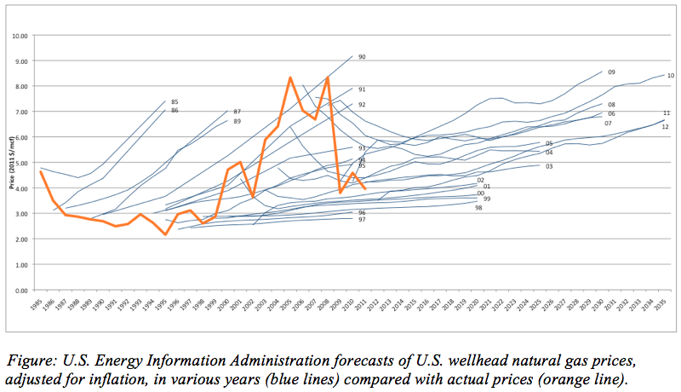
Rocky Mountain Institute, RMI Outlet, September 6, 2012

In contrast, energy efficiency programs are a lot more stable. At least 95% of the time, conservation ends up being a better deal for customers and the utility on a levelized life-cycle basis. This concept was recently illustrated by the Northwest Power and Conservation Council in a graph contrasting the average cost of utility acquired savings with wholesale market electricity prices. While natural gas is not depicted explicitly below, it expresses a similar pattern due to its influence on electric prices:

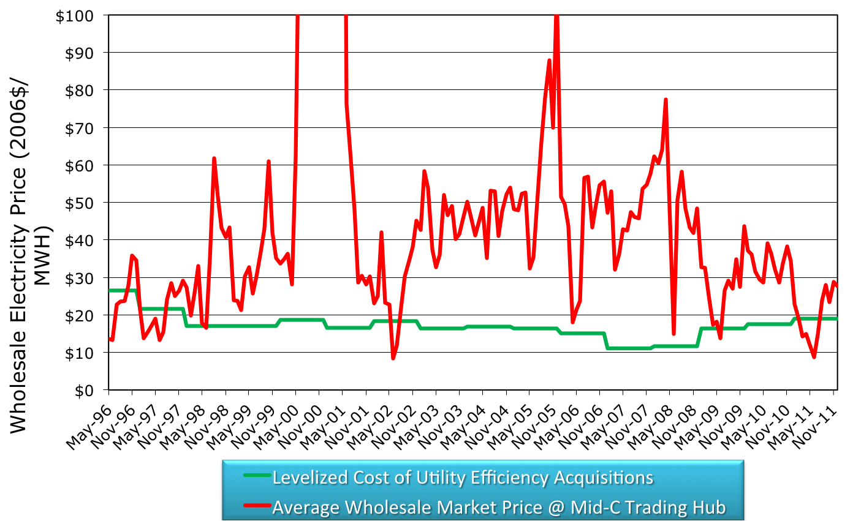
NW Power and Conservation Council, Progress Towards the 6th Plan's Conservation Goals, 2012

This stability confers critical risk hedging benefits for both utilities and their customers. Conservation programs also incur less financial risk than supply-side resources because they typically do not require utilities to raise capital. One possible way to better reflect these benefits within the guise of the TRC would be to lower the discount rate being applied. The Coalition supports the use of a low-risk, long-term customer/societal cost discount rate when evaluating the costs of conservation.

The Coalition agrees with the Northwest Industrial Gas Users that fuel switching can be an important service to offer, particularly when high efficiency equipment is used. That said, it is not appropriate to push for increased use of natural gas without energy efficiency programs to ensure that customers have opportunities to lower their bills over the long-term.

Natural gas prices cannot remain as low as they are because they do not cover the current average cost of exploration and production. The lower than normal prices that we are seeing today are attributable to an unusually warm winter that reduced demand and maximized storage capacity at the same time that lease terms created market pressure to produce more supply. Production has already declined in response to these conditions and industry analysts project that gas prices will rise to somewhere between $5-7 MMBtu over the next 3 to 5 years.

The Coalition agrees with NW Natural that “stopping and starting energy efficiency programs as gas prices rise and fall may have…unintended consequences.” Cutting conservation programs prematurely would force utilities to incur extra administrative costs associated with ramping down and then restarting programs while placing additional strain on their trade ally network. It would also generate confusion for customers as programs are withdrawn and the message to conserve and increase efficiency goes away. Additionally, there are lost opportunities during those stopped periods when customers install gas technology that isn’t energy efficient. Pushing retrofits or second investments back on customers at a future date is costly and counterproductive.

The Commission has the expertise and authority to address the challenges posed by variable market prices and should do so with eyes toward holistic policy that impacts all the gas utilities it regulates. There are several different approaches that the Commission may wish to consider, each of which has its own set of advantages and drawbacks:

Options | Advantages | Drawbacks
Modify cost tests to adjust the discount rate and include additional factors, including non-energy benefits | A more accurate and robust analysis of costs and benefits would strengthen cost effectiveness tests. | Hard-to-quantify factors may lead to the use of proxy values.
Employ a social adder similar to the model used in Vermont (this could be temporary) | This approach acknowledges many of the hard-to-quantify benefits in a manner that is simpler to implement. | Setting the adder could be controversial.
Lower the TRC ratio requirement when gas prices fall below a set price | This approach preserves the benefits of conservation programs without altering the inputs to cost-effectiveness tests. | Must be coupled with prudence determination that holds utilities accountable for program achievement at lower TRC level.
Waive TRC requirements for a set period of time, possibly two years | It took British Columbia nearly a year to develop its Modified TRC. Further research may be required and crafting stakeholder agreement takes time. A temporary waiver allows utilities to avoid prudency concerns while the Commission investigates further. | Other parties may wish for a swifter resolution to the issues at hand.

Conclusion

Given all of the considerations listed above, the Coalition recommends the Commission continue the workshop process and pursue further study.

Coalition staff plans to participate in the stakeholder workshop scheduled for November 16. Any questions regarding this submission should be directed to Lynne Dial, 206-621-0094 or lynne@nwenergy.org.

On August 2, 2012, the Energy Trust of Oregon (ETO) filed a request for exceptions to cost effectiveness standards for natural gas weatherization programs. (UM 1622) ETO requested a two-year suspension of its 1.0 benefit/cost ratio requirement for several natural gas measures, citing “lower-than expected savings from evaluations, higher than expected project costs for several measures, and lower avoided cost forecasts due to changes in market fundamentals.” In doing so, the ETO aims to maintain program stability while working on solutions to manage these challenges.
American Council for an Energy-Efficient Economy, Saving Money and Reducing Risk: How Energy Efficiency Enhances the Benefits of the Natural Gas Boom, September 13, 2012
Center for Climate and Energy Solutions, The Looming Natural Gas Transition in the United States, May 2012
Businessweek, Is Natural Gas too Cheap to Drill?, April 17, 2012
American Council for an Energy-Efficient Economy, Saving Money and Reducing Risk: How Energy Efficiency Enhances the Benefits of the Natural Gas Boom, September 13, 2012
Order Re Cost-Effectiveness Screening Of Heating and Process-Fuel Efficiency Measures and Modifications to State Cost-Effectiveness Screening Tool, Vermont Public Service Board, February 7, 2012
“Adventures in Tweaking the TRC: Experiences from British Columbia”, 2012 ACEEE Summer Study on Energy Efficiency in Buildings

