June 20, 2014

Steven V. King, Executive Director and Secretary
Utilities and Transportation Commission
1300 S. Evergreen Park Dr. SW
P.O. Box 47250
Olympia, WA 98504-7250

RE: Washington Utilities and Transportation Commission v. American Phone Services, Corporation

Commission Staff’s Response to Application for Mitigation of Penalties UT-140865

Dear Mr. King:

On May 30, 2014, the Utilities and Transportation Commission issued a $600 Penalty Assessment in Docket UT-140865 against American Phone Services, Corporation for 6 violations of Washington Administrative Code (WAC) 480-120-382, which requires telecommunications companies to furnish annual reports to the commission no later than May 1 each year.¹

On June 9, 2014, American Phone Services, Corporation wrote the commission requesting mitigation of penalties (Mitigation Request).² In its Mitigation Request American Phone Services, Corporation does not dispute that the violation occurred. The company states, “Due to an unfortunate situation, during the e-file submission of the Annual report, the financial documentation was omitted.” The statement continues, “Since APS is now current with its Annual Report and Financial obligations, and has put additional measures in place to prevent this from reoccurring in the future…”

It is the company’s responsibility to ensure that the regulatory fee is paid and the annual report is filed by the May 1 deadline. On February 28, 2014, Annual Report packets were mailed to all regulated telecommunication companies. The instructions for annual report completion page of
the annual report informed the regulated company that it must complete the annual report form, pay the regulatory fees, and return the materials by May 1, 2014, to avoid enforcement action.

UTC Annual Reports
June 20, 2014
Page 2

On April 30, 2014 American Phone Services, Corporation filed an incomplete annual report via e-file submission #512. On May 9, 2014 American Phone Services, Corporation filed its completed annual report with no regulatory fee due. The company has been active since May 30, 2000. American Phone Services, Corporation was previously delinquent in filing its annual report in 2006. Staff supports the company’s request for mitigation. Staff recommends a reduced penalty of $25 per day for a total penalty assessment of $150.

If you have any questions regarding this recommendation, please contact Amy Andrews, Regulatory Analyst, at (360) 664-1157, or aandrews@utc.wa.gov.

Sincerely,

Sondra Walsh, Director
Administrative Services

ATTACHMENT A
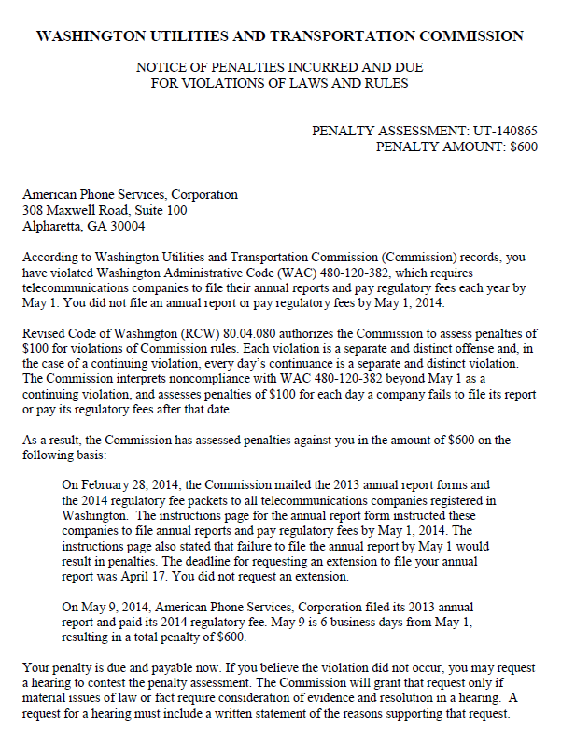

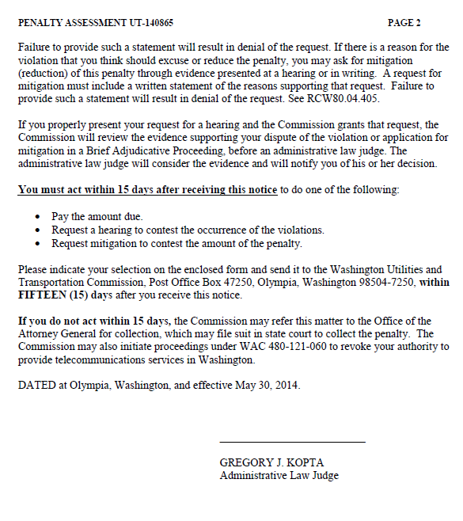

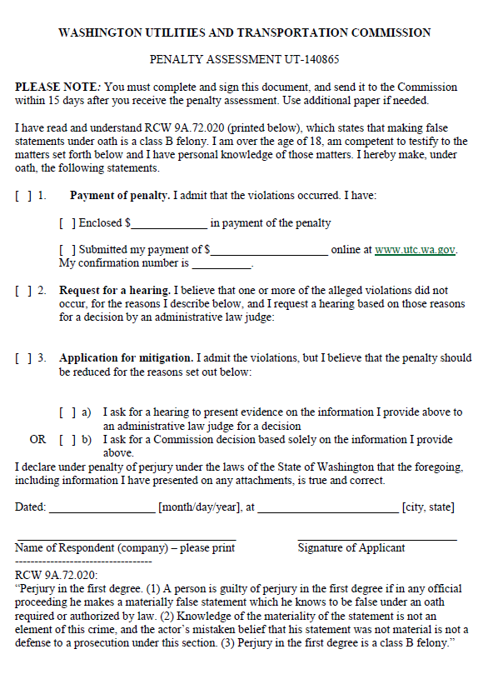

ATTACHMENT B
