January 15, 2010

W.U.T.C.
Tariff Division
1300 S. Evergreen Park Drive SW
Olympia, WA 98504-8002
Re: Shuttle Express Inc. C-975, tariff #6

Shuttle Express is submitting revisions to our tariff #6. The changes are housekeeping in nature. They are:
- Several Hotels have name changes.
- A few additional Hotels have been added to our service.
- All scheduled services will be operated as “Flag stops”.
- Discounted rates for scheduled service will now be offered for our Rider Rewards program. This is a promotional fare to run annually until we discontinue. The decrease in revenue should be offset by additional volume and give us better efficiency.
- Four stops will receive increases resulting in a minor increase and is to match the distance traveled with the fare.
Again, these changes are all mostly revenue neutral and are either housecleaning or causing operational efficiencies.

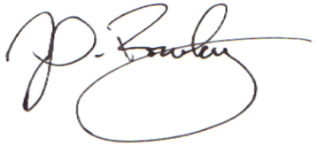
Respectfully,

John Rowley, General Manager

