Dear Washington UTC September 28, 2016
Reference: PSE LNG Docket 151663
I am writing about my concern for the proposed LNG planned by PSE for the Port of Tacoma. Due to the recent release by the Tacoma News Tribune of some of the safety risk assessment, the information needs to be clarified. It appears that PSE is using a probability table to indicate risks. This table shows the probability of many different types of accidents. Each is expressed in the probability for a single year occurrence. If the probability is low enough, PSE does not appear to model the specific accident. There are several fatal flaws using this methodology.
- First, the operational life for this facility might be 50 years. Any risk probability should be based upon the total life of the plant. This would make any single accident 50 times greater.
- PSE does not appear to model the accumulative probability of an accident. While there may be a low probability for most of the accidents, there are a great number of potential problems that need to be accumulated. For instance; If a person’s life expectancy was calculated just by using the actuary tables for each individual cause of death, the probability would be very low and everyone would expect to live for more than 100 years. When accumulated, the probability increases quite a bit.
- Much like the item above, PSE does not include tanker truck traffic into and out of the plant. This is a well studied scenario for many hazardous/explosive chemicals. With the potential of over 1000 trucks per year hauling LNG out of the plant, this can not be ignored.
The above three items will change the PSE risk analysis by huge amounts. If you assume the increase in accumulative probability is in the range of 5 or 10 (Use 7) , The increase for the LNG trucks would be (50)x(7)x(1000) or 350,000 times greater. The increase for the plant alone would be (50) x (7) or 350 times greater than indicated by PSE.
The worst flaw in PSE’s risk analysis is that it does not include consequences. Any risk analysis must require both probability and consequences. I wrote a comment for an article this last week that I will share. It is very important because the consequences so large that it overshadows the low probability.

“Who do you believe, PSE or the Stakeholders that are at Risk?
The recent release of some of the safety analysis done by PSE only adds to the confusion. PSE is basing all of their safety conclusions on probabilities. If they can look at a probability and determine it is low enough, they do not include it in their models. The thing that they do not address is the potential consequences. Any risk analysis should include both probability and consequences. Let me use a hypothetical example to make this concept a little clearer. If, for might be 1 in 10,000 in any given year. This is a relatively low percentage of 0.01%. This is the way that PSE calculates the safety of their plant. If you look at the odds over your lifetime of 50 years of driving, the odds become 0.5%. This is still a relatively small percentage for a head-on accident. Without looking at the consequences of the head-on accident, you might conclude this is still relatively safe. In this case the consequences are that both you and the passenger(s) of the other car would die. The results would be that there is a 0.5% chance that 2 people will die from a head-on collision with your car every 50 years. For a comparison to the LNG plant, let us change the scenario just a little and assume you are the driver for a dynamite delivery company. The probability remains the same at 0.5% over the same 50 year period. This time the consequences change drastically. The potential damage could be a thousand times worse. The explosion could devastate several blocks of buildings and homes, including schools, hospitals, churches, daycares, etc. The accident could also happen next to a gas station or rail cars full of oil. The consequences are much higher. This is what the PSE modeling fails to show and the public deserves to know. Continuing with the same analogy, there is also a probability that the truck load of dynamite might hit something else, like a bridge, a tree, a deer or even have a tire blow out. There are many additional possibilities for an accident that could lead to an explosion. Added together, the probability for an accident could be 5 or 10 times higher than the original 0.5%. This would be the “total probability” for an accident driving your dynamite truck.
What PSE has done is look at each probability separately and eliminated it if it is sufficiently low enough on a one year basis. They only found a case that had the 550 foot danger zone with this methodology. They did not look at the 50 year life span basis. They did not look at any cumulative/additive cases. Like the car scenario above, they only looked at the probability of having a head-on collision and eliminated it from further consideration. The probability increases a lot with the 50 year life outlook and the consequences are extremely dreadful. They dare not let the public know the true risk.
I picked a dynamite truck as the example because that is similar to the thousands of LNG trucks each year that will be required to deliver LNG to customers beside Tote. While the probability and consequences are increased by the number of 12,000 gallon LNG trucks on the road, the consequences are small compared to the consequences of a rupture of the 8,000,000 million gallons LNG storage tank. With a tank this size, the minimum 3 mile radius might not be enough. Some models show that more than 5 miles could be impacted by the flammable vapor cloud. This would truly reach tens of thousands of residents in surrounding cities.
Anytime there are high consequences, even with a low probability, the public should be protected. This is an easy decision; everyone should demand this plant be cancelled. It puts all the stakeholders at risk, everyone from the residents to the other port industries and workers.
Steven Storms
Short Biography
Steven Storms is a retired Chemical Engineer and PE. He has more than 40 years experience in the energy and environmental field. He is a past Chairman of the Puget Sound American Institute of Chemical Engineers. He is also past Chairman of the US Conference Board Council of Competitive Intelligence and was on the Board of Directors of the Strategic and Competitive Intelligence Professionals (SCIP) as the Ethics Chairman.

Contact Information
Steven Storms
1316 Browns Point Blvd NE
Tacoma, WA 98422
Email – storms123@aol.com
Phone – Home 253 212-1777 Cell 253 202-9925 “
In Florida, the Fire Department stood up for the public and published the impacts of a 10,000 gallon LNG rail car accident in a residential area. http://archive.tcpalm.com/news/shaping-our-future/all-aboard-florida/fire-rescue-warning-train-explosion-with-liquefied-natural-gas-could-lead-to-disaster-26e014b9-f455--362537441.html This would be less than the same accident from the 12,000 gallon tanker trucks in Tacoma. Please consider all the information and how PSE has been only representing what makes them look the best. The Utilities and Transportation Commission is supposed to represent and protect the public. It should be obvious that this project is not in our best interest. This plant should not be built in this location. 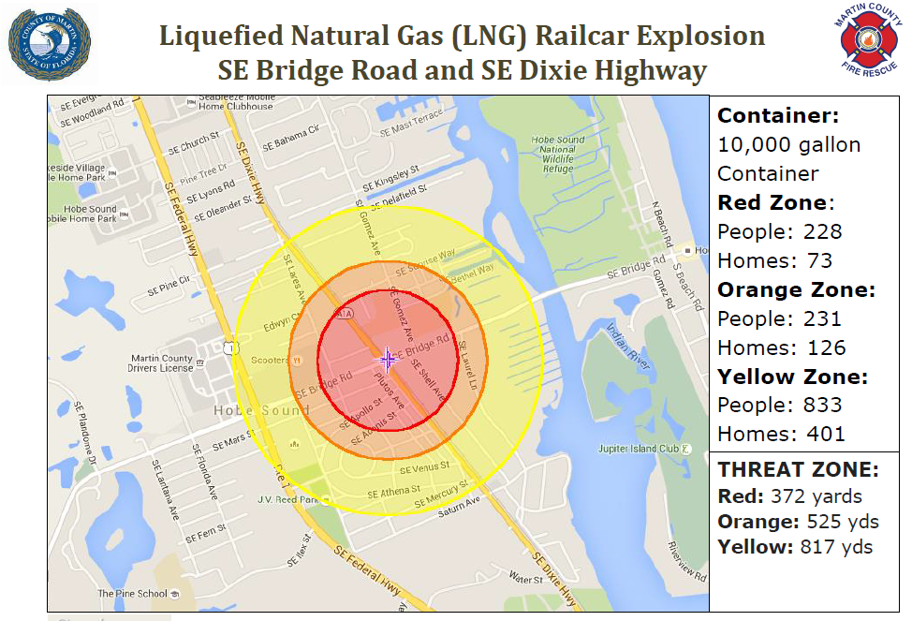 Thank for your consideration.
Steven Storms

