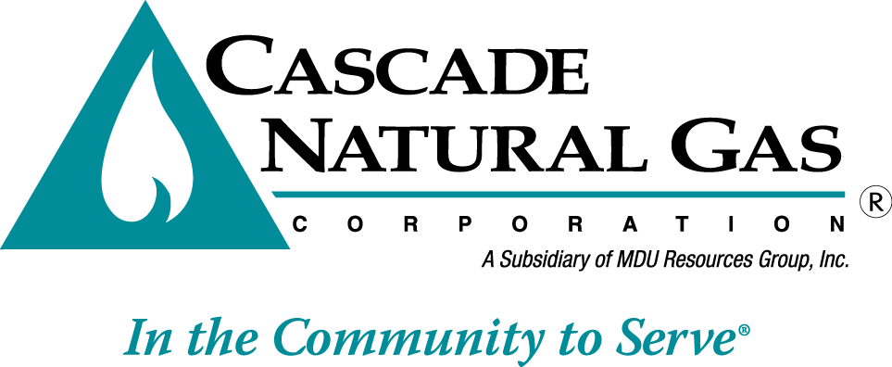
8113 W. GRANDRIDGE BLVD., KENNEWICK, WASHINGTON 99336-7166
TELEPHONE 509-734-4500 FACSIMILE 509-737-9803
www.cngc.com

May 23, 2016

Mr. Steven V. King
Executive Director and Secretary
Washington Utilities & Transportation Commission
Post Office Box 47250
Olympia, Washington 98504-7250

Re: UG-160438 CNGC 2015 Affiliated Interest Report

Dear Mr. King:

On April 25, 2016, in accordance with WAC 480-90-264, Cascade Natural Gas Corporation (Cascade or the Company) filed its Affiliated Interest Report for the 12-month period ending December 31, 2015. The Company inadvertently left out the attachment of the amendment to intercompany administrative services agreement as required per WAC 480-90-264(2)(c).

If there are any questions regarding this filing, please contact Michael Parvinen at (509) 734-4593.

Sincerely,

Pamela Archer
Supervisor, Regulatory Analysis

Attachment

