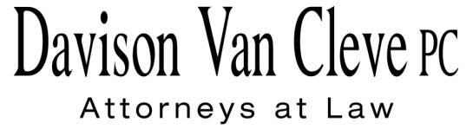
TEL (503) 241-7242 ● FAX (503) 241-8160 ● jog@dvclaw.com
Suite 400
333 S.W. Taylor
Portland, OR 97204

August 27, 2015

Via E-mail and Federal Express

Mr. Steven V. King
Executive Director & Secretary
Washington Utilities & Transportation Commission
1300 S. Evergreen Pk. Dr. S.W.
P. O. Box 47250
Olympia, WA 98504-7250

Re: The Walla Walla Country Club v. Pacific Power & Light Company
Docket UE-143932

Dear Mr. King:

Enclosed for filing in the above-referenced docket, please find the original and four (4) copies of the Cross-Examination Exhibit List on behalf of The Walla Walla Country Club.

Thank you for your assistance. If you have any questions, please do not hesitate to call.

Sincerely,

/s/ Jesse O. Gorsuch
Jesse O. Gorsuch
Enclosures
cc: Service List

CERTIFICATE OF SERVICE

I hereby certify that I have this day served the attached Cross-Examination Exhibit List of The Walla Walla Country Club upon the parties shown below by sending a copy via electronic mail and/or by mailing a copy via First Class U.S. Mail, postage prepaid.
DATED this 27th day of August, 2015.
Davison Van Cleve, P.C.

/s/ Jesse O. Gorsuch
Jesse O. Gorsuch

R. BRYCE DALLEY  Vice President, Regulation  PacifiCorp  825 NE Multnomah STE 2000  Portland, OR 97232  bryce.dalley@pacificorp.com  SALLY BROWN  Assistant Attorney General  WUTC  PO Box 40128  Olympia, WA 98504-0128  sbrown@utc.wa.gov  SIMON FFITCH  Office of the Attorney General  800 Fifth Avenue STE 2000  Seattle, WA 98104-3188  simonf@atg.wa.gov | SARAH WALLACE  Pacific Power & Light Co.  825 NE Multnomah STE 1800  Portland OR 97232  sarah.wallace@pacificorp.com  michelle.mishoe@pacificorp.com  TROY GREENFIELD  CLAIRE ROOTJES  Schwabe, Williamson & Wyatt  1420 5th Avenue STE 3400  Seattle, WA 98101  tgreenfield@schwabe.com  crootjes@schwabe.com

