August 19, 2015

Mr. Steven D. King
Executive Director and Secretary
Washington Utilities and Transportation Commission 1300 South Evergreen Park Drive SW
Olympia, WA 98504-7250

Subject: Petition for De-regulation with regards to the Sale and Transfer of Three Green Mountain H2O Water Systems to Michael McCarthy, Docket UW-150743

Dear Mr. King:

Enclosed is the petition for de-regulation and all applicable supporting documents with regard to the sale and transfer to Michael McCarthy, three Green Mountain H2O water systems; Columbia View 1 (Department of Health ID # 08263V), Columbia View 2 (Department of Health ID # 07762X), and Columbia View 3 (Department of Health ID # 08265W). Please include this filing with Docket UW-150743. Hardcopies to follow via USPS mail.

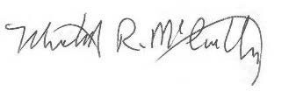Thank you for your attention to this request. Sincerely,

Michael McCarthy 404 Wishman Drive
Woodland WA, 98674 Enclosed

