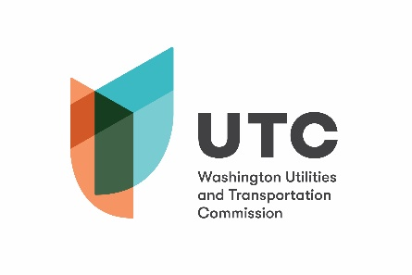
Memorandum
October 4, 2018

To: TR-180329 - File

From: Lori Halstead, Transportation Specialist, Rail Safety

Subject: TR-180329 – Port of Chehalis
Completion of Grade Crossing Protective Fund (GCPF) Project
Signing at 21 Railroad Crossings

On June 14, 2018, the Washington Utilities and Transportation Commission (Commission) awarded a GCPF grant totaling $989.80 to Port of Chehalis for a project related to signage at 21 crossings owned by Port of Chehalis. The total project cost was estimated at $989.80.

On September 27, 2018, Port of Chehalis submitted a request for reimbursement for the project. Rail Safety staff confirmed the signs are in place and that the project was completed according to the specifications outlined in the order approving the grant. The total cost was $997.76. The Port of Chehalis will pay the $7.96 overage amount.

Please close this docket.

