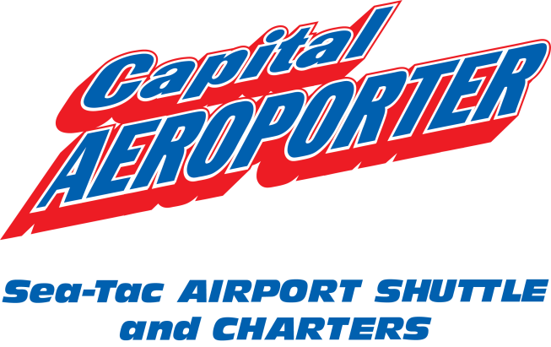

NOTICE TO OUR VALUED CUSTOMERS
March 23, 2015
Recent rule changes implemented by the Washington Utilities and Transportation Commission (WUTC) allow transportation companies to offer flexible fares on regulated services based on currently filed and approved fixed rates. The rule changes allow for a maximum increase of 5% annually over current maximum allowed rates and the lowest rate being reduced to $0.01.

Capital Aeroporter has submitted a request to the WUTC to apply the rule change to our existing fares to be effective May 1, 2015 as allowed by law.

These changes are pending approval. Please visit www.capair.com for the complete list of our current fares and flexible fare options.

Contact us at (360) 754-7113 x105 with questions or comments, or email customerservice@capair.com. To contact the WUTC to comment or oppose, call 360-664-1160, email consumer@utc.wa.gov or mail to Washington Utilities and Transportation Commission, 1300 S Evergreen Park Drive SW, PO Box 47250, Olympia, WA 98504-7250.

We appreciate your loyalty to Capital Aeroporter to serve your transportation needs for over 43 years. Thank you for your continuing to support our local business and economy. We promise to continue to provide safe and friendly service!

Capital Aeroporter
PO Box 2163
Olympia, WA 98507

