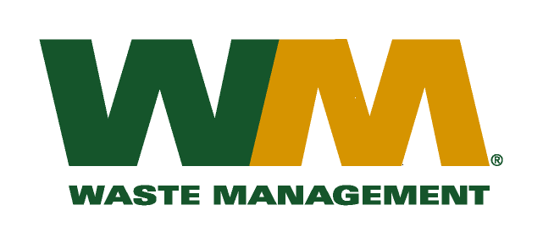

June 2, 2016

Washington Utilities and Transportation Commission
Chandler Plaza Building
1300 S. Evergreen Park Drive SW
P.O. Box 47250
Olympia, WA. 98504-7250

Subject: Waste Management – North Sound and Waste Management - Marysville, divisions of Waste Management of Washington, Inc. (G-237); Tariff No. 19

Enclosed are revised pages 2 and 25 to the above referenced tariff. The purpose of this filing is to add language to Item 100 that clarifies the fact that when residential customers request occasional services at container capacities larger those listed in Item 100 that the rates in Items 240, 255, 260 and 275 will apply. This is not a change in current practices and it will have no additional revenue impact to the company.
If you have any questions or need additional information, please contact me at:
Address: 720 4th Avenue, Suite 400, Kirkland, WA 98033
Telephone /Fax #: (425) 814-7840 / (425) 814-7866
e-mail: mweinstein@wm.com

Respectfully,

Michael A. Weinstein
Senior Pricing Manager, Pacific Northwest Market Area

