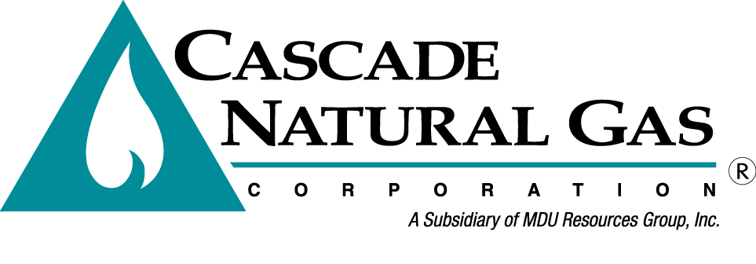
8113 W. GRANDRIDGE BLVD., KENNEWICK, WASHINGTON 99336-7166
TELEPHONE 509-734-4500 FACSIMILE 509-737-9803
www.cngc.com

May 19, 2015

Washington Utilities & Transportation Commission
Mr. Steven King, Executive Director & Secretary
P.O. Box 47250
Olympia, WA 98504-7250

RE: Cascade Natural Gas Corporation 2014 Integrated Resource Plan
(Docket UG-140181)

Dear Mr. King:

Subsequent to recent discussions with Commission Staff in regards to a medical emergency, Cascade Natural Gas Corporation respectfully requests an extension of the filing deadline for the upcoming Integrated Resource Plan (IRP) from May 29, 2015 to July 17, 2015.

With this extension Cascade has agreed to also run a scenario where the amount of Washington conservation modeled in the IRP for cost-effectiveness be equivalent to 100% of the achievable economic potential (with administrative costs included).

Attached is the proposed work plan and schedule based on the requested extension being granted.

If there are any questions regarding this matter, please contact Brian Robertson at (509) 734-4546 or myself at (509) 734-4589. Alternatively, we may be reached at brian.robertson@cngc.com and mark.sellers-vaughn@cngc.com.

Sincerely,
CASCADE NATURAL GAS CORPORATION
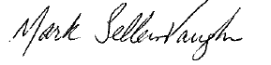
Mark Sellers-Vaughn
Manager, Supply Resource Planning

Enclosures

Date | Reason | Location
Tuesday, June 24, 2014 | TAG 1: Process, Key Assumptions (IRP Team, Timeline, Highlights Most Recent IRPs, Latest Economic Indicators, Price Forecast and Demand Forecast Methodology and High Level Presentation of 20 Yr Forecast) | Portland Airport Conference Center
Tuesday, September 02, 2014 | Distribute Supplemental Forecast #1
Tuesday, September 16, 2014 | Workshop #1: Open discussion and live walk through of the forecast model | Portland Airport Conference Center
Tuesday, November 11, 2014 | Distribute Supplemental Forecast #2
Thursday, November 20, 2014 | Workshop #2: Open discussion and live walk through of the forecast model | Portland Airport Conference Center
Wednesday, November 26, 2014 | Create TAG #2/Workshop #3 Presentation
Wednesday, November 26, 2014 | Approve TAG #2/Workshop #3 Presentation
Wednesday, November 26, 2014 | Distribute TAG #2/Workshop #3 Presentation
Tuesday, December 02, 2014 | Workshop #3: Open discussion and live walk through of the forecast model | Portland Airport Conference Center
Wednesday, December 10, 2014 | Deliver Draft Avoided Cost Calc to Conservation
Wednesday, December 10, 2014 | Engineering 3 YR Outlook Deliver Draft Avoided Cost Calc to Conservation
Wednesday, December 10, 2014 | Conservation Study/Presentation
Monday, December 29, 2014 | Create Tag #2 Presentation
Friday, January 2, 2015 | Approve Tag #2 Presentation
Friday, January 2, 2015 | Distribute Tag #2 Presentation
Tuesday, January 13, 2015 | TAG 2: (Drilling down into the segments of 20 Yr. Demand Forecast, Current Supply Resources,) | Portland Airport Conference Center
Tuesday, January 20, 2015 | Economic Resource Optimization (Sendout)
Tuesday, January 27, 2015 | Review and Approve Resource Optimization
Tuesday, February 10, 2015 | Create TAG #3 Presentation
Thursday, February 12, 2015 | Approve TAG #3 Presentation
Thursday, February 12, 2015 | Distribute TAG #3 Presentation
Thursday, February 19, 2015 | TAG 3: Conservation, Current Supply Resource | Portland Airport Conference Center
Monday, February 27, 2015 | Work begins on IRP Draft (conservation and system overview, supply resources)
Tuesday, March 25, 2015 | Create TAG #4 Presentation
Thursday, March 27, 2015 | Approve TAG #4 Presentation
Thursday, March 27, 2015 | Distribute TAG #4 Presentation
Wednesday, April 1, 2015 | TAG 4: Transport Issues, Alternative Resources, SENDOUT Scenarios, Avoided Costs, Price Forecast | Portland Airport Conference Center
Thursday, June 2, 2015 | Create TAG #5 Presentation
Thursday, June 2, 2015 | Approve TAG #5 Presentation
Thursday, June 2, 2015 | Distribute TAG #5 Presentation
Tuesday, June 9, 2015 | TAG 5: Integration Results, Distribution Enhancements, Update on 2 Year Plan | Portland Airport Conference Center
Friday, June 12, 2015 | Internal Approval of IRP Draft
Friday, June 19, 2015 | Draft of IRP distributed
Friday, July 3, 2015 | Comments due on draft from all stakeholders
Monday, July 6, 2015 | Update IRP per all stakeholder Comments
Thursday, July 9, 2015 | IRP Internal Review
Friday, July 17, 2015 | IRP filing (OR and WA) combined/concurrent single document

