July 28, 2014

Steven V. King, Executive Director and Secretary
Utilities and Transportation Commission
1300 S. Evergreen Park Dr. SW
P.O. Box 47250
Olympia, WA 98504-7250

RE: Washington Utilities and Transportation Commission v. Apex Limo Service LLC

Commission Staff’s Response to Application for Mitigation of Penalties TE-141051

Dear Mr. King:

On May 23, 2014, the Utilities and Transportation Commission issued a $1,000 Penalty Assessment in Docket TE-141051 against Apex Limo Service LLC for 10 violations of Washington Administrative Code (WAC) 480-30-071, which requires charter and excursion carriers to furnish annual reports to the commission no later than May 1 each year.¹

On June 5, 2014 Apex Limo Service LLC submitted a request for a hearing but failed to provide a written statement.² On July 9, 2014 the commission issued a notice denying the request for hearing, but allowed for opportunity to submit reason(s) in support for application for mitigation within one week of the service date.³ In its Mitigation Request⁴ which was received by the commission on July 15, 2014, Apex Limo Service LLC does not dispute that the violation occurred. The company provided a statement regarding the owner’s confusion regarding the UTC requirements and only became aware of the annual report requirement when he asked another company to purchase his vehicle.

It is the company’s responsibility to ensure that the regulatory fee is paid and the annual report is filed by the May 1 deadline. On February 28, 2014, Annual Report packets were mailed to all regulated charter and excursion companies. The instructions for annual report completion page of the annual report informed the regulated company that it must complete the annual report form, pay the regulatory fees, and return the materials by May 1, 2014, to avoid enforcement action.

UTC Annual Reports
July 28, 2014
Page 2

On June 5, 2014, Apex Limo LLC filed the 2013 annual report and paid the required regulatory and late payment fees. The company initial application was submitted on May 3, 2013. No previous violations of WAC 480-30-071 are on commission record. The UTC also recently adopted new rules requiring the annual report to be filed by May 1 while the regulatory fees remained due on December 31. Despite the commission communication regarding these filing changes to all regulated charter and excursion companies, commission staff supports the company’s request for mitigation. Staff recommends a reduced penalty assessment of $200.

If you have any questions regarding this recommendation, please contact Amy Andrews, Regulatory Analyst, at (360) 664-1157, or aandrews@utc.wa.gov.

Sincerely,

Sondra Walsh, Director
Administrative Services

ATTACHMENT A
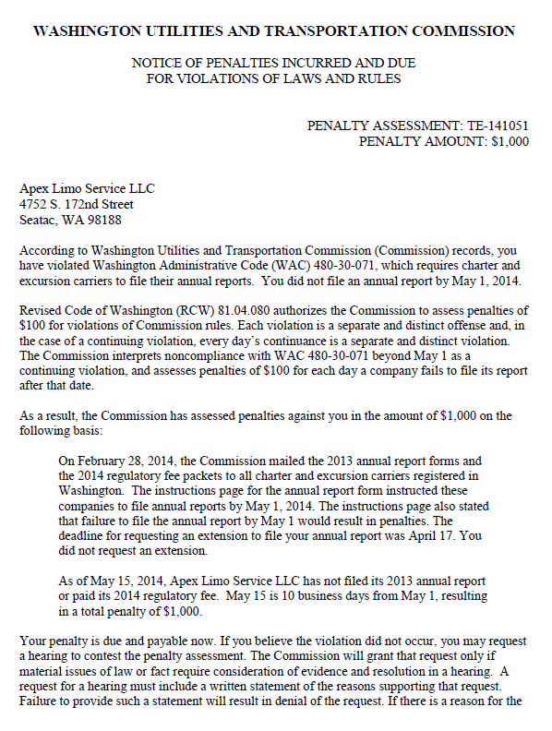

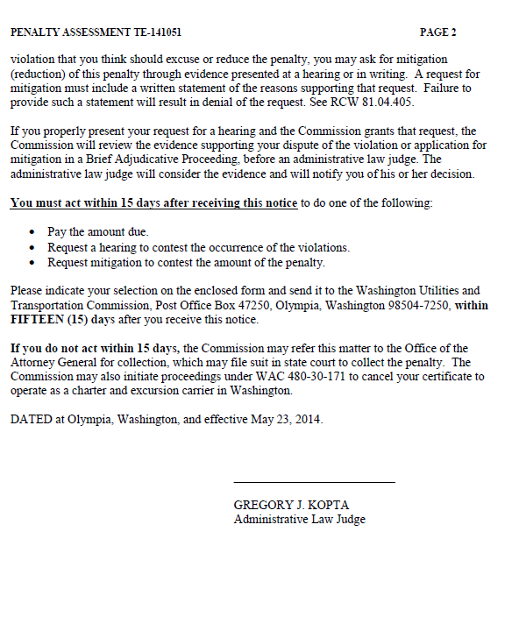

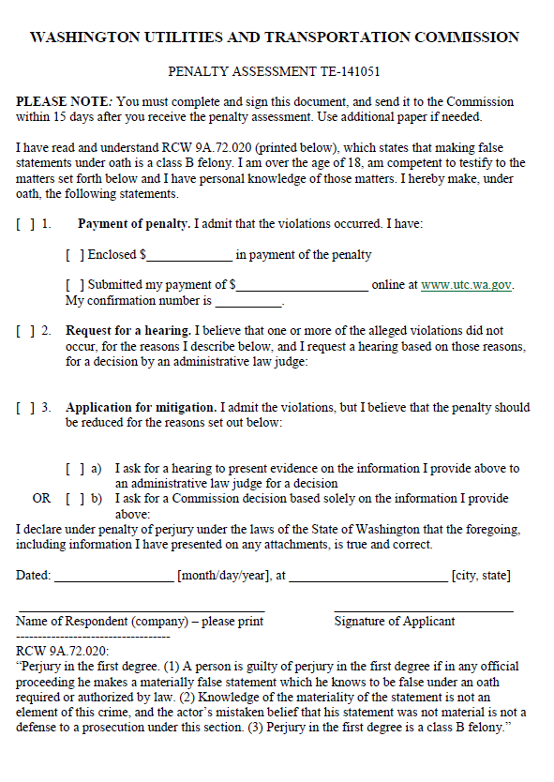

ATTACHMENT B
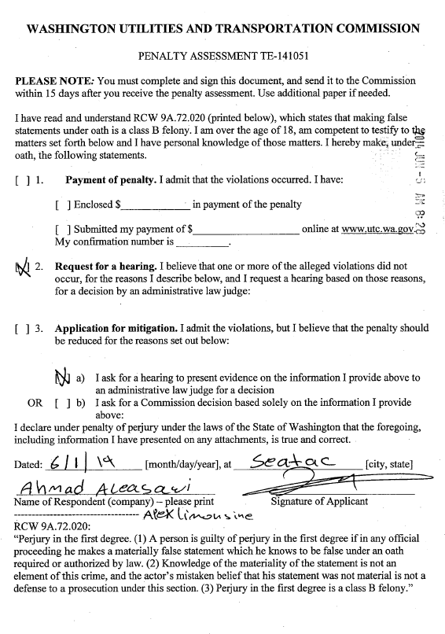

ATTACHMENT C
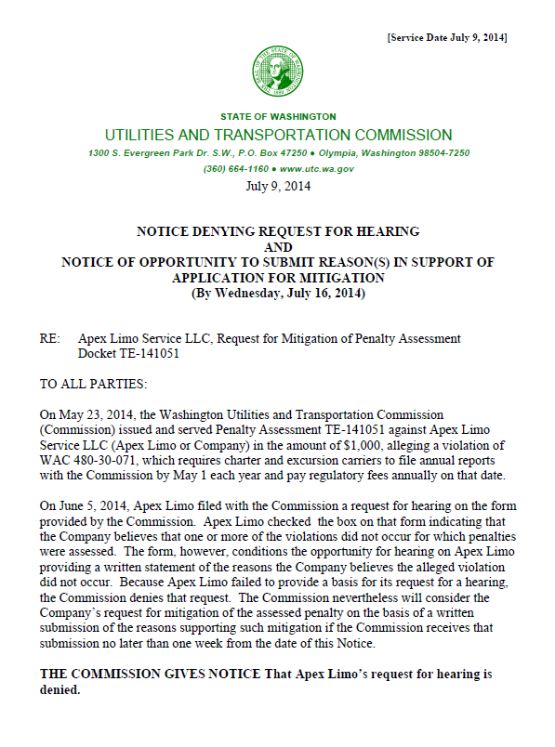

APPENDIX D
