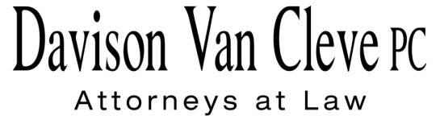
TEL (503) 241-7242 ● FAX (503) 241-8160 ● jog@dvclaw.com
Suite 400
333 S.W. Taylor
Portland, OR 97204

August 27, 2015

Via E-mail and Federal Express

Mr. Steven V. King
Executive Director & Secretary
Washington Utilities & Transportation Commission
1300 S. Evergreen Pk. Dr. S.W.
P. O. Box 47250
Olympia, WA 98504-7250

Re: The Walla Walla Country Club v. Pacific Power & Light Company
Docket UE-143932

Dear Mr. King:

Enclosed for filing in the above-referenced docket, please find the original and four (4) copies of the Cross-Examination Exhibits on behalf of The Walla Walla Country Club (“Club”), along with the original and one (1) copy of all redacted versions.

Please note that two of the Club’s Cross-Examination Exhibits contain material that Pacific Power & Light Company has designated as confidential. Accordingly, the Club is handling the material pursuant to the Protective Order in this docket.

Thank you for your assistance. If you have any questions, please do not hesitate to call.

Sincerely,

/s/ Jesse O. Gorsuch
Jesse O. Gorsuch
Enclosures
cc: Service List

CERTIFICATE OF SERVICE

I hereby certify that I have this day served the attached Cross-Examination Exhibits of The Walla Walla Country Club upon the parties shown below by sending a copy via electronic mail and/or by mailing copies via First Class U.S. Mail, postage prepaid.
DATED this 27th day of August, 2015.
Davison Van Cleve, P.C.

/s/ Jesse O. Gorsuch
Jesse O. Gorsuch

R. BRYCE DALLEY  Vice President, Regulation  PacifiCorp  825 NE Multnomah STE 2000  Portland, OR 97232  bryce.dalley@pacificorp.com  SALLY BROWN  Assistant Attorney General  WUTC  PO Box 40128  Olympia, WA 98504-0128  sbrown@utc.wa.gov  SIMON FFITCH  Office of the Attorney General  800 Fifth Avenue STE 2000  Seattle, WA 98104-3188  simonf@atg.wa.gov | SARAH WALLACE  Pacific Power & Light Co.  825 NE Multnomah STE 1800  Portland OR 97232  sarah.wallace@pacificorp.com  michelle.mishoe@pacificorp.com  TROY GREENFIELD  CLAIRE ROOTJES  Schwabe, Williamson & Wyatt  1420 5th Avenue STE 3400  Seattle, WA 98101  tgreenfield@schwabe.com  crootjes@schwabe.com

