Investigation Report

Ellensburg Telephone Company d/b/a FairPoint Communications

UT-143633

Megan Banks
Compliance Investigations

March 2015

TABLE OF CONTENTS

Purpose, Scope, and Authority 3

Executive Summary 4
Background 6
Compliance History 7

Investigation: Joint User Business Subscription and Residential Foreign Listing

Service Rates 8

Recommendations 10
Attachments …………………………………………………………………….. 14

PURPOSE, SCOPE AND AUTHORITY

Purpose
The purpose of this investigation is to determine whether Ellensburg Telephone Company d/b/a FairPoint Communications (FairPoint) has committed violations of commission rules related to the rates charged for its Joint User Business Subscriptions and Residential Foreign Listing services.

Scope
The scope of this investigation focuses on improper rates charged by FairPoint between April 1, 2013, and May 31, 2014.

Authority
Staff undertakes this investigation pursuant to Revised Code of Washington (RCW) 80.04.070, which grants the commission specific authority to conduct such an investigation.

Staff
Megan Banks, Compliance Investigator
(360) 664-1129
mbanks@utc.wa.gov

EXECUTIVE SUMMARY

In FairPoint’s tariff revision, filed on May 23, 2014, the company stated that the rates billed for the Joint User Business Subscriptions and the Residential Foreign Listing services were different than the rates listed in its tariff for these services. Commission staff determined a broader investigation was necessary to determine the scope and frequency of the improper charges.

An investigation into the business practices of FairPoint established that the company is in violation of commission rules and its own tariff, as follows:

- 46 violations of RCW 80.36.130 for improperly charging a rate of $3.45 instead of the approved tariff rate of $0.95 for the listing service of Joint User business for 23 subscriptions (21 individual customers) between April 2013 and May 2013, for a total of $115 in overcharges.
- 66 violations of RCW 80.36.130 for improperly charging a rate of $3.45 instead of the approved tariff rate of $0.95 for the listing service of Joint User business for 22 subscriptions (20 individual customers) between June 2013 and August 2013, for a total of $165 in overcharges.
- 189 violations of RCW 80.36.130 for improperly charging a rate of $3.45 instead of the approved tariff rate of $0.95 for the listing service of Joint User business for 21 subscriptions (19 individual customers) between September 2013 and May 2014, for a total of $472.50 in overcharges.
- Two (2) violations of RCW 80.36.110 for failure to provide statutory notice for tariff changes to the rates charges for the Joint User business subscription and the Residential Foreign Listing services.

During the two-year period of review, FairPoint improperly charged Joint User business subscription fees 301 times, for a total of $752.50 in overcharges. There were no charges to any customers for the Residential Foreign Listing service. While staff can only look at the previous two years, due to the state’s statute of limitations, it should be noted that according to FairPoint’s written statements, the company had been charging the incorrect rates for more than eight years.

FairPoint was unable to determine whether the incorrect Joint User business subscription and Residential Foreign Listing service fees resulted from a manual or system-generated error. According to the company, the error occurred prior to the 2006 conversion of its billing system. Based on the documentation and information provided, the company did not file tariff revisions related to either of these rates prior to the tariff filing in May 2014. The company did request a repagination of their tariff on June 26, 2013, including the page where the Joint User business subscription and Residential Foreign Listing service fees were listed.

Recommendation
Staff recommends the commission issue a formal complaint against FairPoint alleging 303 violations of commission laws and rules; and recommending a total penalty of up to $32,100 for the following violations:

- Up to $4,600 for 46 violations of RCW 80.36.130 for improperly charging a rate of $3.45 instead of the approved tariff rate of $0.95 for the listing service of Joint User business for 23 subscriptions (21 individual customers) between April 2013 and May 2013, for a total of $115 in overcharges.
- Up to $6,600 for 66 violations of RCW 80.36.130 for improperly charging a rate of $3.45 instead of the approved tariff rate of $0.95 for the listing service of Joint User business for 22 subscriptions (20 individual customers) between June 2013 and August 2013, for a total of $165 in overcharges.
- Up to $18,900 for 189 violations of RCW 80.36.130 for improperly charging a rate of $3.45 instead of the approved tariff rate of $0.95 for the listing service of Joint User business for 21 subscriptions (19 individual customers) between September 2013 and May 2014, for a total of $472.50 in overcharges.
- Up to $2,000 for two violations of RCW 80.36.110 for failure to provide statutory notice for tariff changes to the rates charges for the Joint User business subscription and the Residential Foreign Listing services.

Staff also recommends that FairPoint refund $752.50 to its customers for monies collected through improper rate charges.

BACKGROUND

Company History
On May 23, 2014, FairPoint submitted a proposed tariff revision to the commission. On June 26, 2014, the commission approved the proposed tariff revisions, in Docket UT-141130.

The company’s 2013 annual report reflects FairPoint’s total gross intrastate operating revenue as $6,003,984. The 2012 annual report shows FairPoint’s total gross intrastate operating revenue as $6,798,006. The company provided 17,165 voice grade lines in 2012 and 15,759 voice grade lines in 2013.
Consumer Complaints
According to commission records, consumer protection staff received four complaints against FairPoint between 2010 and 2014. Of the four complaints, one was company upheld, one was company upheld with arrangements, and two were consumer upheld. If a complaint is company upheld, it means that the company acted property with respect to the consumer’s issues. If a complaint is company upheld with arrangements, it means that the company acted property with respect to the consumer’s issues, but other, unrelated, violations were recorded. Finally, if a complaint is customer upheld, it means that the actions of the company were improper and the customer’s position is upheld.

Investigation
Staff initiated this investigation into FairPoint’s business practices to determine whether the overcharge identified through the proposed tariff revision was widespread and ongoing. Staff determined a broader investigation was necessary to determine the scope and frequency of the improper charges.

INVESTIGATION

Data Request
On June 20, 2014, staff requested the following data from FairPoint:

- The current rates FairPoint was charging for all services to both residential and business customers in Washington state. The service rates were to be listed separately. In addition, the company was to include the prior rate and the date the current and prior rates went into effect.
- An explanation to why the tariff showed a different rate for Joint User Business Subscriptions and the Foreign Listing services than what the company was actually charging customers.
- A list of all customer complaints received in the past year (June 2013-May 2014) related to rate charges.
- Copies of all billing statements sent to customers over the past year (June 2013-May 2014) showing the rates charged. This was to only include bills that had charges related to Joint User Business Subscriptions or Foreign Listing services.

Staff requested that FairPoint respond to the data request no later than July 7, 2014. In addition, Staff requested that FairPoint provide a contact person for questions related to the data request. On June 24, 2014, and again on June 26, 2014, FairPoint requested clarification regarding the data request. On July 7, 2014, staff received an email from Beth Westman, FairPoint’s State Government Affairs Manager, and from Pat Morse, FairPoint’s Senior Vice President of Governmental Affairs, requesting a one-day extension to produce the data requested. Staff granted an extension to July 8, 2014.

On July 8, 2014, FairPoint provided the requested documentation as an email attachment.

On Aug. 13, 2014, staff sent the company the following additional question: How many customers had Joint User Business Subscriptions between June 2012 and May 2013. FairPoint responded the same day and stated that in June 2012, the company had 22 customers (24 listings) that had Joint User Business Subscriptions and in May 2013, the company had 20 customers (22 listings) that had Joint User Business Subscriptions.

On Aug. 14, 2014, staff requested clarification from the company regarding the number of customers who had Joint User Business Subscriptions between June 2012 and May 2014. FairPoint responded on Aug. 21, 2014, and included documentation of the number of customers per month that had Joint User Business Subscriptions between June 2012, and May 2014.

Scope of Investigation
Staff used the documents and information furnished from the data request, the subsequent response from FairPoint, FairPoint’s tariff, and commission records to conduct this investigation.
Joint User Business Subscription and Residential Foreign Listing Service Fees

Investigation
RCW 80.36.130 states that no telecommunication company “shall charge, demand, collect or receive different compensation for any service rendered or to be rendered than the charge applicable to such service as specified in its schedule on file and in effect at that time...”

RCW 80.36.110 states that a telecommunication company may not make any changes in any rate, toll, rental, or charge, without providing the required notice to the commission and customers. Specifically, “[f]or changes to any rate, toll, rental, or charge filed and published in a tariff, the company shall provide thirty days’ notice to the commission and publication for thirty days as required in the case of original schedules in RCW 80.36.100.”

On May 23, 2014, FairPoint submitted an electronic tariff filing to the commission. Commission Regulatory Services staff contacted the company by email on May 27, 2014, requesting additional information about the tariff revisions, including the estimated annual revenue impact for the proposed price increase and the proposed language to let customers know about the increase in price.

On May 29, 2014, FairPoint’s State Government Affairs Manager, responded by email to commission Regulatory Services staff and stated that the annual revenue impact would be $15,564 for both residential and business customers. In addition, she provided the notice, regarding the rate increase that customers would see on their June billing statements. Commission Regulatory Services staff responded by email on May 30, 2014, pointing out that the stated increased rates on the notice for Joint User Business Subscribers and Residential Foreign Listing services were less than the staff calculated rate increases using the company’s current tariff rates. Specifically, commission Regulatory Services staff pointed out that the current tariff rates for Joint User Business Subscriptions were $0.95.

On June 2, 2014, FairPoint responded that there was “some discrepancy in the tariff vs the billing system. The [Joint User Business Subscription] rate in the tariff hasn’t been $0.95 for a very long time…Additionally, this same type of situation applies to the Foreign Listings. We have been billing both business and residential customers $0.95 for this service, but the tariff indicates $0.45 for the [R]esidential [F]oreign [L]istings.” The rate the company had been charging for Joint User Business Subscription and Residential Foreign Listing services were higher than the rates listed in the tariff.

On June 4, 2014, Commission Regulatory Services staff communicated their concerns regarding the Joint User Business Subscription and Residential Foreign Listing service rate discrepancies, and the company’s response, to the commission’s Consumer Protection and Communications division.

Staff reviewed the data FairPoint provided and found that the subscriptions to Joint User Business services were improperly charged a rate of $3.45 instead of the approved tariff rate of $0.95. The improper charges affected 23 subscriptions between April 2013 and May 2013; 22 subscriptions between June 2013 and August 2013; and 21 subscriptions between September 2013 and May 2014. According to the documentation and information provided, there were no subscriptions to Residential Foreign Listing services during the same time periods.

In its July 8, 2014, response, FairPoint stated that the billing “error” that caused customers to be charged a higher rate than the tariff rate for Joint User Business Subscriptions occurred prior to a 2006 billing system conversion. According to FairPoint, when the company examined a “few invoices prior to the billing system conversion, we discovered that the wrong rate had been billed before the [2006] billing conversion.” Based on their review, FairPoint could not determine exactly when or “why the rate in the billing system does not match the rate in the tariff” and had not discovered the discrepancy in the rate charged for the Joint User Business Subscriptions until they filed the recent tariff changes and commission Regulatory Services staff pointed out the discrepancy. According to FairPoint, while the rate for Residential Foreign Listing services were also to be charged at a different rate that the tariff rate, no customers actually received that service. Additionally, according to its response, FairPoint had not received any consumer complaints regarding rate charges between June 2013 and May 2014.
Findings
Staff finds that FairPoint violated RCW 80.36.130 a total of 301 times by charging non-tariffed rates for Joint User Business Subscriptions in conflict with those published in the company’s tariff WN U-4, Section 18, First Revision Sheet No. 126. In addition, staff finds FairPoint violated RCW 80.36.110 a total of two times by failing to provide statutory notice for tariff rate changes prior to changing the rates billed from $0.95 to $3.45 for Joint User Business Subscriptions and $0.45 to $0.95 for Residential Foreign Listing services. Although it is unclear when the rate changes occurred, but for the July 2014 tariff revision, the commission would not have known about the violations and FairPoint would have continued to profit from the improper charges.
RECOMMENDATION

Penalty
Staff typically recommends a per violation penalty against a regulated company where the violations result in serious customer harm; for repeat violations of a rule after a company receives technical assistance from staff; or for intentional violations of commission laws or rules. The commission has the authority to assess penalties of up to $100 per violation, per day against a regulated company without providing the opportunity for a hearing. The commission has the authority to assess penalties of up to $1,000 per violation, per day following a formal complaint and hearing. The commission also has the authority to order a public service company to refund overcharges for any service rendered in excess of the lawful rate in force at the time of such charge following a formal complaint and hearing.

In this investigation, staff documented 301 violations of RCW 80.36.130 and the company’s tariff resulting from an overcharge of Joint User Business Subscriptions assessed between April 2013 and June 2014. The violations resulted in the company overcharging customers a total of $752.50. In addition, staff documented two violations of RCW 80.36.110 related to the failure to provide statutory notice for tariff changes to the rates charged for the Joint User Business Subscription and Residential Foreign Listing services. Staff considered the following factors to determine the recommended penalty amount:

- How serious or harmful the violation is to the public.

Staff believes the violations caused serious harm to customers. Of the 303 violations cited in this report, 301 directly impacted customers. Charging incorrect rates for services are violations with significant impacts. FairPoint customers were assessed a charge that was $2.50 higher than the tariff rate for the Joint User business subscription. This caused an overcharge to the customers of $30 per year for each subscription to the service. While staff limited its investigation to the past two years due to the state’s statute of limitations, it should be noted that according to FairPoint’s written statements, the company had been charging the incorrect rates for more than eight years.

- Whether the violation is intentional.

Regulated companies have a responsibility to charge rates according to statutory, rule, and tariff requirements. It is the company’s responsibility to ensure that the rates charged are in compliance with the approved tariff rates. Charging incorrect rates for more than eight years supports a finding that the violations were intentional.

- Whether the company self-reported the violation.

The violations occurred between April 2013 and June 2014. Staff received a tariff revision request in May 2014. Commission Regulatory Services staff reviewed the tariff and communicated with the company regarding the discrepancies in the rate charged and the tariff rate of Joint User Business Subscriptions and Residential Foreign Listing services. The company admitted that the billing rates were different than the tariff rates and had been for a “long time.” Commission Regulatory Services staff communicated their concerns, and the company’s response, regarding the rate discrepancies to the commission’s Consumer Protection and Communications division, who began this investigation. The company did not, on its own initiative, refund the overcharge to the individuals who were billed the non-tariff rate. The company also did not, on its own initiative, investigate the overcharge to determine whether it was widespread and ongoing. Staff does not believe the evidence supports a finding that FairPoint self-reported the violation.

- Whether the company was cooperative and responsive.

Staff believes that the company has been cooperative, and has responded timely to staff requests for information.

- Whether the company promptly corrected the violations and remedied the impacts.

The tariff revision that went into effect on July 1, 2014, corrected the rates for the Joint User Business Subscriptions and the Residential Foreign Listing services. However, based on the information provided, the company has not provided any refunds to any customers who subscribed to the Joint User business subscription service between April 2013 and June 2014. Staff believes the company has not promptly remedied the impacts.

- The number of violations and the number of customers affected.

FairPoint committed a 301 violations between April 2013 and June 2014 by billing rates for the Joint User Business Subscription service that did not match the rates in its published tariff, and another two violations for not providing statutory notice to customers for rate changes in its Joint User Business Subscription and Residential Foreign Listing services Approximately 21 per month customers were affected by the Company’s overcharge. Many of the customers affected were impacted multiple times during the eight plus years of violations. Staff believes that the number of violations, 301, is substantial.

- The likelihood of recurrence.

Absent a comprehensive compliance plan to ensure billing rates are consistent with tariff rates, staff believes that the violations are likely to recur.

- The company’s past performance regarding compliance, violations and penalties.

The company does not have a history of violations or penalties. In four years, the company has had four consumer complaints against it. Of the four complaints, two were consumer upheld. None of the complaints were related to Joint User business subscription or Residential Foreign Listing service rates or charges.

- The company’s existing compliance program.

Staff is not aware of any existing compliance program. The volume of the violations create a presumption that the company does not have a compliance program in place to prevent improper charges. The company likely would not have corrected the improper rates but for commission staff questioning the rates in the company’s submitted tariff revision.
- The size of the company.

FairPoint provided 17,165 voice grade lines in 2012, and 15,759 voice grade lines in 2013. The company reported a total gross intrastate operating revenue of $6,798,006 in 2012, and a total gross intrastate operating revenue of $6,003,984 in 2013.

Recommendation
Staff recommends the commission issue a formal complaint assessing a total penalty of up to $32,100 for the following violations.

- Up to $4,600 for 46 violations of RCW 80.36.130 for improperly charging a rate of $3.45 instead of the approved tariff rate of $0.95 for the listing service of Joint User business for 23 subscriptions (21 individual customers) between April 2013 and May 2013, for a total of $115 in overcharges.
- Up to $6,600 for 66 violations of RCW 80.36.130 for improperly charging a rate of $3.45 instead of the approved tariff rate of $0.95 for the listing service of Joint User business for 22 subscriptions (20 individual customers) between June 2013 and August 2013, for a total of $165 in overcharges.
- Up to $18,900 for 189 violations of RCW 80.36.130 for improperly charging a rate of $3.45 instead of the approved tariff rate of $0.95 for the listing service of Joint User business for 21 subscriptions (19 individual customers) between September 2013 and May 2014, for a total of $472.50 in overcharges.
- Up to $2,000 for two violations of RCW 80.36.110 for failure to provide statutory notice for tariff changes to the rates charges for the Joint User business subscription and the Residential Foreign Listing services.

Staff also recommends that FairPoint refund $752.50 to its customers for monies collected through improper rate charges.

Additionally, staff recommends that FairPoint closely review this investigation report, which provides detailed technical assistance. Future violations will result in additional enforcement action, including penalties.

Attachment A

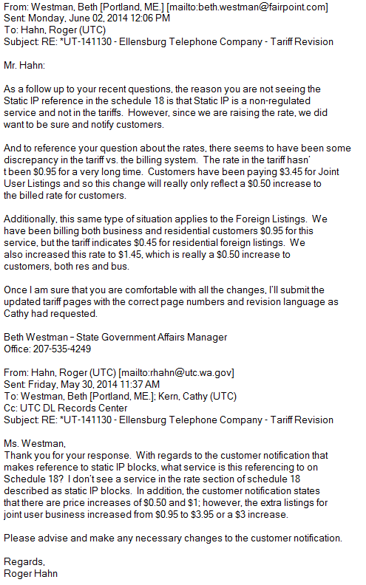
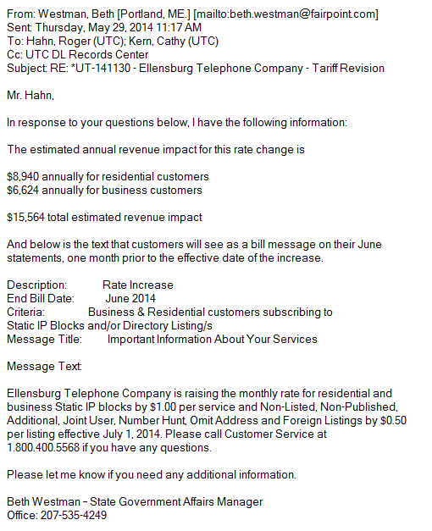
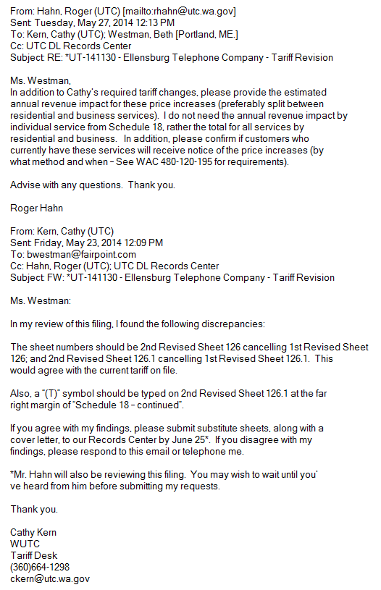
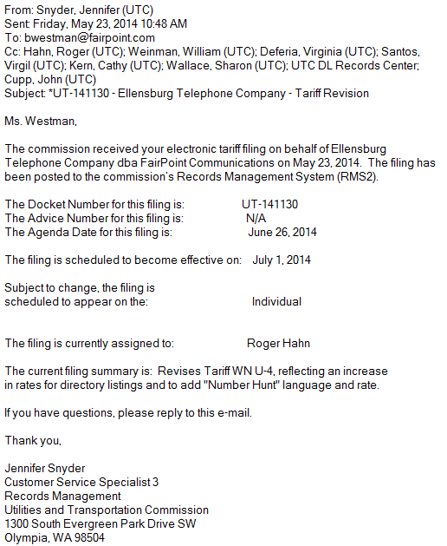

Attachment B
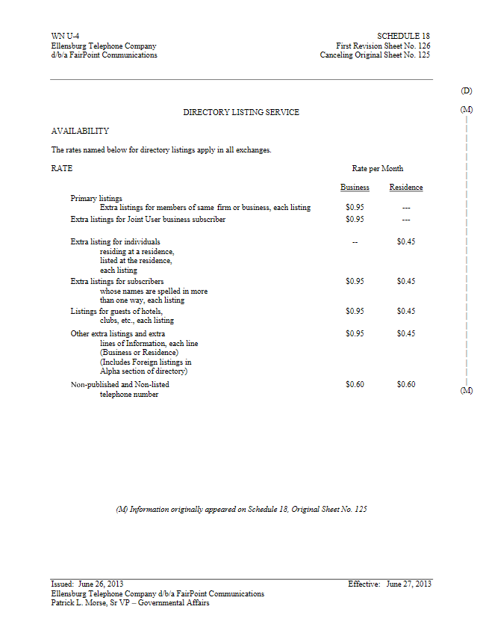

Attachment C
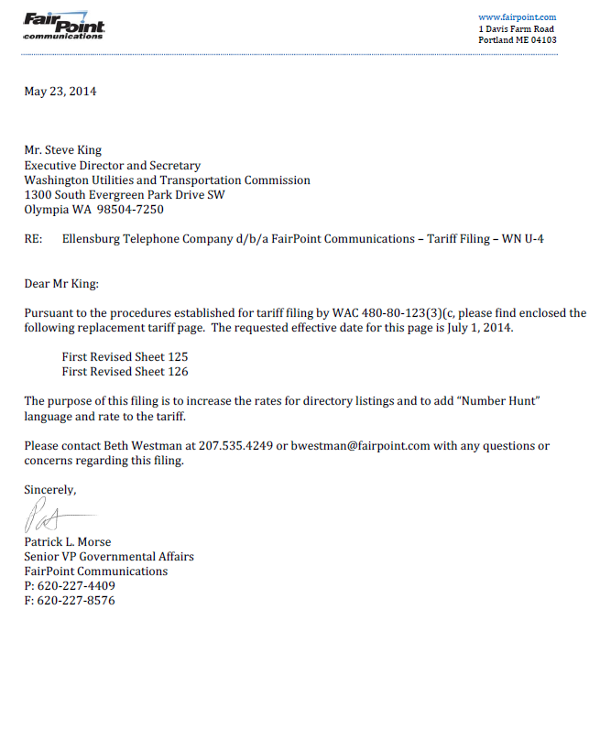
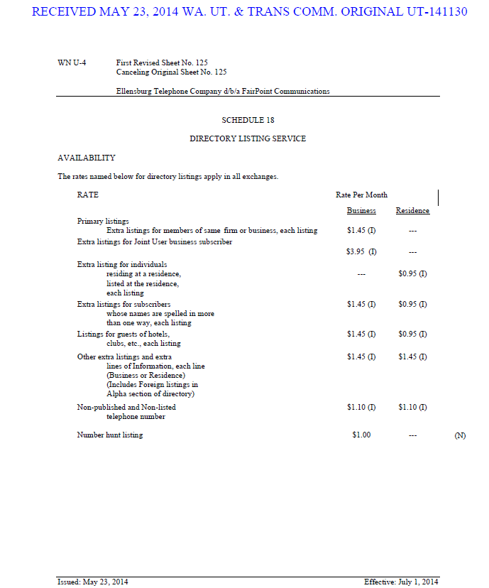

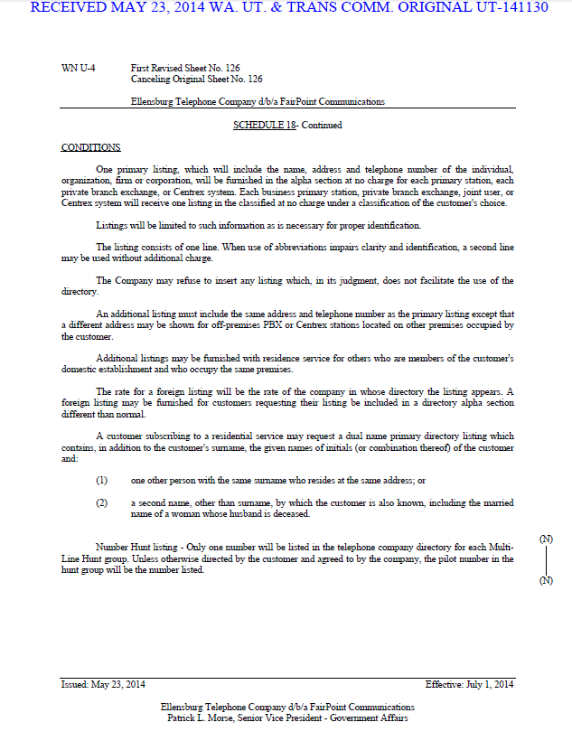

Attachment D

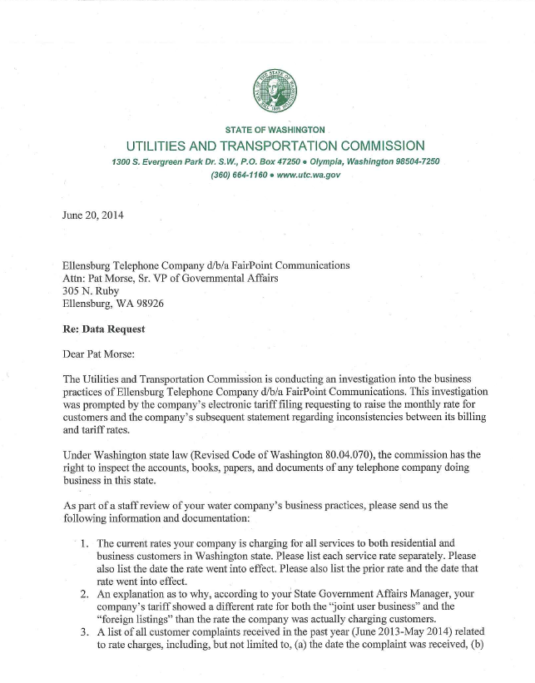

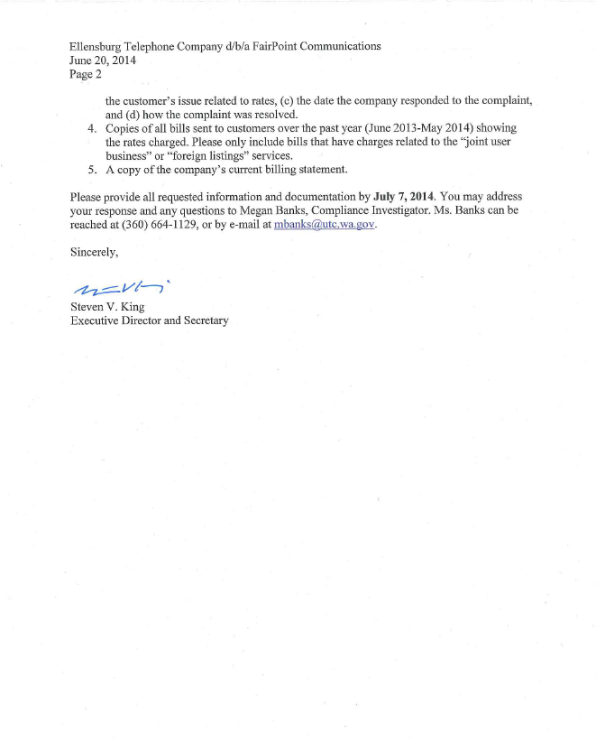
Attachment E

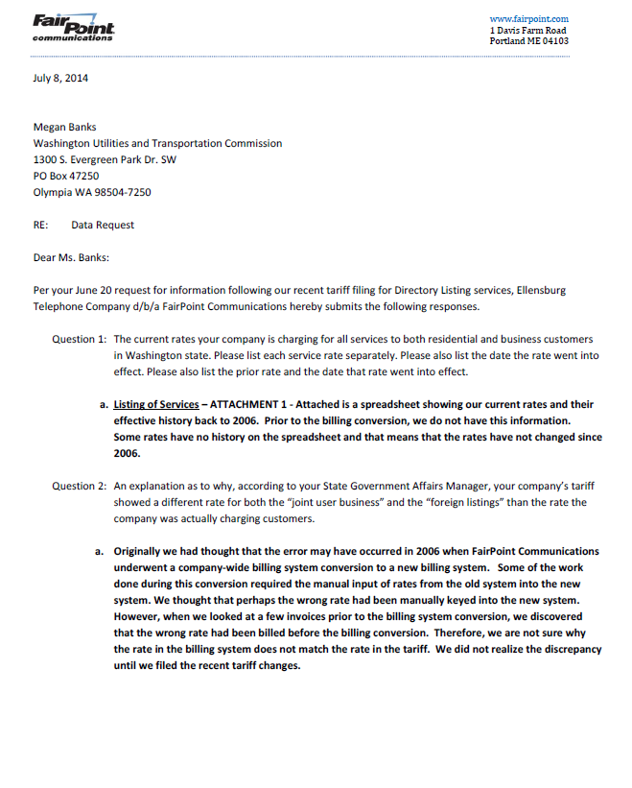
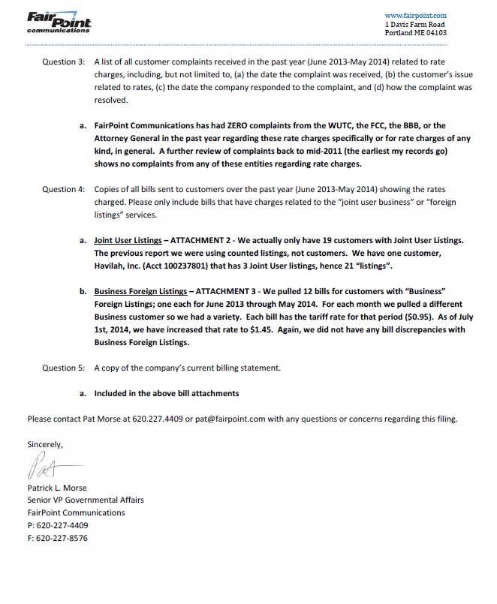

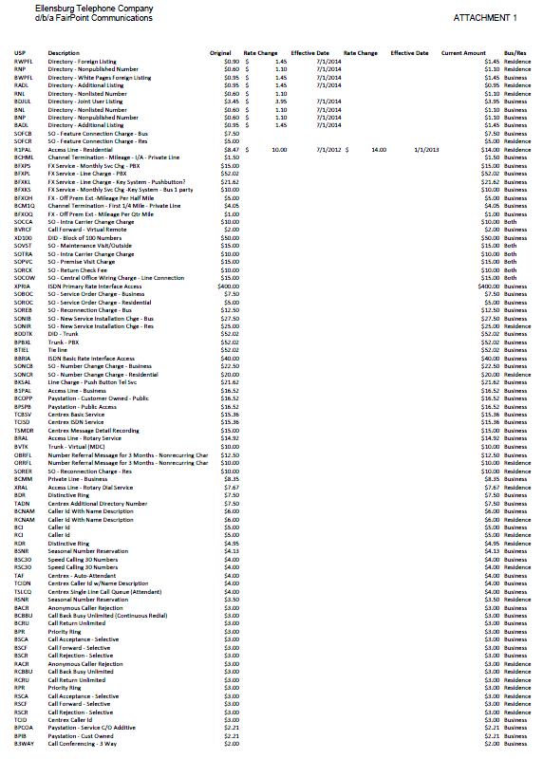
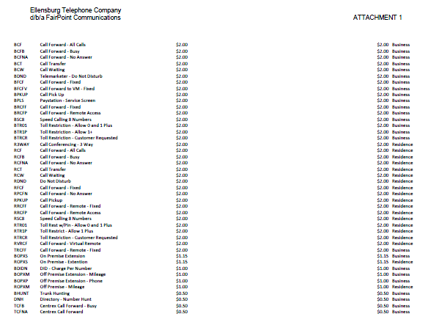

Attachment F
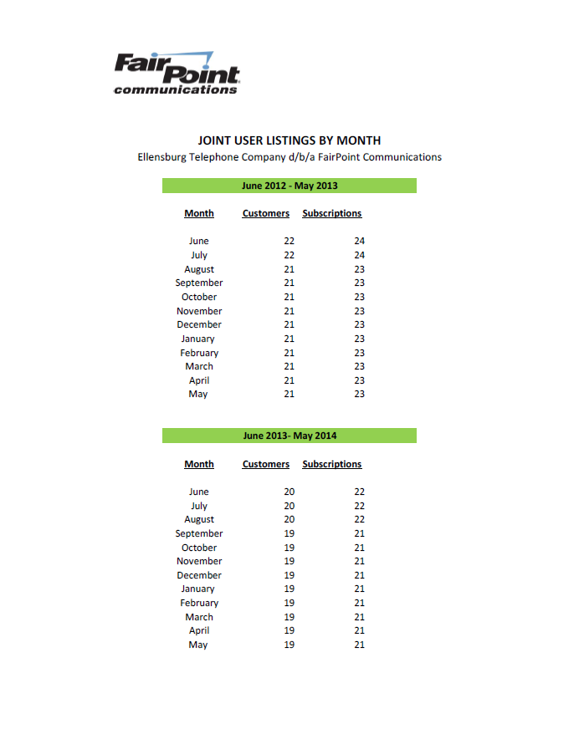

See attachment A for a copy of the email correspondence from May 23, 2014 through June 2, 2014, between FairPoint and staff regarding the proposed tariff revisions.
See attachment B for a copy of the company tariff in effect during the relevant time period, First revision sheet No. 126; Effective June 27, 2013.
RCW 4.16.100(2) allows the commission two years to file an action against the company from the time the cause of action accrues.
See attachment C for a copy of the June 23, 2014, cover letter and initial filing on behalf of FairPoint.
See attachment D for a copy of the data request sent to FairPoint on June 20, 2014.
See attachment E for a copy of FairPoint’s data request response, including “attachment 1” that provides the company’s current rates and history back to 2006.
See attachment F for a copy of FairPoint’s documentation of the number of customers who received joint user listing business subscriptions between June 2012, and May 2014.
See attachment A for a copy of the email correspondence from May 23, 2014 through June 2, 2014, between FairPoint and staff regarding the proposed tariff revisions.
RCW 81.04.405 allows the commission to assess an administrative penalty for any violation by a regulated company of a statute, rule, the company’s own tariff or an order of the commission.
RCW 81.04.380 allows the commission to assess a penalty of up to $1,000 for each violation after hearing.
RCW 81.04.230 allows the commission to order refunds for any service rendered in excess of the lawful rate in force at the time of such charge.

