ABOUT PSE

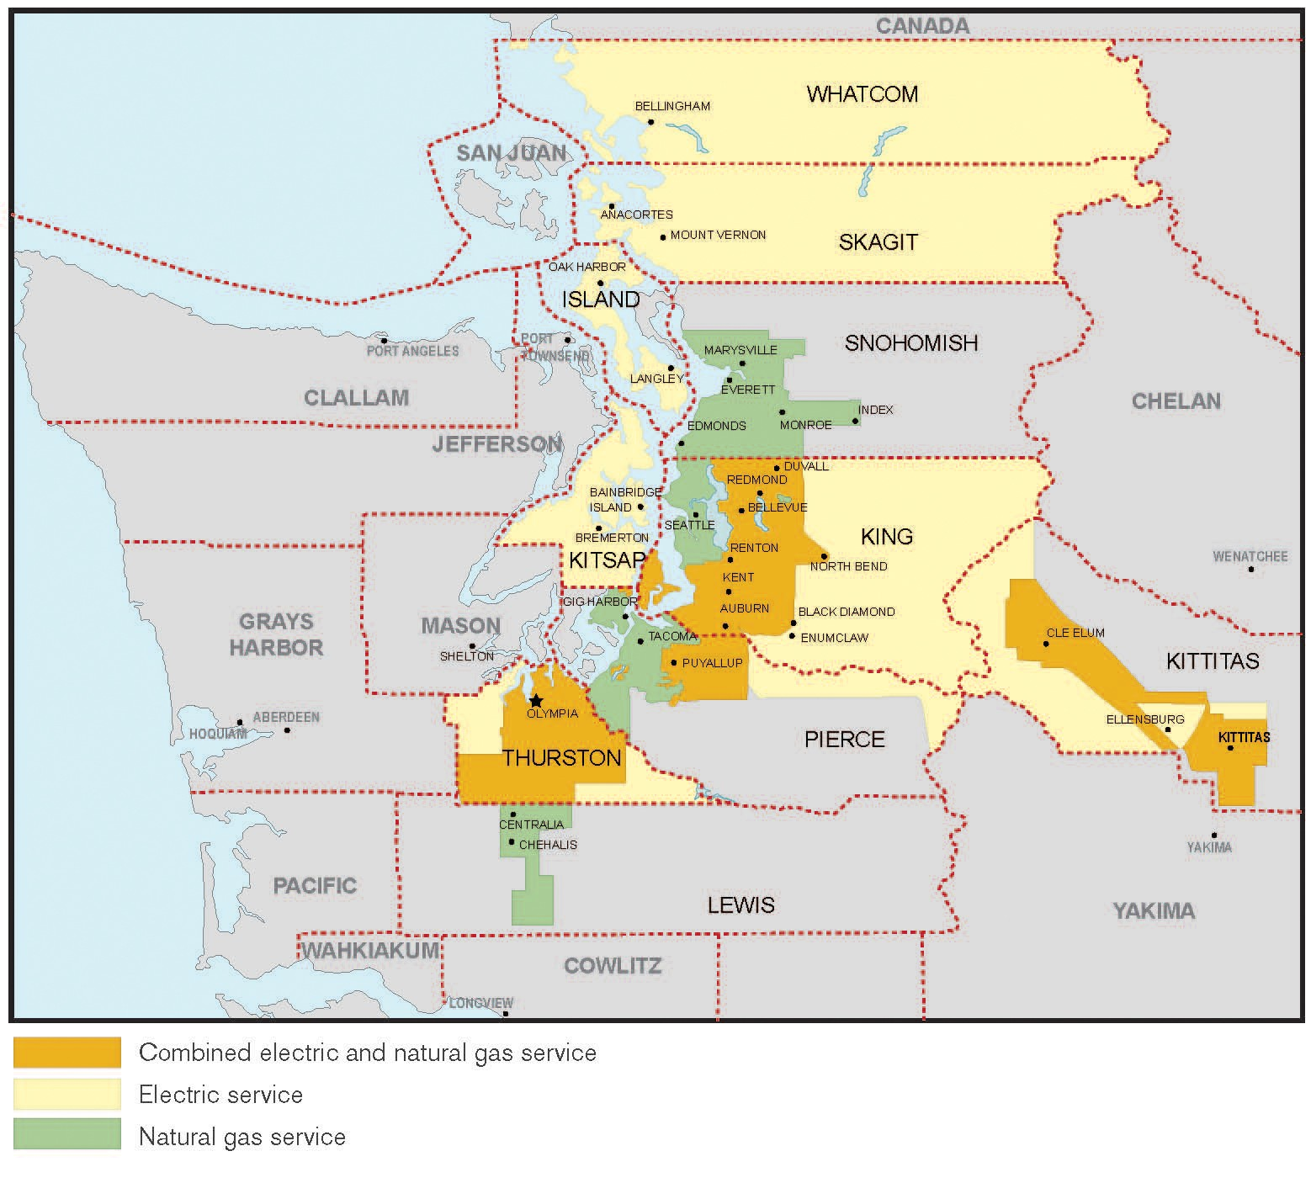
Puget Sound Energy is Washington State’s oldest local energy company, providing electric and natural gas service to homes and businesses primarily in the vibrant Puget Sound area. With a service area that covers more than 6,000 square miles and stretches from south Puget Sound to the Canadian border, and from central Washington's Kittitas Valley west to the Kitsap Peninsula, we serve more than 1.1 million electric customers and more than 790,000 natural gas customers in 10 counties.

