BEFORE THE WASHINGTON UTILITIES AND TRANSPORTATION COMMISSION

Motion to Reopen the Hearing Reconsideration of a final order 6-22-2017
WAC 480-07-830 WAC 480-07-850

- Commission should, as allowed by WAC 480-07-830, “reopen the record” to allow receipt of all evidence that is essential to a decision and evidence that was “unavailable and not reasonably discoverable” by the restricted time limits and wrongly allowing the assertion of collateral estopple. GO VIP contends that the WUTC is moving the goal posts. NOTICE OF OPPORTUNITY FOR HEARING. Go VIP, may request a hearing to contest the factual allegations set out in this notice. (WUTC’s Notice of Intent to Deny) or moving forward;
- Following standard procedure, after 3.5 years, grant GO VIP’s request for Charter and Excursion permits RCW 81.70.230(2) and let the WUTC professionals (Mathew Perkinson Director of Transportation Safety) vet the Insurance, Drug & Alcohol, Drivers files, maintenance files himself. Mr. Perkinson testified that he is trained in both Federal and state laws and besides the GO VIP team was the only person at TE-161295 other than GO VIP Team that understands the documents and procedures well enough to make a qualified decision.
Steve Valentinetti and the GO VIP staff believe WUTC’s Mathew Perkinson, Director of Transportation Safety and WUTC’s Sandi Yeomans Special Investigator both have integrity and will perform their job according to the state & federal laws.

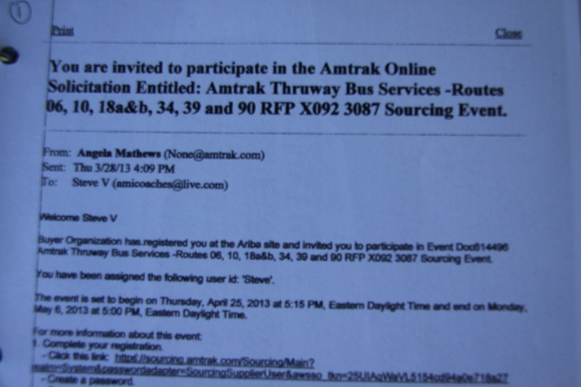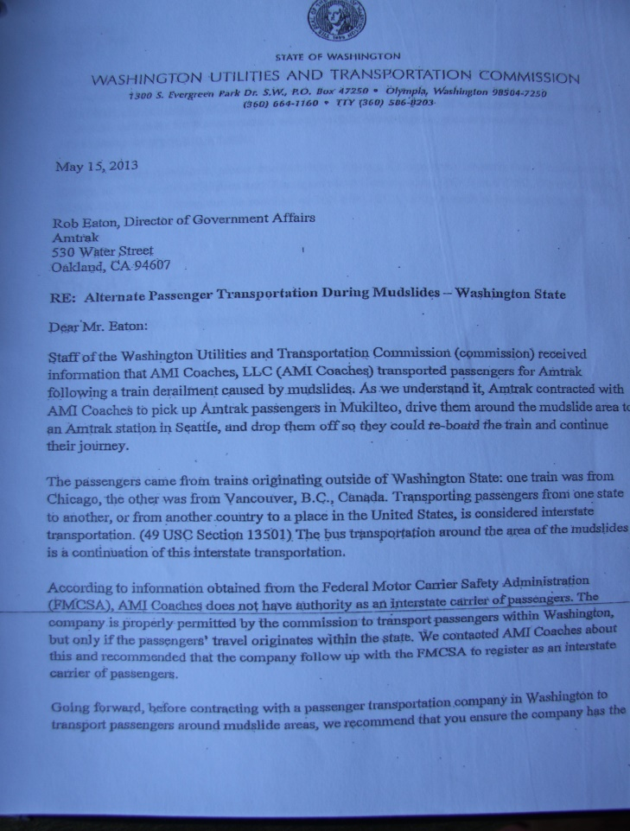
Above left Amtrak invitation to bid – Above right WUTC’s Pratt telling Amtrak AMI Coaches is not authorized as an Interstate carrier May 15th 2013

Below left FMCSA Decision granting AMI Coaches “MC-816340” authority February 25th 2013 – Official DOT letter April 1st 2013

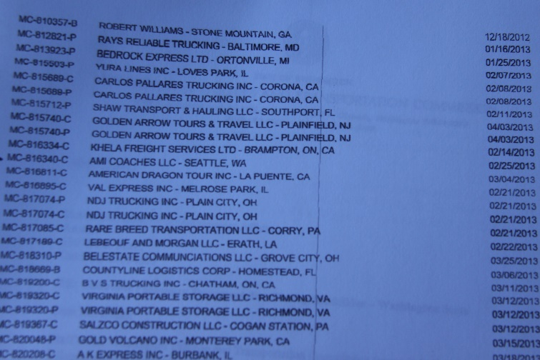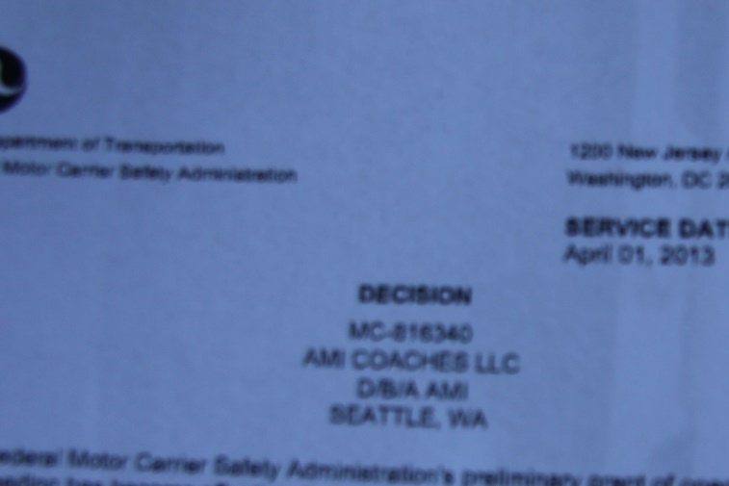

Steve Valentinetti makes the following accusations including the WUTC and the FMCSA are engaged in a continued cover-up because certain members of the WUTC are engaged in business interference concerning federal contracting as displayed by letters, e-mails, phone calls and direct race related interactions and retaliation consequently Steve Valentinetti’s companies were and are now held out of business and to a different standard by the DOT. Without every one of the DOT’s false violations being true in total (DOT’s Uniform Fine Assessment, UFA 4.0) it isn’t enough to shut down either company AMI Coaches or Airline Shuttle thus the DOT is unable to admit fault on any violation, regardless of the laws, undisputed evidence, professional testimony, case law. When confronted with undisputable evidence the DOT at all levels and without investigation openly denies it but is unable to prove their assessed violation. To be clear “nothing the DOT says can be trusted anymore, at any level” “It is critical that we now (as we always did) look up each law & regulation ourselves.
“if Go VIP had shown that it had not committed any regulatory violations, the commission should still deny the petition” – Assistant Attorney General Jeff Roberson

The undisputed Facts are
- AMI Coaches was fully authorized by both the WUTC & the FMCSA to pick up Amtrak accident involved passengers April 8th 2013 that resulted in a $25,000 fine and AMI Coaches being put out of business without review.
- May 15th 2013 WUTC’s David Pratt wrote a letter, e-mailed and called to Amtrak’s office during vetting of X092 transportation contract stating “AMI Coaches does not have authority to operate” causing AMI Coaches to not be considered for the multi-million dollar contract.
- May 17th 2013 Valentinetti contracted transportation lawyers
- May 20th 2013 WUTC’s John Foster poses as a Federal Investigator in an attempt to frighten and threaten perceived foreign business owner Valentinetti. There is a confrontation after AMI/AS staff was threatened of losing visas up to family’s being deported.
- WUTC’s Foster finds 114 violations (in conflict with WUTC’s Ray Gardner 7 months earlier) but the WUTC doesn’t move forward with the violations as they know they are false and just a threat against Valentinetti for applying for it’s 2nd federal contract and filing a civil rights claim with the WUTC. Instead of investigating the claims of discrimination, they retaliate by calling the FMCSA who adopts WUTC Fosters findings as being found to include “No Authority to Operate”
- December 2013 the FMCSA shuts down AMI Coaches and doesn’t allow a hearing as per law.
- Valentinetti demands a hearing per APA Administrative procedure Act but knowing the violations are false and the FMCSA will now look foolish trying to protect their friends (WUTC) they disallow a hearing and retaliate against Valentinetti’s unregulated hotel van operation. (without authority but shut down anyway to cause legal costs and time and loss of reputation)
- 3.5 years later without a hearing for either AMI Coaches or Airline Shuttle Valentinetti completes the application for GO VIP moving on in life but the corrupt DOT attacks again in trying to block GO VIP.
- The DOT has gone directly to our customers, insurance companies, contractors, drivers, other bus companies spreading slanderous lies and insinuations all in an attempt to protect the WUTC from being exposed as corrupt and racist.

“Mr. Valentinetti did not offer any documentary evidence for admission into the record. However, Mr. Valentinetti provided the presiding officer an “evidence book,” Valentinetti offered undisputable evidence that neither AAG Roberson or WUTC’s Perkinson disputed while under oath.
- “Valentinetti alleges that the denial of Go VIP’s application resulted from a discriminatory conspiracy against him and employees of his companies. Staff treats these allegations with the utmost seriousness and asks the Commission to reject any request for relief by Mr. Valentinetti”. Not serious enough to investigate the claims, only serious enough to deny the claims, deny investigating the claims then retaliate by keeping Valentinetti out of business and continuing discrimination by Not Allowing a Hearing.
- “evidence often does not support its argument that AMI Coaches or Airline Shuttle did not commit the alleged violation” DOT first states GO VIP didn’t present any evidence then makes the statement “evidence often does not support its argument”. It is becoming more apparent that while Pearson and Roberson are smart people but they don’t know or understand transportation law. It is the DOT that doesn’t have evidence to support their fictional findings so they ask the Commission to disallow a hearing.

- Collateral Estoppel does not apply as the violations (regardless of what Roberson writes while not under oath) have not been ever “fully and fairly litigated” in any hearing or court, only covered up and decided behind closed doors without evidence, testimony, witnesses, industry professionals.

- Rules of Civil Procedure do not apply to a 3 hour time limit “Brief informal Hearing” where Mr. Valentinetti was stopped from presenting all evidence or from even making a closing statement.

- Statements from AAG Roberson can’t be trusted as his office has a different motive. Please take Notice Mr. Roberson always third persons himself out of liability knowing the statement to be false by saying “Staff Found” “ALJ Pearson correctly found” “Mathew Perkinson stated”.
(See 2014/15 interactions between AG’s office & SV below)

- Evidence was presented and disappeared and is not acknowledged from the record at TE-161295 “WUTC Hearing Valentinetti’s Explanation of Evidence Book Submitted & Closing Statement” AAG Roberson acknowledges the evidence that is now missing from the file. STAFF’S ANSWER TO GO VIP

- Jurisdiction VS Operating Authority “Staff noted that the Washington Administrative Code (WAC) incorporates provisions from the Code of Federal Regulations” (CFR’s) admitted by AAG Roberson in STAFF’S ANSWER TO GO VIP Mr. Valentinetti contends the words “Jurisdiction and Authority” have 2 different legal meanings. (see 49 USC 13506 below) “WAC 480-30-221 adopts by reference a number of the federal regulations set out in Title 49 of the Code of Federal Regulations”
“During the beginning of the review and up until the time the review was being finished, the carrier repeatedly cited a WAC 480-30-011, claiming the company was exempt and not regulated by FMCSA. It was explained several times that the only exemption the carrier received was for operating authority when conducting flight crew transportation within 25 miles of the airport” That’s why we are here today, we disagree on the common words of the law, the exact reason for a judicial system where 2 opposing side present their views. Airline Shuttle only moved flight crew 3.5 miles to the layover hotel, for the hotel, clearly exempt WUTC & FMCSA jurisdiction. (See below)
49 USC 13506(3) - Neither the Secretary nor the Board has jurisdiction (3) a motor vehicle owned or operated by or for a hotel. Payment to Airline Shuttle during the last 12 months before the investigation came only from the hotel.

WAC 480-30-011(6)(9)(11) Exemptions – (6) Persons owning, operating, controlling, or managing taxi cabs, hotel buses, or school buses. (9) Transporting transient air flight crew or in-transit airline passengers between an airport and temporary hotel accommodations. (11) Transporting passengers who have had or will have had a prior or subsequent movement by air.
The fact that the DOT tries to imply these above clearly written laws do not apply to Airline Shuttle is Differential Treatment alone.
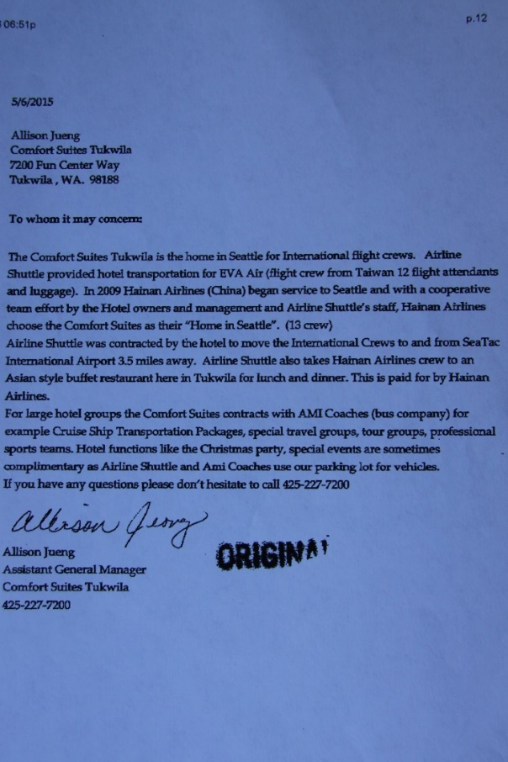
- Case Law – There is NO CASE LAW History that supports or even resembles the FMCSA or WUTC having jurisdiction over a non CDL, 14 passenger hotel van because the law clearly states no jurisdiction.

- Commercial Motor Vehicle – Airline Shuttle’s vehicle is a 14 passenger hotel van and not a CMV, no CDL requirement and no drug & alcohol required by any Federal legal description.
49 CFR 390.5/3
49 CFR 382.107 = 26,000 or 16 passengers
49 CFR 383.5 = 26,000 or 16 passengers

Does the FMCSA have jurisdiction over a 14 passenger hotel van?
”NO”, Admitted by FMCSA’s Ray Gassaway - 49 USC 13506(3)
Jeffery James FMCSA Division Administrator Washington State, “I don’t know”
Nolan Rice FMCSA Investigator, “I don’t know”
Does WUTC have jurisdiction over hotel vans? NO, Admitted at TE-161295 by WUTC’s Motor Carrier Safety Supervisor Mathew Perkinson -
WAC 480-30-011
s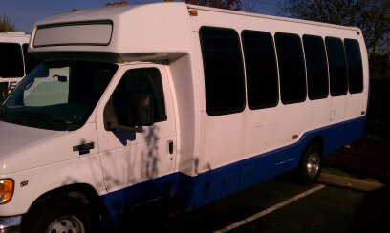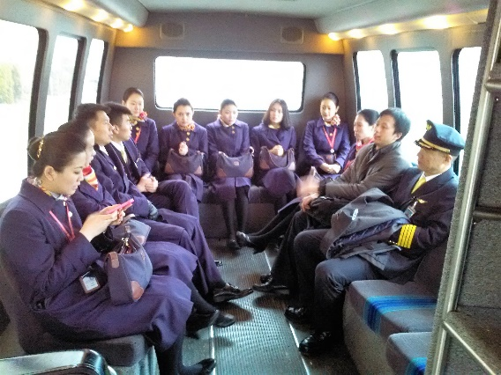
Above Airline Shuttles 14 passenger van with Hainan Airline Flight crew
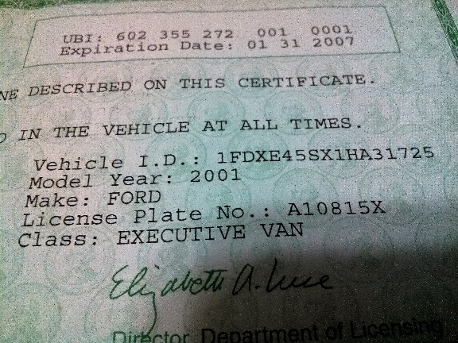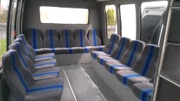
Above - Airline Shuttles Limousine License and interior photo of its 14 passenger hotel van (Vin 1725).
Below – Washington State answering an e-mail from the FMCSA stating Vin #1725, plate # B19199X is not a CMV by seat count or by weight
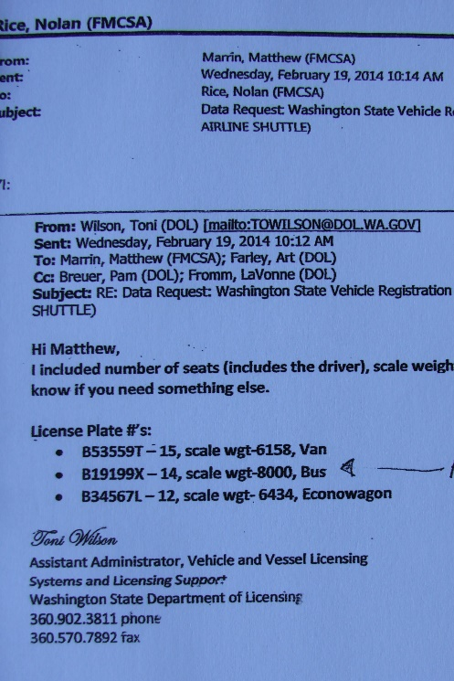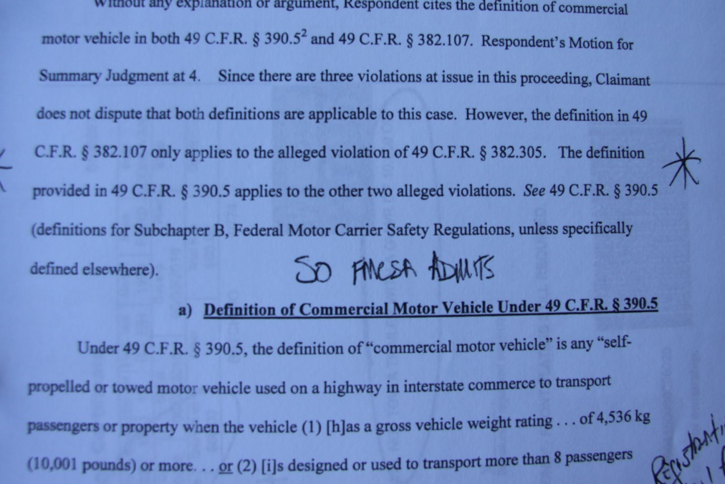
Above – Washington State says 14 passenger, 8000 gvw = Not a Commercial Motor Vehicle. “Unless specifically defined elsewhere”
(see 49 CFR 390.3)

- AAG Roberson states “and a record of contradictory statements and unpersuasive evidence”– No examples because it’s not true. Just a demeaning meritless false statement. This is a direct continued personal attack against victim Steve Valentinetti trying to get a hearing for 3+ years to challenge falsely assessed violations in retaliation for filing civil rights claims against the WUTC & FMCSA. Neither agency has investigated the claims or allowed a hearing for the possibility the violations are false in fact the DOT knowingly refuse, mishandle and discard the undeniable evidence that the violations are false.
Example #1 – AMI Coaches Operating Authority decided February 25th 2013 (photo below), (Decisions and Notices released) WUTC’s Pratts letter May 15th 2013 stating “Not Authorized” (see evidence TE-161295)

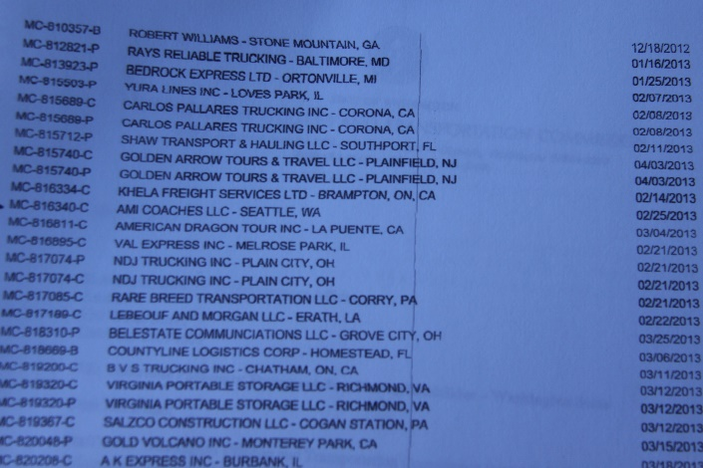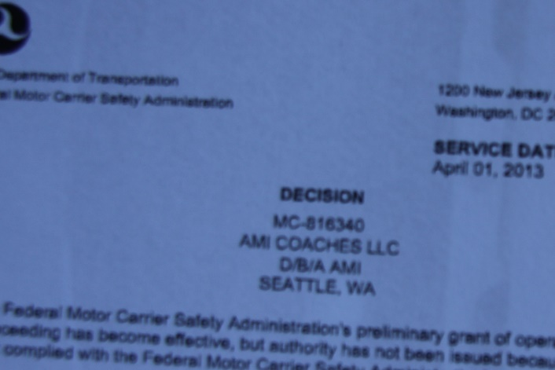

Example #2 – AMI Coaches & Airline Shuttle 3 easily & already proven false Insurance violations – The DOT violations states No Insurance, Not the correct amount & No proof of insurance. Valentinetti provided the Policy, Certificate, Cab Card & MCS-90b and also live testimony by broker owner Doug Ferguson who stated AMI Coaches, Airline Shuttle and separately Steve Valentinetti personally (extra 5 million) had the correct amount, required proof & no lapse in the policy. Steve Valentinetti & staff provided these documents for DOT investigators during the investigations and in 7 Corrective Action Plans for AMI Coaches & 6 Corrective Action Plans for Airline Shuttle over a 3 year period. AAG Roberson’s false statement“no evidence at hearing shows that AMI Coaches maintained proof of insurance” “Mr. Ferguson testified that all of Mr. Valentinetti’s companies have maintained required levels of insurance at all times”, Roberson contradicts himself again.
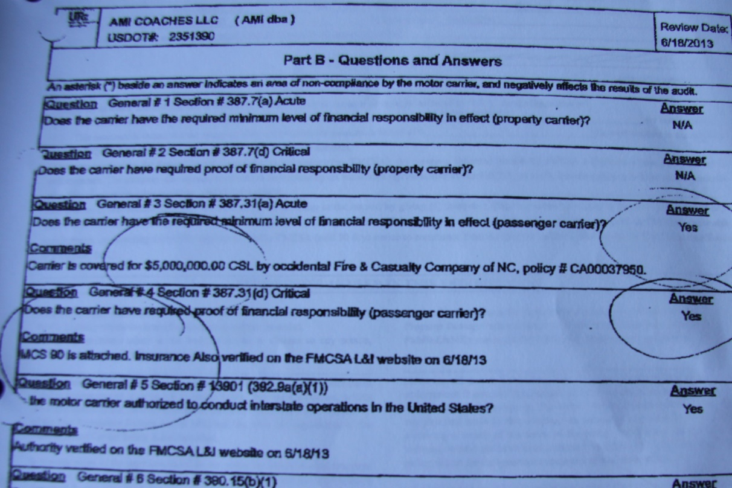
Above WUTC’s John Foster answers insurance question #4, Does the carrier have required proof of financial responsibility – YES
MCS 90 is attached. Insurance also verified on the FMCSA website 6/18/2013. Doug Ferguson in live testimony stated that AMI Coaches always had insurance, the correct amount, proof of, no lapse of insurance and paid their bills on time.
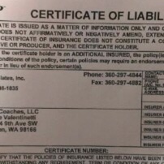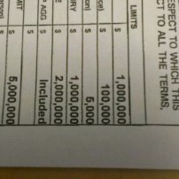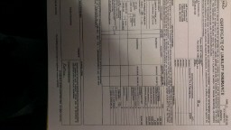
AMI Coaches Cert of Liability and MCS-90b for $5 million, above
Steve Valentinetti Cert of Liability and MCS-90b for $5 million, above
AMI Coaches & Steve Valentinetti Cab Card below
Airline Shuttle Cert of Liability for $1.5 million, below
British Columbia $5 Million Insurance – AMI Coaches
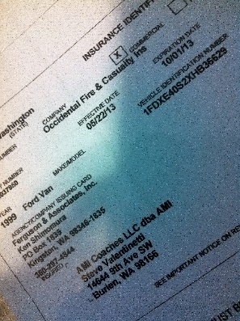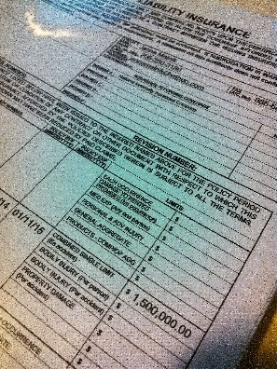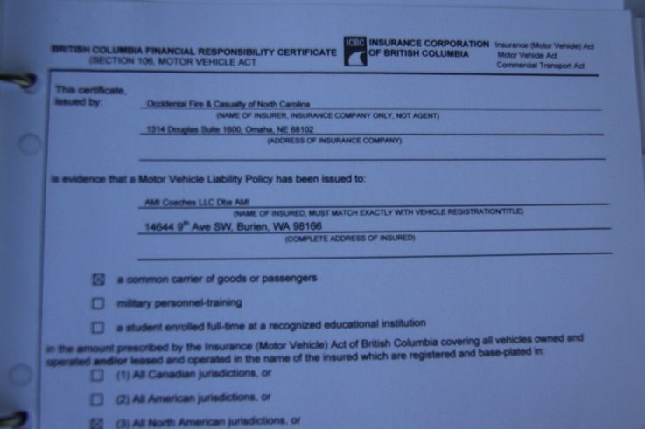

Example #3 - No Drug & Alcohol for either AMI or Airline Shuttle both false easily proven wrong.
AAG Roberson’s without investigation false statement “or that either AMI Coaches or Airline Shuttle had a random drug testing regime on the date of the violations” (evidence does not show a random drug testing program at the time of violation); Even if the violations were true, and it’s not, obviously it was corrected well before any investigation. (see dates)
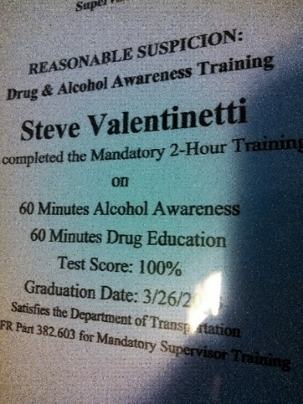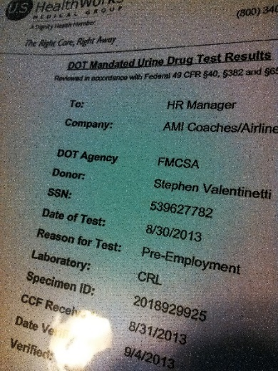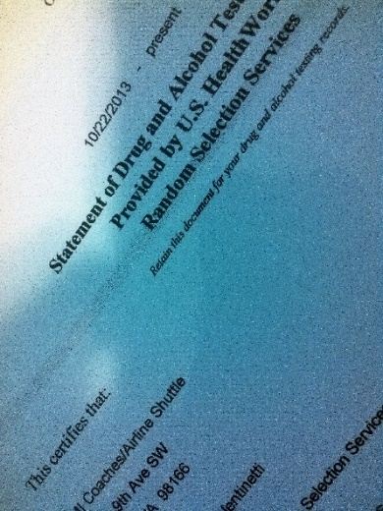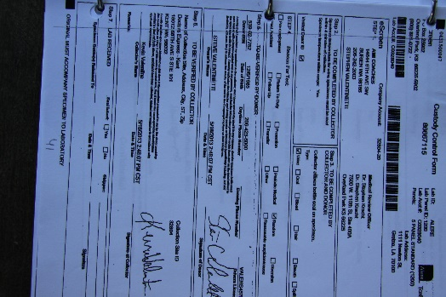
Above - SV D & A Training Cert 100%
SV AMI & Airline Shuttle Pre-Employment pass 8-30-2013
Random Selection pool added Airline Shuttle 10-22-2013
SV Custody and Control Form
AMI Coaches or Airline Shuttle or GO VIP employees have never failed a Drug & Alcohol test
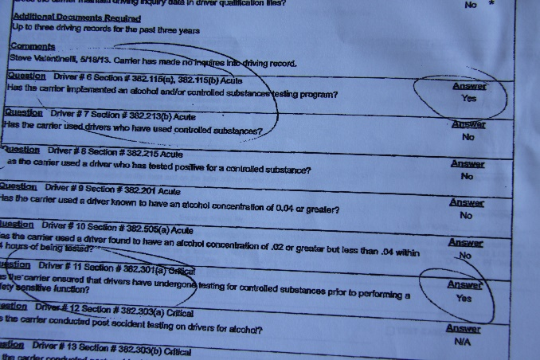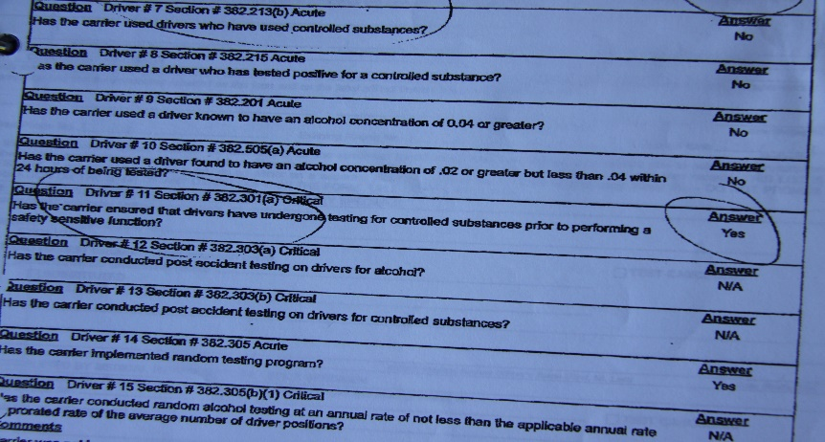
See above questions #6, #7, #11, #14
- Civil Rights investigation – Attorney General’s office is involved in the cover up and are trying to stop any chance of SV bringing discrimination allegations to a hearing as they already know the allegations are true and the Attorney General’s Office discarded Valentinetti’s claims without investigation to protect office mate David Pratt & the WUTC. AAG Roberson’s office state they did an investigation and Valentinetti’s claims are meritless however they never talked with anyone on the AMI/Airline Shuttle, Valentinetti side and as of today are unable to produce the results of the phantom investigation.
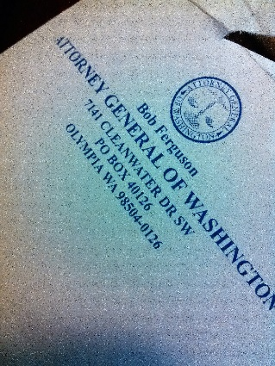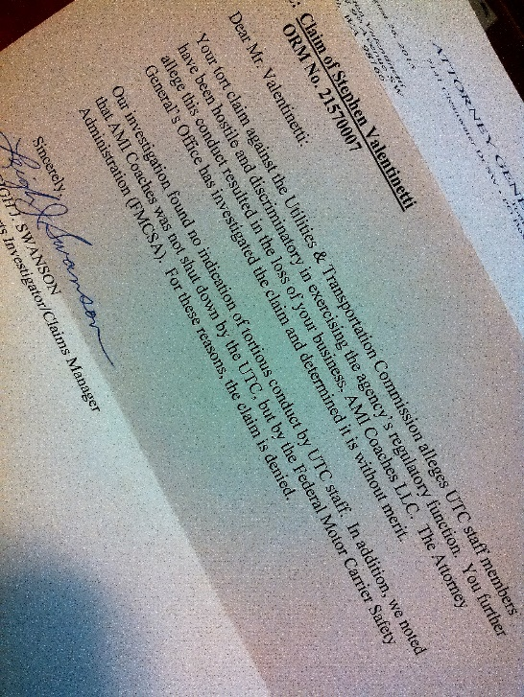
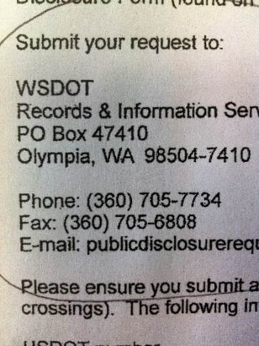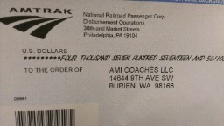
- AG Roberson evokes Collateral Estoppel – “Staff objected, arguing that collateral estoppel prevented Go VIP from doing so. The ALJ sustained that objection”. “An administrative tribunal’s order may have a preclusive effect on later proceedings”

- The ALJ properly determined that Go VIP is not fit for authority while prohibiting Go VIP from arguing that it had not committed the violations found by FMCSA If a challenge is allowed it will show the violations were false and a product of retaliation. Roberson uses the word “found” loosely as the violations were assessed in retaliation by WUTC’s John Foster posing as a Federal Investigator to scare what he believed as foreigners.
Collateral Estoppel doesn’t apply in this case for 3 reasons.
1) These violations have never been litigated “full & fair litigation” at any hearing or court (litigated is a legal term for CE)
2) CE doesn’t apply for a Brief Hearing
3) The WUTC asked SV to dispute the violations in its “Notice of Intent to Deny Application” not to show evidence of drivers files, maintenance files, drug & Alcohol testing and insurance (already shown)
TE-161295 “These allegations, if not satisfactorily rebutted, support findings that Go VIP LLC is not fit to operate as a charter or excursion carrier”. GO VIP and Valentinetti were limited to 3 total hours including breaks and answering the states questions. We were not allowed time to produce GO VIP documents (Driver files, maintenance files, random D & A Pool, Insurance etc.)
- AAG Roberson is moving the goal posts trying to help Pratt in his original goal to stop Valentinetti at any cost from obtaining a second Federal Transportation contract

- DOT/WUTC refuses to acknowledge their own investigators Compliance Reviews and documents when they are not in the DOT’s favor. Documents show that in November 2012, WUTC’s Investigator Ray Gardner checked and approved AMI Coaches 5 million insurance and Drug & Alcohol testing program, drivers files, maintenance files, DVIR’s etc. Documents show that in June 2013, WUTC’s Investigator John Foster also checked and approved AMI Coaches 5 million insurance and Drug & Alcohol testing program.

- DOT is trying to stop non-white people from operating successful transportation companies – 2001, 2005, 2013, 2014 (see record on these dates)

- Staff reasoned that Valentinetti (Non-white people) have a history of Non Compliance is what the DOT is saying because AMI Coaches, Airline Shuttle or GO VIP has never received a violation in its 24 year history until 5 days after the WUTC / David Pratt incident.

- AAG Roberson states Valentinetti “Can’t be trusted” – is that just a meritless opinion by the WUTC and Roberson or is it the white black thing again?

- “AMI Coaches and Airline Shuttle had the opportunity to appeal the results of the safety audits and the resulting unsatisfactory safety ratings”. Not true, we were never given the opportunity just like now AAG Roberson is attempting to stop a hearing.

- AAG Roberson makes knowingly false statements like “noting that AMI Coaches never challenged the finding of violations or the unsatisfactory safety rating” The truth is the DOT in their cover up wouldn’t allow a hearing to challenge the violations. AMI & Airline Shuttles / Steve Valentinetti’s APA rights have been violated and will be again if not allowed a hearing by the WUTC. We asked for the first hearing for Airline Shuttle 4-7-2014 and we are asking for an unrestricted hearing now. If the WUTC prevails at the hearing it would be over but to continue to suppress the right for a hearing will bring continued accusations of intentional cover-up and discrimination.

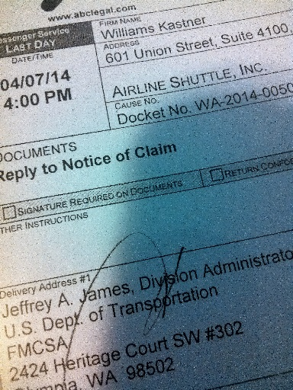
- “Valentinetti has been told his company is under federal jurisdiction” – We don’t believe anything the self-serving DOT says now. The DOT will obviously say anything to get out of trouble for false violations leading to the shut-down of Airline Shuttle without jurisdiction. We read, investigate and study ourselves and follow the law.
UTC Executive Director Steven Kings letter stating May 26th 2017 the FMCSA has issued regulatory guidance that it considers “prearranged travel” to or from airports to be interstate travel requiring interstate operating authority.
- “A pattern of frequent and serious violations” – After 24 years violation, complaint and accident free, AMI Coaches / Airline Shuttle and Valentinetti’s trouble began 5 days after WUTC Pratt’s “Business Interuption Letter” !!!!

- “The recency and severity of those violations alone justifies the denial Go VIP’s application” Is that a law or is Roberson loading the future record with meritless statements like the one above? The DOT has been unable to prove any of the violations against Valentinetti’s companies. The worst violations are “operating without authority” easily and already proved wrong, “No insurance” proven false with evidence and unchallenged live testimony at TE-161295 and for the past 3.5 years. “no random drug & alcohol program” also easily and already proved wrong.
- The ALJ found Go VIP’s denials lacked credibility Did Valentinetti make a false statement or does the DOT just not like what they are hearing.
- Staff also disputes Mr. Valentinetti’s claim that he has never been given an opportunity to the address the violations found by the FMCSA Ok, when was the hearing and the court date? AAG Roberson 3rd persons himself out of the statement again.
- the ALJ noted in Order 01, Mr. Valentinetti admitted at hearing that AMI Coaches and Airline Shuttle had committed a significant number of the violations. Again ALJ Pearson and Roberson obviously doesn’t understand the transportation laws. Roberson was unable to challenge testimony in TE-161295 because Valentinetti knows the laws and could have provided the evidence but without a challenge we didn’t provide the evidence.
- “Go VIP’s evidence often does not support its argument that AMI Coaches or Airline Shuttle did not commit the alleged violation” This indirect false statement has no examples, just a meritless statement trying to stop Valentinetti from getting a hearing. Roberson admits Valentinetti presented evidence in this statement but the evidence is now missing from the hearing.
- “companies owned and operated by Mr. Valentinetti have a history of violating safety regulations Mr. Valentinetti’s companies operated at a high risk of accident”. (after 24 years accident free the false history started 5 days after WUTC’s Pratt’s business interuption letter trying to block AMI Coaches from obtaining its 2nd Amtrak contract.
- Mr. Valentinetti’s continuing denials that AMI Coaches and Airline Shuttle committed any violations indicate that Go VIP would not operate any differently than those companies
Great, 24 more years accident free.
- Similarly, Go VIP claims that Staff witness Mat Perkinson testified that Go VIP was exempt from FMCSA jurisdiction. He did not. That’s correct, WUTC’s Mathew Perkinson testified that Airline Shuttle is exempt from WUTC & FMCSA jurisdiction.
- “collaterally estopping Go VIP from contesting the violations amounted to legal error” AAG Roberson admits CE doesn’t apply here.
- or if Go VIP had shown that it had not committed any regulatory violations, it should still deny the petition Direct and blatant discrimination and retaliation by the WUTC

- Mr. Valentinetti also refuses to accept that Airline Shuttle’s operations were subject to FMCSA oversight despite repeatedly being advised that Airline Shuttle was required to follow federal motor carrier safety regulations Valentinetti follows the laws not the advice of dishonest, racist, corrupt regulators that are now in trouble because they are caught discriminating.
WAC 480-30-011 & 49 USC 13506(3)

- it appears Mr. Valentinetti incorporated Go VIP to conceal a history of noncompliance and avoid compliance with orders forbidding AMI Coaches and Airline Shuttle from operating (Same name , address, number, & both Airline Shuttle and AMI Coaches were incorporated) (it appears that the DOT is continuing to use derogatory terms trying to hold 24 year accident / violation free Mr. Valentinetti out of business instead of doing their jobs and research into understanding transportation and civil rights laws) AMI Coaches was falsely put “Out of Service” December 29th 2013 well over 3 years as asked on the application

- Valentinetti alleges that the denial of Go VIP’s application resulted from a discriminatory conspiracy against him and employees of his companies. Staff treats these allegations with the utmost seriousness and asks the Commission to reject any request for relief by Mr. Valentinetti. Not serious enough to investigate the claims, only serious enough to deny the claims then continue to retaliate by keeping Valentinetti out of business and Not Allowing a Hearing.
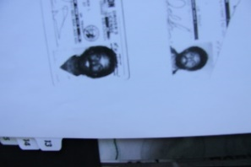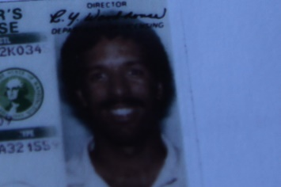
AMI Coaches & Airline Shuttle past office staff

- “Staff strenuously denies ever discriminating against Mr. Valentinetti or his employees” DOT staff is discriminating today 3.5 years later by not accepting Valentinetti’s/ Go VIP’s proof of 5 million insurance, Go VIP’s proof of a Drug & Alcohol program, proof of drivers and maintenance files, company policy etc. or evidence presented at TE-161295 showing Operating Authority.
- AAG’s Office hides investigation results – Where is the AG’s Discrimination Investigation Report? They didn’t do an investigation and now are trying to cover it up.
- The DOT changes WAC’s and CFR’s numbers and spelling by Steve Valentinetti so other people following can’t understand
- The DOT falsely states that Steve Valentinetti admitted the violations
- No driver or office staff for AMI Coaches or Airline Shuttle has ever tested positive for substance testing.
- The DOT changes titles, dates then states the document wasn’t timely
- Refuses undeniable evidence including the DOT’s own documents regarding “Authority to Operate” and investigations with contradicting findings that put SV out of business then they ask to block the hearing so they won’t be exposed.
“Insurance”
“Drug & Alcohol”
“Authority”
- Blocks evidence, testimony and witnesses
- Threatens office staff, customers
- Threatens contractors
- Tries to stop Civil Rights investigations (L.H)
- Attempts to exhaust Valentinetti resources with time
- Invents new reasons why not to issue Charter and Excursion to GO VIP

- If the Commission approves Go VIP’s application, it sends a signal that any company unsatisfied with a federal revocation of its operating authority should seek state operating authority. It sends a signal to make sure the violations assessed are valid and can be proved before you shut a company down, also don’t assess false violations because of color, race or trying to control Federal Contracts. The corrupt DOT did it 2 times to Mr. Valentinetti first with AMI Coaches then in retaliation for trying to dispute the false violations and for making civil rights claims. It sends a signal to allow hearings to vet claims as per law.
- Other false violations include bus markings & DVIR’s, annual inspections – The DOT has no answers for the obviously false violations thinking we will never have to prove the violations because if Valentinetti complains we will deport him.
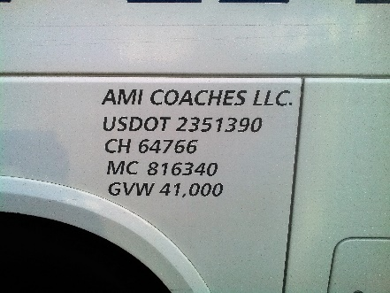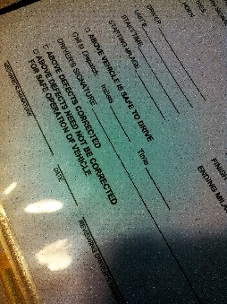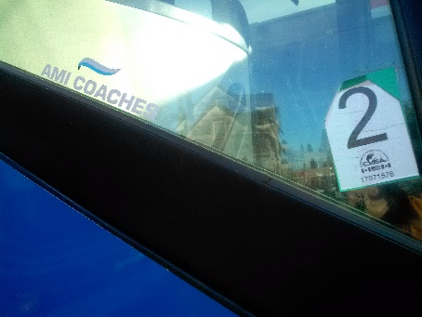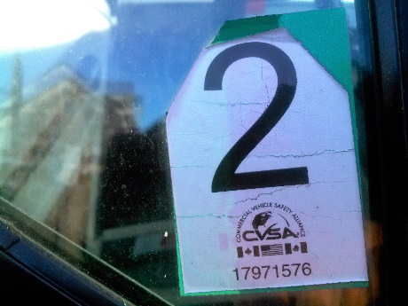
Bus markings, DVIR, Annual Inspection tags
Mr. Valentinetti made numerous demeaning statements about both Commission and FMCSA Staff, as follows” “Mr. Valentinetti’s statements demonstrate a lack of candor, a fundamental inability to accept responsibility for his conduct, a blatant disregard for safety regulations”,
- The history of Valentinetti’s 24 year accident free companies is unmatched in the country. The only problem is Valentinetti and team is we are not “White”
- The DOT attacked 2 companies of Valentinetti not 1. Airline Shuttle (the 2nd company) is a non CMV, non CDL, 14 passenger hotel van. Now the DOT is trying to find reasons why they have jurisdiction over a hotel van when the law and case history clearly states they don’t. The only way out for the DOT is “stall for 3+ years without allowing a hearing hoping Valentinetti because of age, dies, runs out of money etc.
- We continue to believe the DOT is corupt as instead of having or allowing hearing to vet the allagations made by the DOT, they hide stateing there is no reason for a hearing. Let’s have a hearing. The DOT could embarras Valentinetti and prove they are not racist based organization…..or maybe not!
- AMI & Airline Shuttle staff are educated, honest good people. The DOT’s staff are dishonest, racist, corupt and they know it so we don’t understand why their feelings would be hurt by any derogatory statements made by anyone in the transportation industry. That is what happens when you lie and get caught.
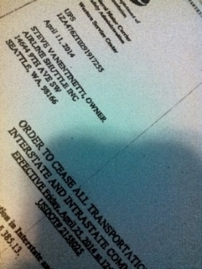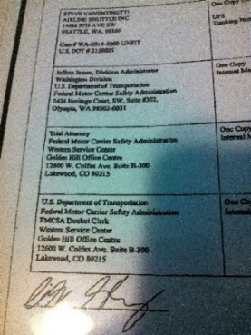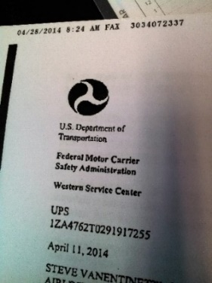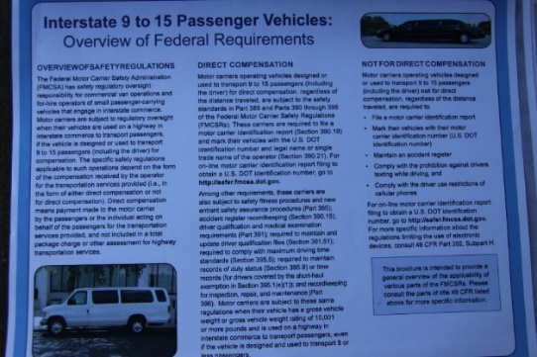
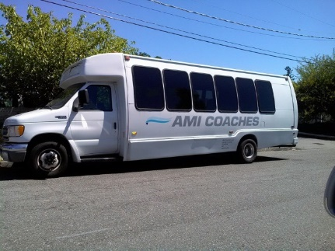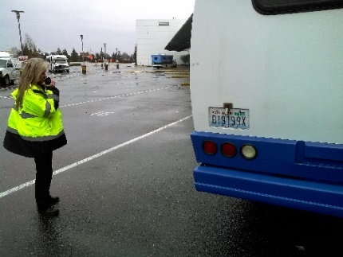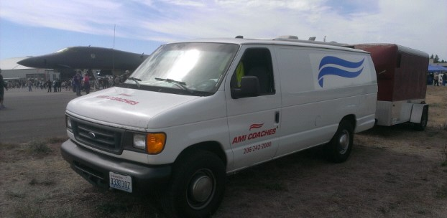
AMI Coaches 24 Passenger bus Airline Shuttles 14 passenger van Valentinetti’s Emergency Service Vehicle
Ski Season 2013/14 Valentinetti’s Emergency Service Vehicle spent 5 days a week on Snoqualimie Pass chaining up AMI Coaches ski school buses so our drivers could focus on safe driving in the snow. We then assisting other bus companies and trucks free of charge while waiting for our buses to return after school.
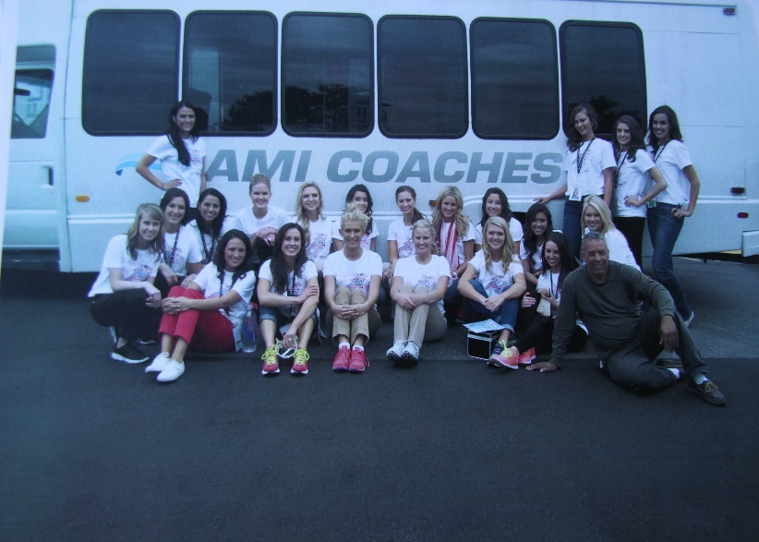
Valentinetti and the GO VIP team respectfully requests that the WUTC Commision, David Danner, Ann Rendahl and Jay Balasbas issue a Charter & Excursion permit as the law dictates then allow Mathew Perkinson, Director of Motor Carrier Safety or Sandi Yeomans Special Investagator, Motor Carrier Safety Vet GO VIP Inc. as designed by Washington State Law or reopen the hearing allowing time for witnesses testamony, eveidense, Industry Professionals and explainations of transportation law. If you have any questions please feel free to e-mail or call. The GO VIP does not dislike regulation or regulators, we just want everyone to play by the same rules but are disapointed by the special treatment we continue to receive.
Respect, Professionalism, Integerety, Accountability …………….words the WUTC & Commision should live by, just like the GO VIP team
Thank You
Steve Valentinetti & the GO VIP Team
steve@GO-VIP.us
206-242-2000
6-22-2017

