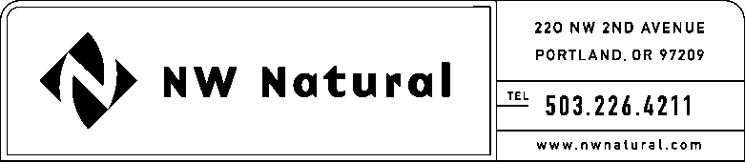

GAIL HAMMER
Rates and Regulatory Affairs
Tel: 503.226.4211 ext. 5865
Fax: 503.721.2516
email: gail.hammer@nwnatural.com

February 25, 2016

Steven V. King, Executive Director and Secretary
WASHINGTON UTILITIES &
TRANSPORTATION COMMISSION
1300 S Evergreen Park Drive, SW

Post Office Box 47250
Olympia, Washington 98504-7250

Re: Docket UG-100677: Smart Energy™ Annual Report

Northwest Natural Gas Company, dba NW Natural (“NW Natural” or the “Company”), files herewith its Smart Energy™ Annual Report in compliance with the terms established in Schedule U, “Smart Energy™ Program.”

Please address correspondence on this matter to me with copies to the following:

eFiling; Rates & Regulatory Affairs
NW Natural
220 NW Second Avenue

Portland, Oregon 97209
Telephone: (503) 226-4211, x3589
eFiling@nwnatural.com

Sincerely,

NW NATURAL

/s/ Gail Hammer

Gail Hammer
Rates and Regulatory Affairs

attachment

