September 28, 2012

David W. Danner, Executive Director and Secretary
Washington Utilities and Transportation Commission
1300 S. Evergreen Park Dr. SW
P. O. Box 47250
Olympia, Washington 98504-7250

RE: Washington Utilities and Transportation Commission v. Telecare, Inc.
Commission Staff’s Response to Application for Mitigation of Penalties
Docket UT-121011

Dear Mr. Danner:

On July 31, 2012, the Washington Utilities and Transportation Commission issued a $500 Penalty Assessment in Docket UT-121011 against Telecare, Inc. for 10 violations of Washington Administrative Code (WAC) 480-120-382, which requires competitively classified telecommunications companies to furnish annual reports to the commission no later than May 1 each year.

On August 21, 2012, Telecare, Inc. wrote the commission requesting mitigation of penalties (Mitigation Request). In its Mitigation Request, Telecare, Inc. does not dispute that the violation occurred. The company states, “Unfortunately we do not do much business in Washington. We can’t afford a $500 penalty. Can we pay $250.”

It is the company’s responsibility to ensure that the regulatory fee and the annual report are filed by the May 1 deadline. On February 29, 2012, Annual Report forms and Regulatory Fee packets were mailed to all regulated competitively classified telecommunications companies. In addition to other information, the cover letter informed the regulated company it must complete the annual report form, pay any regulatory fees and return the material by May 1, 2012 to avoid enforcement action. On May 14, 2012, the commission mailed a letter to those companies that had not yet filed an annual report notifying them that, to date, they had incurred a penalty of $800. The letter went on to explain that companies who filed their annual reports no later than May 25, 2012, would receive mitigated penalties of $25 per day, with an additional $25 per day for each instance in the previous five years that the company received a penalty for filing a late report.

Telecare, Inc. filed its annual report on May 15, 2012, which is 10 business days past the deadline of May 1, 2012. The penalty was mitigated from $100 per day to $25 per day, for a penalty of $250. Telecare, Inc. became regulated in January 1996 and received a penalty in 2010 for filing a delinquent annual report. The prior penalty increased the current penalty by $25 per business day, resulting in an additional $250, for a total penalty of $500.

Staff does not support mitigating the assessed penalty as it was already reduced and because of Telecare, Inc.’s, continued violations of WAC 480-120-382. Telecare, Inc’s annual report was 14 days past the deadline of May 1, 2012, making the company liable for a penalty of up to $1,400. The commission nevertheless exercised its discretion and assessed a penalty of $250 against Telecare, Inc. based on the number of business days the company’s filing was late, rather than on the basis of calendar days. The commission, as a courtesy mails each company an annual report form and regulatory fee sheet. Staff believes that the $500 penalty assessed is a reasonable punitive measure to impose for the company’s continued violations of WAC 480-15-480.

If you have questions regarding this recommendation, please contact Mathew Perkinson, Compliance Investigator, at (360) 664-1105 or at mperkinson@utc.wa.gov.

Sincerely,

Sharon Wallace, Assistant Director
Consumer Protection and Communications

Attachment A
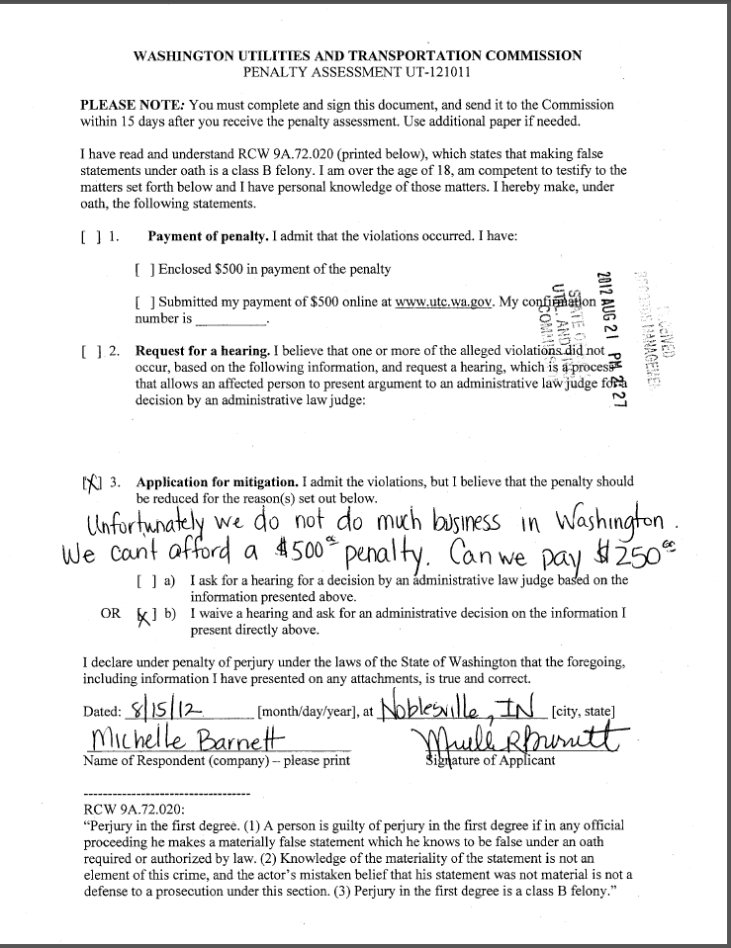
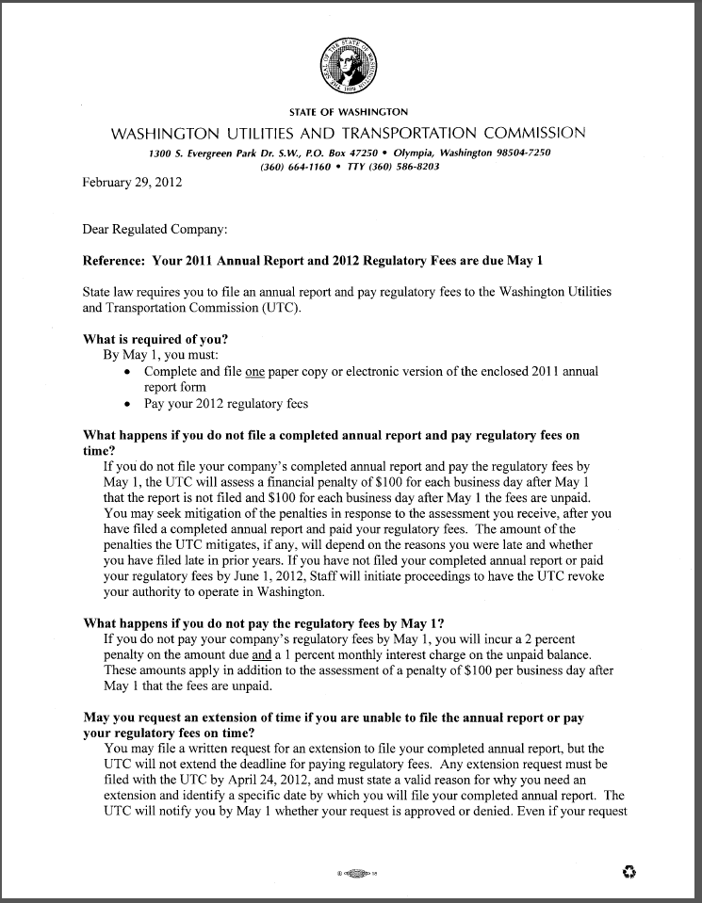
Attachment B
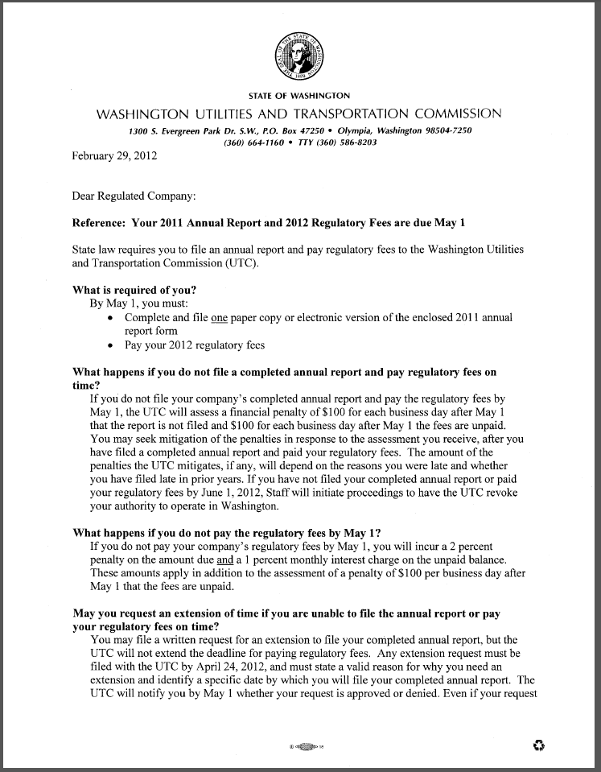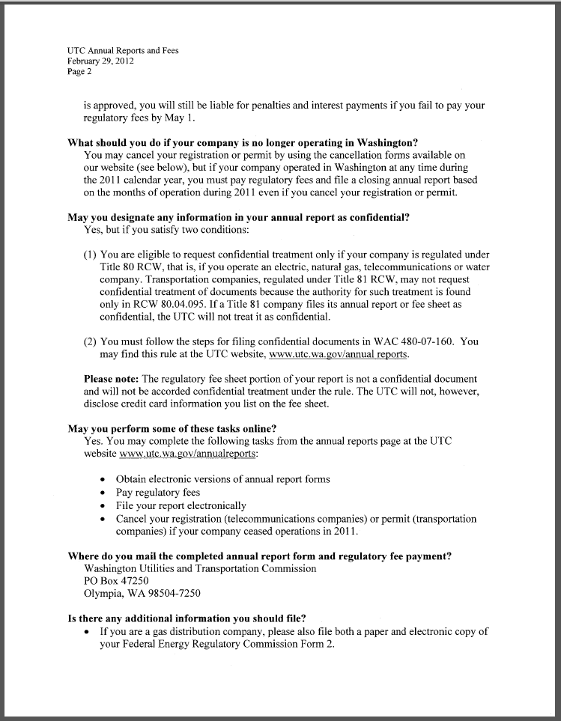

Attachment C
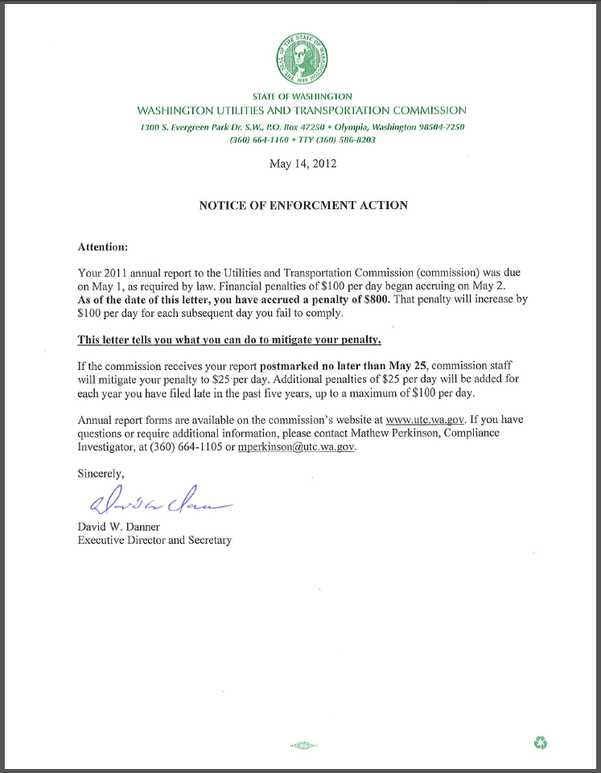

See attachment A for a copy of Telecare, Inc.’s Mitigation Request.
See attachment B for a copy of the letter sent to all regulated companies on February 29, 2012.
See attachment C for a copy of the enforcement letter sent to the company on May 14, 2012.

