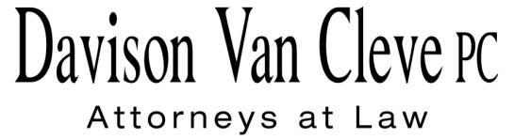
TEL (503) 241-7242 ● FAX (503) 241-8160 ● mail@dvclaw.com
Suite 400
333 S.W. Taylor
Portland, OR 97204

May 18, 2015

Via E-Mail

Mr. Steven V. King
Executive Director & Secretary
Washington Utilities & Transportation Commission
1300 S. Evergreen Pk. Dr. S.W.
P. O. Box 47250
Olympia, WA 98504-7250

Re: Pacific Power & Light Co. 2015 Integrated Resource Plan
Docket UE-140546

Dear Mr. King:

Pursuant to the Commission’s Notice of Opportunity to File Written Comments in the above-captioned proceeding, please find the Comments of Boise White Paper, L.L.C.

Thank you for your assistance. If you have any questions, please do not hesitate to call.

Sincerely,

/s/ Jesse O. Gorsuch
Jesse O. Gorsuch

Enclosure

