Agenda Date: May 14, 2009
Item Number: B1

Docket: TC-090637
Company Name: San Juan Transit, Inc., C-1006

Staff: David Gomez, Deputy Assistant Director
Dennis Shutler, Consumer Protection Staff

Recommendation
- Issue a Complaint and Order Suspending Time Schedule 51 filed by San Juan Transit, Inc.; and

- Grant an exemption to WAC 480-30-316 and allow Time Schedule 51 to go into effect on May 15, 2009, on a temporary basis, to allow customers an opportunity to comment on the proposed time schedule changes.
Discussion
On April 28, 2009, San Juan Transit, Inc., (San Juan Transit or company) filed a revised Time Schedule 51 replacing Time Schedule 50 that expired on September 14, 2008. The company requested that the time schedule take effect on May 15, 2009. The company provides scheduled auto transportation service between Friday Harbor and Roche Harbor on San Juan Island during the summer tourist season. In 2008, the company transported over 15,000 passengers.
The company’s proposed schedule would reduce from three to two the runs between Friday Harbor and Roche Harbor (including intermediate points) and eliminate service between Friday Harbor and American Camp located on the southeast part of the island (see Figure 1). The company cites lower ridership and higher costs as the reason for the service reduction. The customer notice was posted on April 29, 2009. WAC 480-30-316(1) states that an auto transportation company must provide notice to its customers at least thirty days prior to the stated effective date for any proposed tariff change that would increase recurring or prepaid rates or restrict access to services (e.g., rate increase, route reduction, time schedule change).

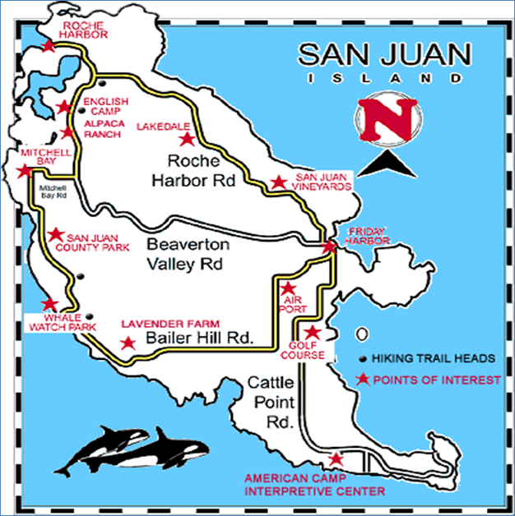
Figure 1, San Juan Transit, Inc. Service Area Map
Staff has worked with the company to make corrections to its time schedule, received May 6, 2009, and May 8, 2009, and customer notice in order for it to conform to WAC 480-30-281 and WAC 480-30-316, respectively. Notice will be posted at each vehicle, passenger facility and posted at the company’s web site.
Conclusion
- Issue a Complaint and Order Suspending the Time Schedule 51 filed by San Juan Transit, Inc.; and

- Grant an exemption to WAC 480-30-316 and allow Time Schedule 51 to go into effect May 15, 2009, on a temporary basis, to allow customers an opportunity to comment on the proposed time schedule changes.

