June 24, 2016

FILED ELECTRONICALLY VIA WEB PORTAL

Mr. Steven V. King
Executive Director & Secretary
Washington Utilities and Transportation Commission
Post Office Box 47250
1300 S. Evergreen Park Dr. SW
Olympia, Washington 98504-7250

Subject: United States Cellular Corporation – USAC Form 481
Docket UT-160030

Dear Mr. King:

On behalf of United States Cellular Corporation, LLC (“USCC”) (SAC 529001), please find attached copies of both the “confidential” and “public” versions of USCC’s FCC Form 481 Carrier Annual Report submitted pursuant to Section 54.313 of the Commission’s Rules (“Form 481 Report”).

Pursuant to WAC 480-07-140, we are making this filing electronically only. In the confidential portion of the filing, each electronic file will contain, as part of the file name, the word "CONFIDENTIAL." Additionally, each page containing confidential information in the confidential electronic files will be labeled "Confidential Per WAC 480-07-160." A redacted copy of each confidential exhibit will also be filed.

Pursuant to RCW §80.04.095 enclosures designated as "confidential" contain valuable commercial information, including trade secrets and confidential marketing, cost, or financial information, or customer-specific usage and network configuration and design information. Accordingly, pursuant to RCW §80.04.095 such information should not be subject to inspection or copying under RCW Chapter 42.56. Moreover, the records designated as "confidential" contain valuable formulae, designs, and research data, the disclosure of which would produce private gain and public loss and should be exempt from public disclosure pursuant to RCW 42.56.270(1).

In addition to the undersigned, the following might be directly affected by disclosure of the confidential information:

U. S. Cellular Corporation
8410 West Bryn Mawr Avenue
Chicago, IL 60631
Phone: (773) 864-3167
E-mail: John.Gockley@uscellular.com
Attention: John C. Gockley

If you have any questions please contact the undersigned.

Very truly yours,
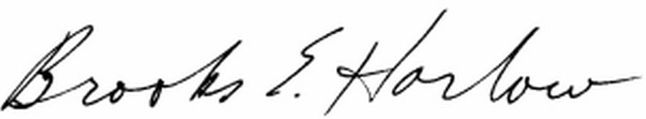
Brooks E. Harlow, P.C.
cc: Mr. Tim Zawislak
Ms. Stephanie Cassioppi

