Report to the Washington Utilities and Transportation Commission

Electric Service Reliability - Major Event Report

Event Date: July 22, 2016
Date Submitted: October 13, 2016
Primary Affected Locations: Sunnyside/Yakima
Primary Cause: Loss of Supply
Exclude from Reporting Status: Yes
Report Prepared by: April Brewer
Report Approved by: Heide Caswell / Kevin Putnam / David O’Neil / Steve Henderson

Event Description
On July 22, 2016, Sunnyside and Yakima operating areas, experienced a system average interruption frequency index-driven (SAIFI)-based major event when a loss of transmission event occurred on the Bonneville Power Administration (BPA) 230kV transmission feed. Initial indication is that the outage occurred as a result of a lightning strike on the BPA feed, causing Pacific Powers Outlook substation to trip open. The outage affected 15,205 customers with all customer restorations completed within 13 minutes. Sustained interruptions were experienced by 14% of the combined total customers in the Sunnyside and Yakima operating areas.

Event Outage Summary
# Interruptions (sustained) | 15
Total Customer Interrupted (sustained) | 15,206
Total Customer Minutes Lost | 187,013
Event SAIDI | 1.40 Minutes
CAIDI | 12
Major Event Start | 7/22/16 12:00 AM
Major Event End | 7/23/16 12:00 AM

Restoration Summary
On the morning of July 22, 2016, a loss of transmission feed from BPA Midway substation to PacifiCorp’s Outlook substation occurred. The loss of transmission affected power feeds from the Outlook substation to four other substations, feeding 13 distribution feeds, and approximately 15,205 customers. During the summer fire season automated system testing is turned off to allow personnel proper time to diagnose an outage. When the circuit breaker at the Outlook substation opened, dispatcher turned off reclosing prior to reenergizing this section of line. Once it was confirmed that the Midway substation was stable and energized, dispatch closed the circuit breaker at the Outlook substation restoring feeds and service to all substations and circuits downstream.
Impact to Pacific Power customers was increased during this event given an off-normal system configuration as part of the ongoing construction at the Union Gap Substation. Union Gap Substation is currently undergoing a multi-year rebuild project that includes constructing two new buses and adding a third transformer for improved system reliability, increasing load service to comply with North American Electric Reliability Corporation standards. Following completion of the Union Gap Substation rebuild in 2017, the system will be reconfigured such that customers will not experience a loss of supply for faults on the BPA line. A discussion with BPA regarding possible mitigation options is currently in the process of being scheduled.
There were no company or commission customer complaints made regarding the major event.
Restoration Intervals
Total Customers Sustained | < 3 Hrs. | 3 - 24 Hrs. | 24+ Hrs.
15,206 | 15,206 | 0 | 0

Restoration Resources
No additional restoration resources were used during this event.
State Estimated Major Event Costs
No additional costs were accrued during this event.
Major Event Declaration
Pacific Power is requesting designation of this event and its consequences to be classified as a “Major Event” for exclusion from underlying network performance reporting. This major event exceeded the company’s current Washington system average interruption frequency index-driven (SAIFI) threshold of 10% total operating area customers served sustained interruptions (15,206 customers interrupted out of a combined total of 104,922 Sunnyside and Yakima operating area customers, or 14% of the operating area customers) simultaneously in a 24-hour period.

Event Detail
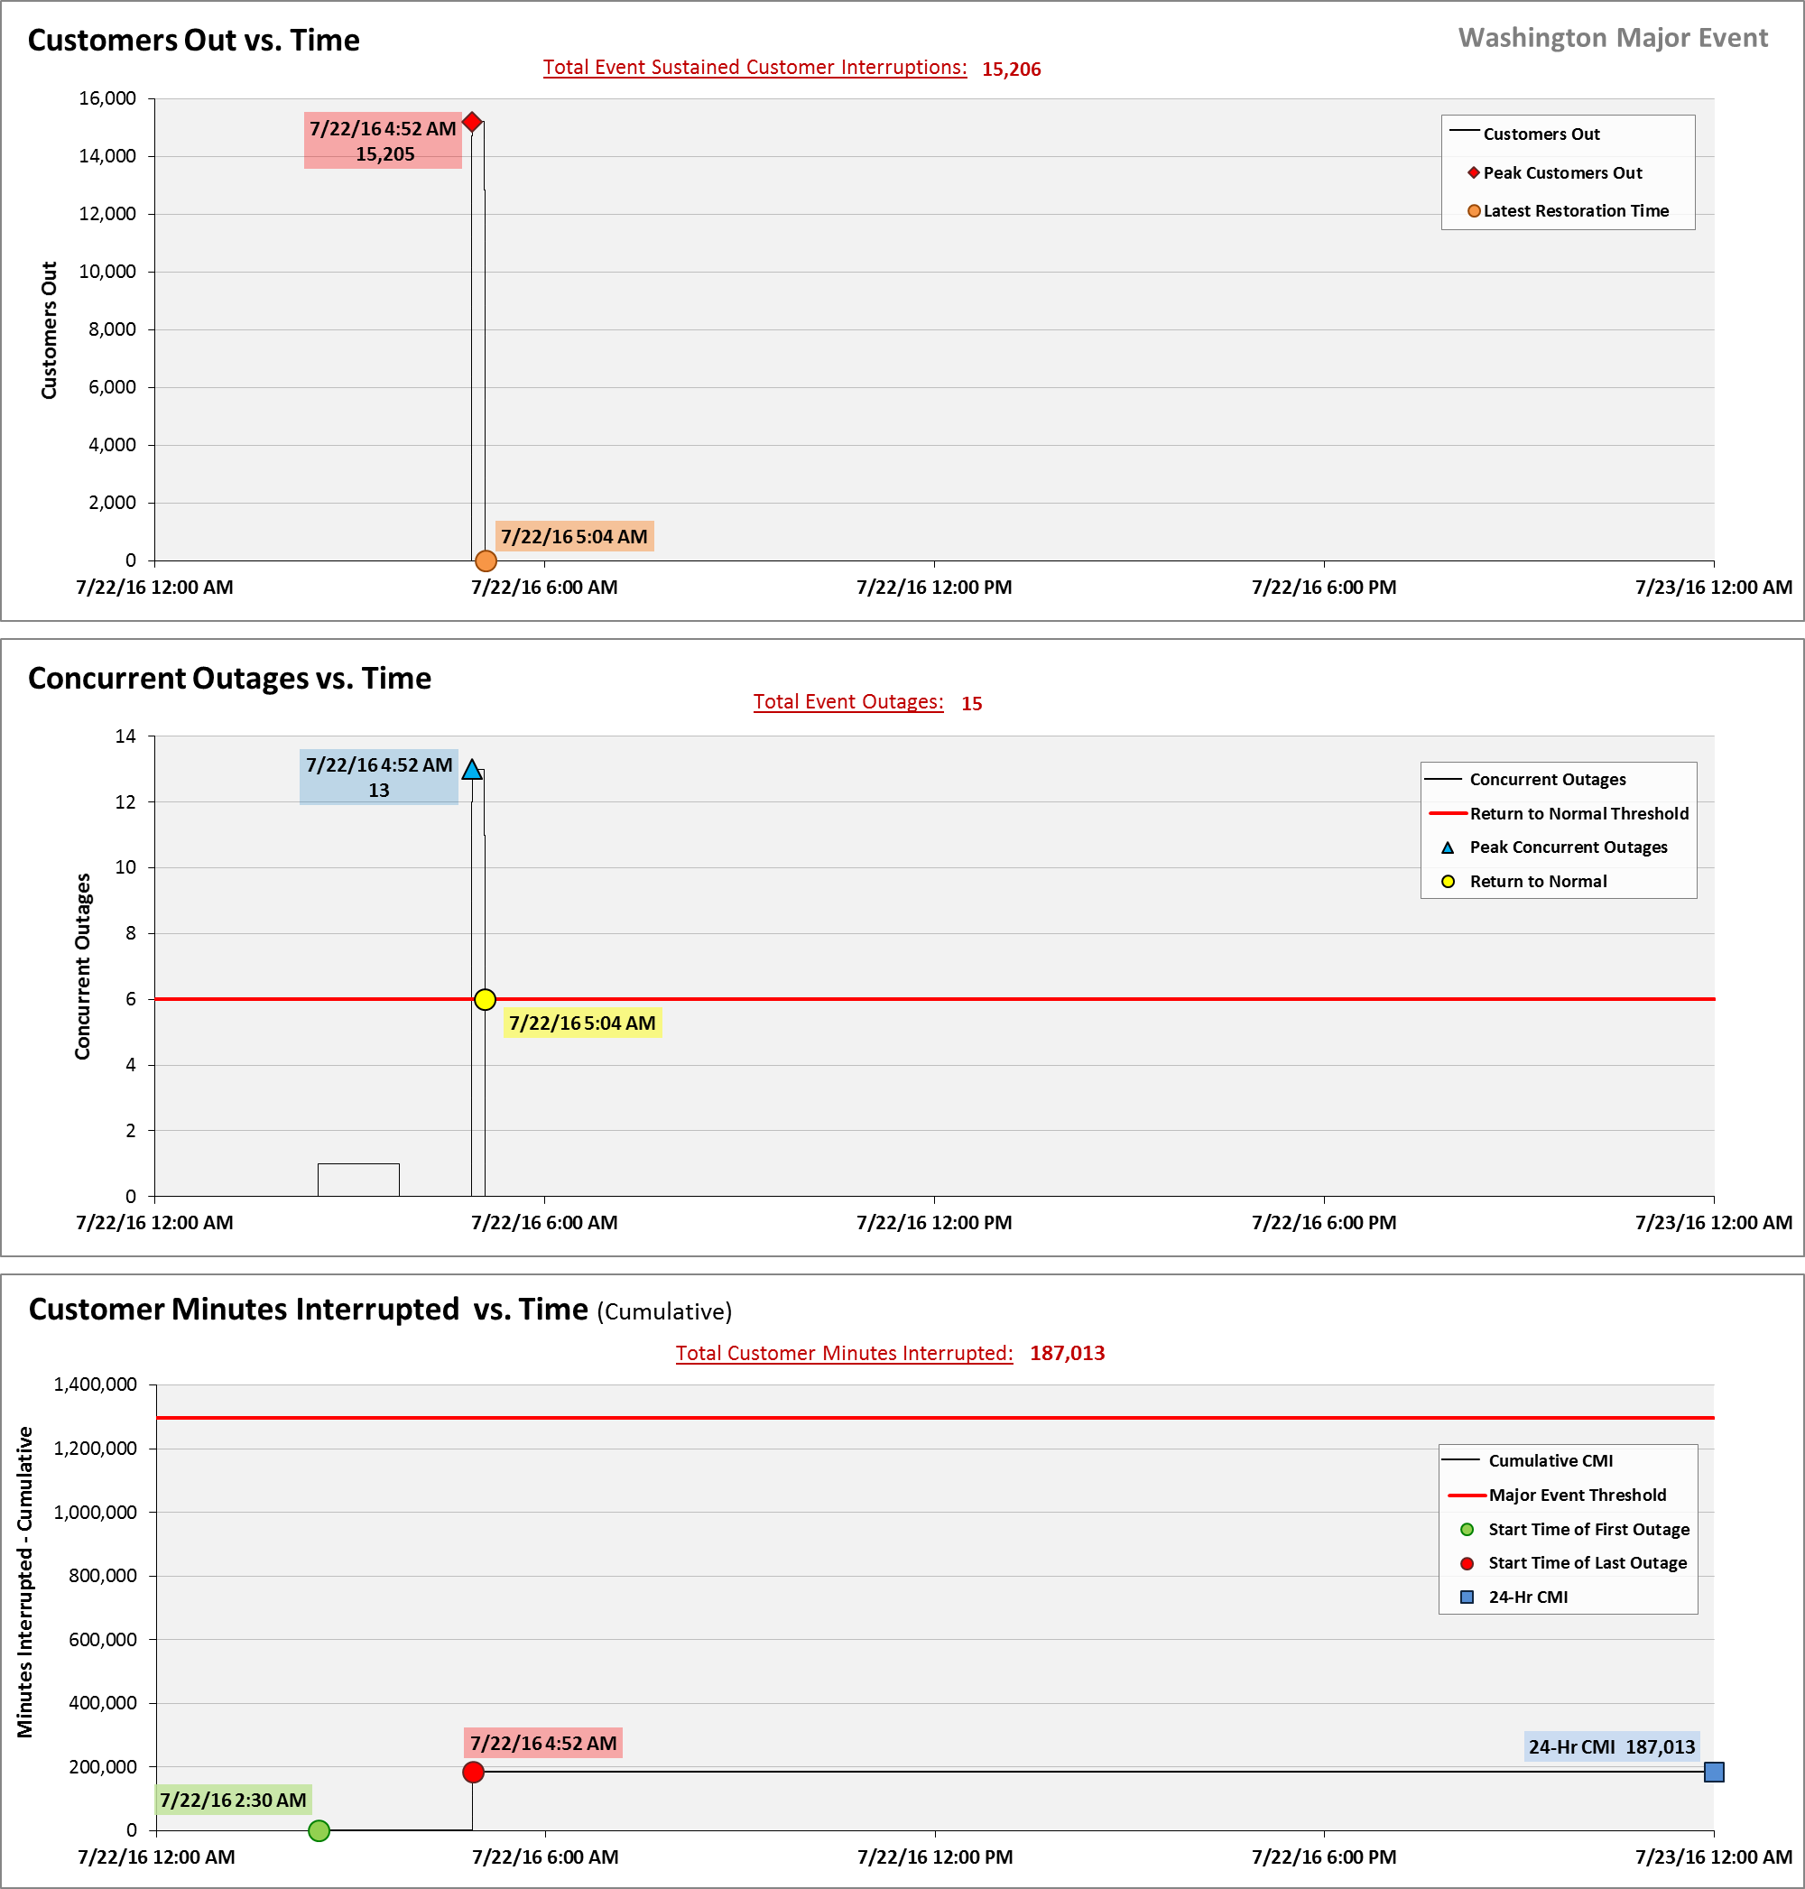
SAIDI, SAIFI, CAIDI by Reliability Reporting Region
Please see the attached system-generated reports.

A SAIFI-based major event threshold (as identified in PacifiCorp’s reporting plan, pursuant to Washington Administrative Code (WAC) 480-100-393 & 398 Electric Reliability Annual Monitoring and Reporting Plan) is defined as an event in which more than 10% of an operating area’s customers are simultaneously without service as a result of a sustained interruption. Sunnyside operating area’s Calendar 2016 Frozen Customer Count is 24,317 customers and Yakima’s 2016 Frozen Customer Count is 80,605, for a combined total of 104,922.

