July 30, 2014

FILED ELECTRONICALLY VIA WEB PORTAL
Mr. Steven V. King
Acting Executive Director & Secretary
Washington Utilities and Transportation Commission
Post Office Box 47250
1300 S. Evergreen Park Dr. SW
Olympia, Washington 98504-7250

Subject: United States Cellular Corporation – FCC Form 690
Docket UT-131808

Dear Mr. King:

Attached for filing in Docket No. UT-131808 on behalf of U.S. Cellular Corporation (“U.S. Cellular”) are the public and confidential versions of U.S. Cellular’s FCC Form 690 2014 Annual Report for the State of Washington (SAC 528004, 528005, 528006, and 528007), filed pursuant to Section 54.1009 of the Commission’s Rules (“Form 690 Report”).
U.S. Cellular’s Form 690 for Washington was filed with the FCC on July 28, 2014, and the FCC’s rules require that a copy be filed with the state commission. We have included both the confidential and public redacted copies, and we ask that the commission accord confidential treatment to the designated information therein pursuant to WAC 480-123-060. U.S. Cellular is requesting confidential treatment of the responses contained in lines 201, 205, and 206 in the FCC Form 690 and certain information contained in the Exhibit to the Project Update Information (090).

Pursuant to WAC 480-07-140, we are making this filing electronically only. In the Confidential portion of the filing, each electronic file will contain, as part of the file name, the word "CONFIDENTIAL." Additionally, each page in the confidential electronic files will be labeled "Confidential Per WAC 480-07-160." A redacted copy of the reports will also be filed.

Pursuant to RCW §80.04.095 enclosures designated as "confidential" contain valuable commercial information, including trade secrets and confidential marketing, cost, or financial information, or customer-specific usage and network configuration and design information. Accordingly, pursuant to RCW §80.04.095 such information should not be subject to inspection or copying under RCW Chapter 42.56. Moreover, the records designated as "confidential" contain valuable formulae, designs, and research data, the disclosure of which would produce private gain and public loss and should be exempt from public disclosure pursuant to RCW 42.56.270(1).

In addition to the undersigned, the following might be directly affected by disclosure of the confidential information:

U. S. Cellular Corporation
8410 West Bryn Mawr Avenue
Chicago, IL 60631
Phone: (773) 864-3167
E-mail: John.Gockley@uscellular.com
Attention: John C. Gockley

If you have any questions please contact the undersigned.

Very truly yours,
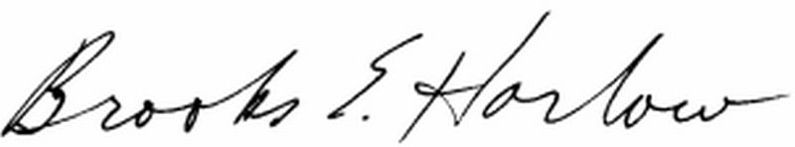
Brooks E. Harlow, P.C.
cc: Ms. Stephanie Cassioppi

