July 9, 2014

Steven V. King, Executive Director and Secretary
Utilities and Transportation Commission
1300 S. Evergreen Park Dr. SW
P.O. Box 47250
Olympia, WA 98504-7250

RE: Washington Utilities and Transportation Commission v. Crossette, Matthew S.

Commission Staff’s Response to Application for Mitigation of Penalties TV-140953

Dear Mr. King:

On June 4, 2014, the Utilities and Transportation Commission issued a $1,000 Penalty Assessment in Docket TV-140953 against Crossette, Matthew S. for 10 violations of Washington Administrative Code (WAC) 480-15-480, which requires household goods carrier companies to furnish annual reports to the commission no later than May 1 each year.¹

On June 24, 2014, Matthew Crossette submitted to the commission a signed application requesting mitigation of penalties (Mitigation Request).² In its Mitigation Request, Matthew Crossette did not provide a written statement of the reasons supporting the request.

It is the company’s responsibility to ensure that the regulatory fee is paid and the annual report is filed by the May 1 deadline. On February 28, 2014, Annual Report packets were mailed to all regulated household goods companies. The instructions for annual report completion page of the annual report informed the regulated company that it must complete the annual report form, pay the regulatory fees, and return the materials by May 1, 2014, to avoid enforcement action.

As of June 30, 2014, Matthew Crosette has not filed its 2013 annual report or paid any subsequent regulatory fees due. The company has been active since July 2, 2013. No previous violations of WAC 480-15-480 are on commission record. Staff does not support the company’s request for mitigation as no written statement was provided for consideration as required.

UTC Annual Reports
July 9, 2014
Page 2

If you have any questions regarding this recommendation, please contact Amy Andrews, Regulatory Analyst, at (360) 664-1157, or aandrews@utc.wa.gov.

Sincerely,

Sondra Walsh, Director
Administrative Services

ATTACHMENT A
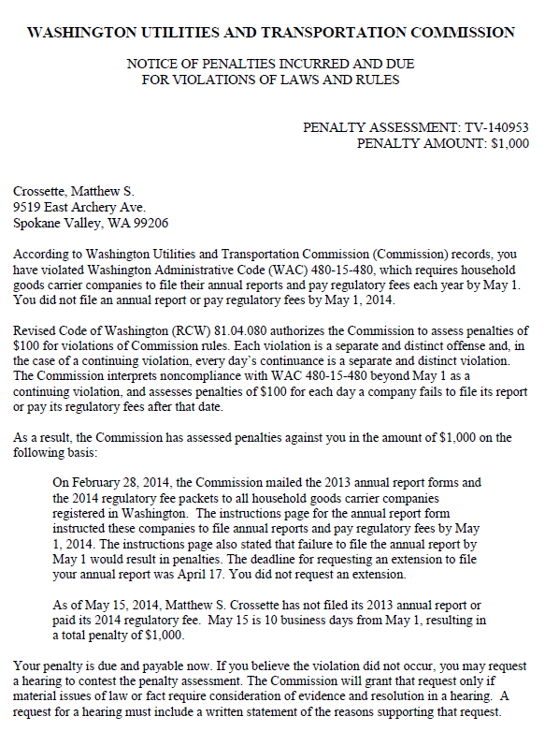

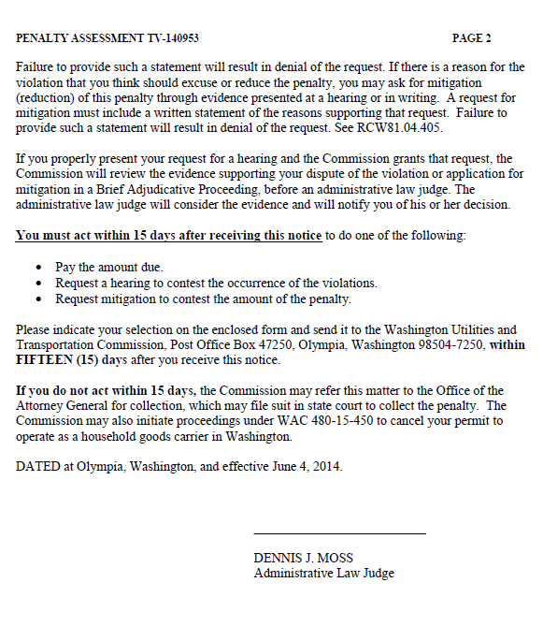

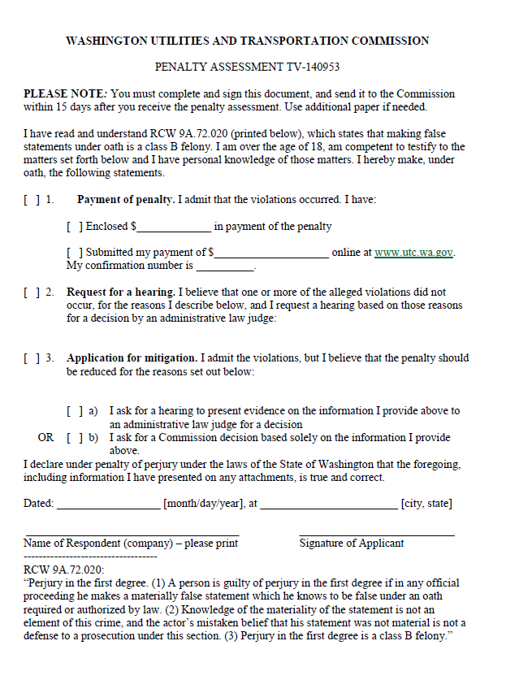

ATTACHMENT B
