[Service Date January 10, 2011]

January 10, 2011

TECHNICAL ASSISTANCE REGARDING FUEL SURCHARGE FILINGS
AND FUEL FILINGS

RE: Fuel Surcharge Inquiry
Docket T-101661

TO: REGULATED SOLID WASTE, AUTO TRANSPORTATION AND COMMERCIAL FERRY COMPANIES

Effective January 31, 2011, the Washington Utilities and Transportation Commission (commission) rescinded Order 02 in Docket A-042090 which authorized the secretary to permit temporary fuel surcharges for auto transportation, commercial ferry and household goods companies to go into effect on less than statutory notice and without notice to customers, provided the companies filed specified documents to support the calculation of the proposed fuel surcharge. The commission’s rescission of Order 02 also ends a similar process informally adopted for solid waste companies.

This letter provides technical assistance to companies regarding fuel surcharge filing requirements through January 25, 2011, and the tariff filing requirements after January 25, 2011, if the commission does not take action to amend the current decision that will become effective January 31, 2011.

FUEL SURCHARGE FILINGS THROUGH JANUARY 25, 2011
The diagram below shows timelines to guide companies in making their final fuel surcharge filings using Order 02.
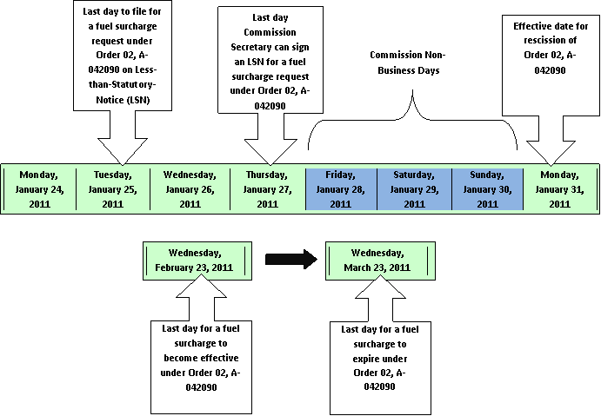
FUEL FILINGS AFTER JANUARY 25, 2011
In the absence of the Order 02 process, companies wishing to recover any increase in fuel costs since their last rate case may do so only by filing for a rate increase in which the company must show that the proposed rates are just, fair, reasonable, and sufficient as required by RCW 81.28.010.
Companies may do this by filing a general rate case or filing a single item (fuel) rate case and requesting the appropriate exemptions from rules. Please see Attachment A for the filing requirements for each industry.
Should you have any questions regarding these filing requirements, please contact Dave Gomez at 360-664-1240 or dgomez@utc.wa.gov.

Sincerely,

EUGENE K. ECKHARDT
Assistant Director of Solid Waste, Water and Transportation

Filing Requirements By Industry
Solid Waste Companies
- General rate increase filing
  - Must provide the commission with:
    - The minimum information required by WAC 480-07-520; and
    - Forty-five day notice to the commission as required by WAC 480-70-266 unless the company requests less than statutory notice handling (WAC 480-70-276).
  - Must provide customers with 30 day’s notice as required by WAC 480-70-271(1)
- Single item adjustment to rates – Solid waste companies may file a petition seeking exemption from the rules governing general rate increases and notice requirements in order to make an adjustment to rates based only on the changes to fuel costs.
Auto Transportation Companies
- General rate increase filing
  - Must provide the commission with:
    - The minimum information required by WAC 480-30-426; and
    - Thirty day notice to the commission as required by WAC 480-30-316 unless the company requests less than statutory notice handling (WAC 480-30-326).
  - Must provide customers with 30 day’s notice as required by
WAC 480-30-316 (1).
- Single item adjustment to rates – Auto transportation companies may file a petition seeking exemption from the rules governing general rate increases and notice requirements in order to make an adjustment to rates based only on the changes to fuel costs.

Commercial Ferry Companies
- General rate increase filing – Must provide:
  - The commission with 30 day’s notice as required by WAC 480-149-120 (1) unless the company requests less than statutory notice handling (WAC 480-149-120 (3)).
  - Customers with 30 day’s notice as required by WAC 480-149-120 (1).
- Single item adjustment to rates – Commercial ferry companies may file a petition seeking exemption from the rule governing notice requirements in order to make an adjustment to rates based only on the changes to its fuel costs.

The commission has received requests from the Washington Refuse & Recycling Association and Seatac Shuttle, LLC to extend the current fuel surcharge methodologies beyond January 31, 2011. The commission will consider those requests on January 20, 2011. See the open meeting notice section later in this document the end of this notice.
Companies regulated by the commission may petition for exemptions to commission rule as specified in WAC 480-07-110. The standard for consideration is the public interest standard. Factors the commission may consider include whether application of the rule would impose undue hardship on the requesting person, of a degree or a kind different from hardships imposed on other similarly situated persons, and whether the effect of applying the rule would be contrary to the underlying purposes of the rule. The commission will enter an order granting or denying the petition, or setting it for hearing.

