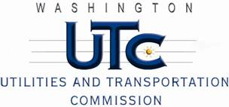

Memorandum
May 26, 2010

To: TR-091201 - File

From: Kathy Hunter, Deputy Assistant Director Transportation Safety

Subject: TR-091201 Washington and Idaho Railway
Grade Crossing Protective Fund (GCPF) Project at 7th Street in the City of Rosalia, Washington

On August 14, 2009, the Washington Utilities and Transportation Commission (Commission) awarded a GCPF grant totaling $3,217.83 for replacing incandescent lights with LEDs and installing a power off indicator light at the 7th Street crossing in the City of Rosalia. The USDOT number assigned to this crossing is 059027B.

On May 20, 2010, the applicant, Washington and Idaho Railway submitted a request for reimbursement pursuant to Commission order. On May 11, 2010, Commission staff conducted a site visit and verified that the project is completed according to the specifications outlined in the order approving the grant.

Please close this docket.

