June 26, 2014

Steven V. King, Executive Director and Secretary
Utilities and Transportation Commission
1300 S. Evergreen Park Dr. SW
P.O. Box 47250
Olympia, WA 98504-7250

RE: Washington Utilities and Transportation Commission v. Ride the Ducks of Seattle, LLC

Commission Staff’s Response to Application for Mitigation of Penalties TE-141074

Dear Mr. King:

On May 27, 2014, the Utilities and Transportation Commission issued a $700 Penalty Assessment in Docket TE-141074 against Ride the Ducks of Seattle, LLC for 7 violations of Washington Administrative Code (WAC) 480-30-071, which requires charter and excursion carriers to furnish annual reports to the commission no later than May 1 each year.¹

On June 12, 2014, Ride the Ducks of Seattle, LLC wrote the commission requesting mitigation of penalties (Mitigation Request).² In its Mitigation Request, Ride the Ducks of Seattle, LLC does not dispute that the violation occurred. The company provided a statement as to the reasons for the request being the changes to the annual report form for the charter and excursion industry and transitioning roles of staff within the company. The company requested the penalty be waived.

It is the company’s responsibility to ensure that the regulatory fee is paid and the annual report is filed by the May 1 deadline. On February 28, 2014, Annual Report packets were mailed to all regulated charter and excursion companies. The instructions for annual report completion page of the annual report informed the regulated company that it must complete the annual report form, pay the regulatory fees, and return the materials by May 1, 2014, to avoid enforcement action.

On May 12, 2014, Ride the Ducks of Seattle, LLC filed the 2013 annual report and timely paid the required regulatory fees on December 26, 2013. The company has been active since October 21, 1999. No previous violations of WAC 480-30-071 are on commission record. The UTC also
UTC Annual Reports
June 26, 2014
Page 2

recently adopted new rules requiring the annual report to be filed by May 1 while the regulatory fees remained due on December 31. Despite the commission communication regarding these filing changes to all regulated charter and excursion companies, commission staff supports the company’s request for mitigation. Staff recommends a reduced penalty assessment of $200.

If you have any questions regarding this recommendation, please contact Amy Andrews, Regulatory Analyst, at (360) 664-1157, or aandrews@utc.wa.gov.

Sincerely,

Sondra Walsh, Director
Administrative Services

ATTACHMENT A
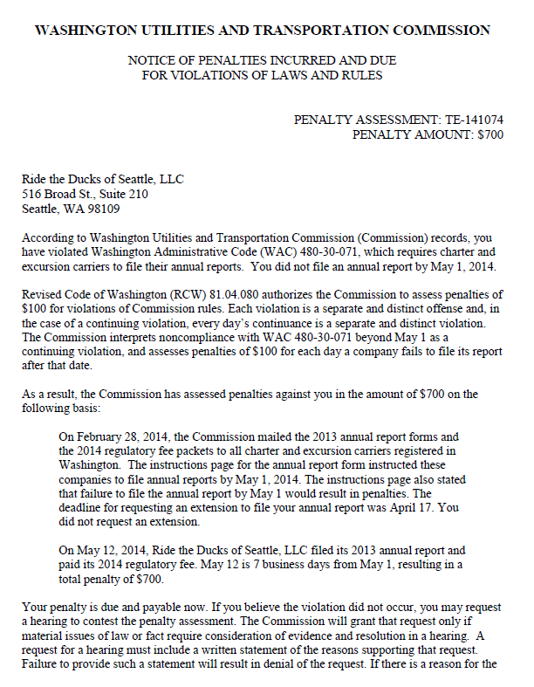

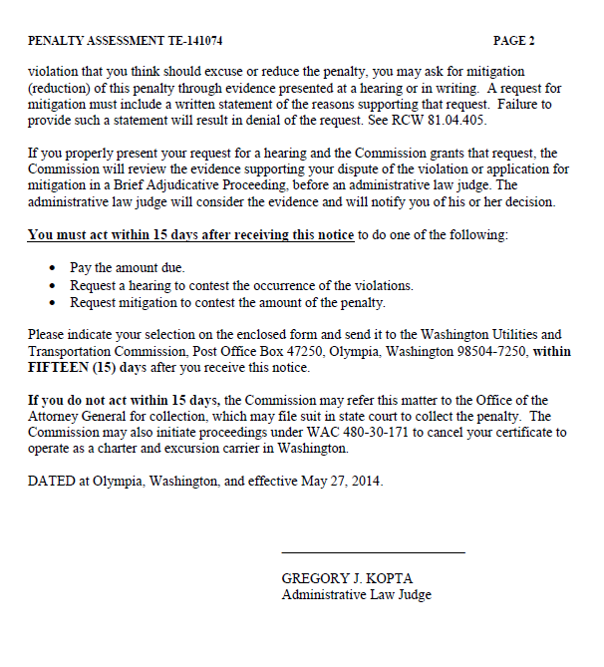

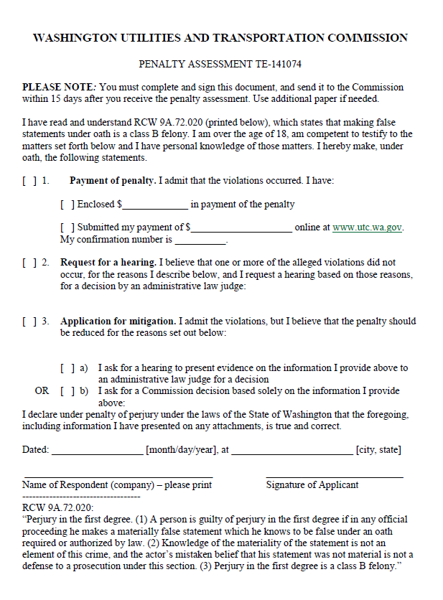

ATTACHMENT B
