July 11, 2014

Steven V. King, Executive Director and Secretary
Utilities and Transportation Commission
1300 S. Evergreen Park Dr. SW
P.O. Box 47250
Olympia, WA 98504-7250

RE: Washington Utilities and Transportation Commission v. Tacoma Moving & Storage Co

Commission Staff’s Response to Application for Mitigation of Penalties TV-140995

Dear Mr. King:

On June 6, 2014, the Utilities and Transportation Commission issued a $1,000 Penalty Assessment in Docket TV-140995 against Tacoma Moving & Storage Co for 10 violations of Washington Administrative Code (WAC) 480-15-480, which requires household goods carrier companies to furnish annual reports to the commission no later than May 1 each year.¹

On June 30, 2014, Tacoma Moving & Storage Co wrote the commission requesting mitigation of penalties (Mitigation Request).² In its Mitigation Request, Tacoma Moving & Storage Co does not dispute that the violation occurred. The company states, “Please remove the proposed assessment of a $1,000 penalty, based on our attempt at filing the report online on 4/29/2014. We were under the impression that it was filed successfully on 4/29/2014. The method of scanning and attaching gave us errors that, we thought, had been corrected. I would have resubmitted this earlier, but I have been out of the office taking care of my elderly mother post-surgery.”

It is the company’s responsibility to ensure that the regulatory fee is paid and the annual report is filed by the May 1 deadline. On February 28, 2014, Annual Report packets were mailed to all regulated household goods companies. The instructions for annual report completion page of the annual report informed the regulated company that it must complete the annual report form, pay the regulatory fees, and return the materials by May 1, 2014, to avoid enforcement action.

UTC Annual Reports
July 11, 2014
Page 2

On June 30, 2014, Tacoma Moving & Storage Co filed its 2013 annual report and paid the regulatory fees and late payment penalty. The company has been active since August 27, 2003. Tacoma Moving & Storage Co was delinquent in filing the 2012 annual report. Staff does not support the company’s request to remove the penalty assessment. However, due to the compelling reasons provided in the company’s statement, staff does support mitigation of the penalty. Staff recommends a reduced penalty of $25 per day for a total penalty assessment of $250.

If you have any questions regarding this recommendation, please contact Amy Andrews, Regulatory Analyst, at (360) 664-1157, or aandrews@utc.wa.gov.

Sincerely,

Sondra Walsh, Director
Administrative Services

ATTACHMENT A
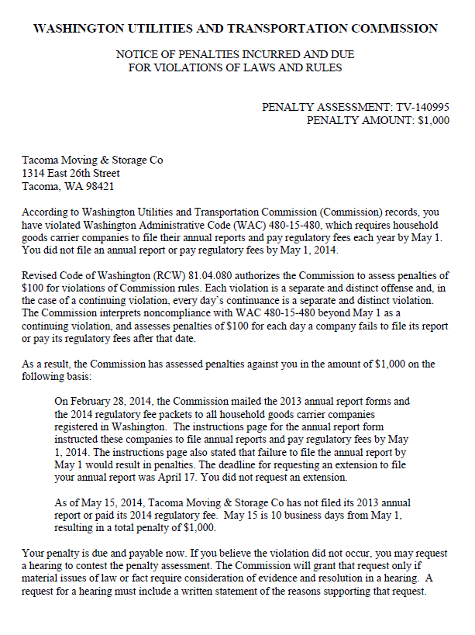

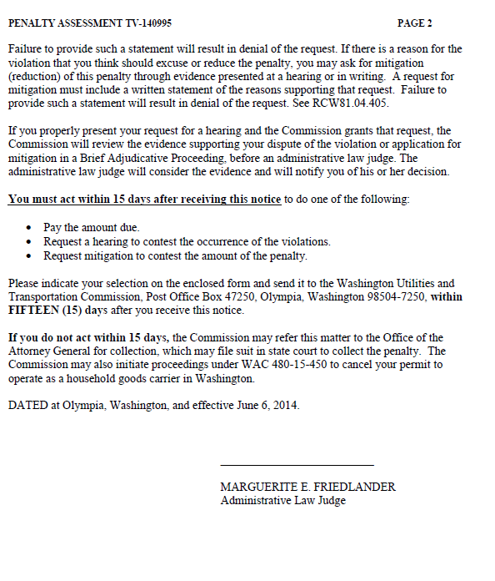

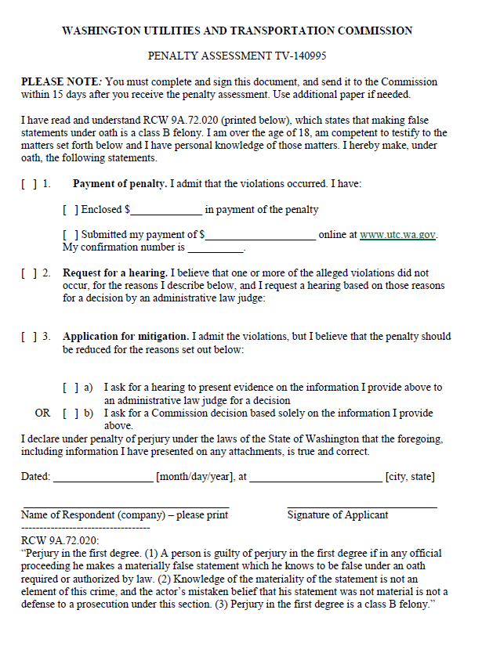

ATTACHMENT B
